|  |  |
| --- | --- |
| GIET LOGO | **GIET UNIVERSITY, GUNUPUR – 765022**  M. Tech ( First Semester – Regular) Examinations, April / May – 2021  **MPEPC1010– ELEECTRIC DRIVE SYSTEM**  **SET 01**  **(Branch)** |
| Time: 3 hrs Maximum: 70 Marks | |

**SCHEME OF VALUATION**

**PART – A (10 x 2= 20 Marks)**

Q1. Answer **ALL** questions

1. When an electric motor rotates, it is usually connected to a load which has a rotational or translational motion. The speed of the motor may be different from that of the load. To analyse the relation among the drives and loads, the concept of dynamics of electrical drives is introduced.
2. Load torques which always oppose the motion and change their sign on the reversal of motion are called passive load torques.
3. Various speed transitions can be classified into the following categories:

Decrease in speed in the same direction.

Speed reversal.

Increase in speed in the same direction.

1. Everywhere DC motors are used in large applications, the use of drives are very necessary for the smooth running and operating of these motors. The DC motor drives are used mainly for good speed regulation, frequent starting, braking and reversing.
2. It is the time during which the chopper is on (Ton) relative to the whole period (T = Ton+Toff). The output voltage can be changed by changing the duty cycle (Ton/T). The duty cycle is between 0 and 1.
3. The motor which works on the principle of electromagnetic induction is known as the induction motor. The electromagnetic induction is the phenomenon in which the electromotive force induces across the electrical conductor when it is placed in a rotating magnetic field.
4. Theoretical analyses of the induction machine consider it to be a transformer with a rotating secondary. The stator windings constitute primary windings that induce flux in the rotor and stator iron. The rotor windings constitute a secondary winding that is shorted. Hence, an equivalent circuit similar to that representing the transformer is derived and appears as in Fig.

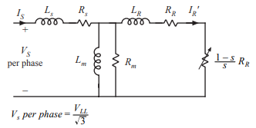

1. A polyphase induction motor consists of a poly phase winding embedded in a laminated stator and a conductive squirrel-cage embedded in a laminated rotor. Three-phase currents flowing within the stator create a rotating magnetic field which induces a current and consequent magnetic field in the rotor.

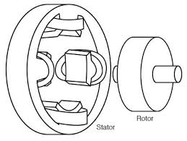

1. Only series and compound dc motors are suitable for traction work. With a dc series motor, the current and torque produced at standstill may be reduced by strengthening the field or lowering the terminal voltage or both. Motors may be placed in series, reducing the terminal voltage of each without loss in external resistance. External resistance may be placed in series with the motors to limit the starting current to any desired value, and by varying the resistance the current may be kept constant during notching up period as desired, as the back emf is being built up. Since maximum torque while starting demands full field strength, any shunt or reduced field connections are usually thrown out of action in starting.

Ideal traction system should have the capability of developing high tractive effort in order to have rapid acceleration.

• The speed control of the traction motors should be easy.

• Vehicles should be able to run on any route, without interruption.

• Equipment required for traction system should be minimum with high efficiency.

• It must be free from smoke, ash, durt, etc.

• Regenerative braking should be possible and braking should be in such a way to cause minimum wear on the break shoe.

• Locomotive should be self-contained and it must be capable of withstanding overloads.

• Interference to the communication lines should be eliminated while the locomotive running along the track.

**PART – B (5x 10=50 Marks)**

Answer ***ANY FIVE*** questions

**2. a.**

A motor generally drives a load (machine) through some transmission system. Whilethe motor always rotates, the load may rotate or may undergo a translational motion. The load speed may be different from that of the motor; if the load has many parts, their speeds may be different, and while some may rotate, others may go through a translational motion. It is convenient, however, to represent the motor load system by an equivalent rotational system, as shown in figure. The following notation is adapted:

J = polar moment of inertia of the motor-load system referred to the motor shaft,

Wm = instantaneous angular velocity of the motor shaft, rad/ sec

T = developed torque of the motor, N-m

TL = the load (resisting) torque, referred to the motor shaft, N-m **(2M)**

Any motor-load system can be described by the following fundamental torque equation:

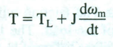

The drive accelerates or decelerates depending on whether T is greater or less than TL. During the acceleration period, the motor should supply not only the load torque but an additional component Jdwm/dt to overcome the inertia of the drive. In applications having a load with large inertia, such as trains, the motor torque must exceed the load torque by a large amount to get an adequate amount of acceleration. Similarly, in applications requiring fast response, the motor torque should be maintained at the highest value and the motor-load system should be designed to have the lowest possible inertia. When the speed increases, the kinetic energy of the drive given by 1/2Jwm2also increases; and, therefore, in addition to the energy supplied to the load, the motor should also supply the kinetic energy. During the deceleration period, the dynamic torque Jdwm/dt changes its sign, and thus assists the motor torque T in maintaining the motion of the drive by extracting energy from the stored kinetic energy. When the load has a high inertia, the motor should produce a large braking torque (negative T) to get adequate deceleration. When fast response is required, the braking torque should be maintained at the highest value and the motor load system should be designed with the lowest possible inertia. **(3M)**

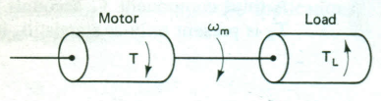

**2. b.**

The load torque TL can be further divided into the following components:

Friction torque TF: The friction will be present at the motor shaft and also in the various parts of the load. The friction torque TF is the equivalent value of various friction torques referred to the motor shaft.

Windage torque Tw: When a motor runs, the wind generates a torque opposing the motion. This is known as the windage torque.

Torque required to do the useful mechanical work, TM: The nature of this torque depends on the type of load. It may be constant and independent of speed, it may be some function of speed, it may be time invariant or time variant, and its nature may also vary with the change in the load's mode of operation. **(2M)**

The variation of friction torque with speed is shown in figure a. Its value at standstill is much higher than its value at slightly above zero speed. Friction at zero speed is called stiction or static friction. For the drive to start, the motor torque should at least exceed stiction. The friction torque can be resolved into three components as shown in figure b. The component Tv which varies linearly with speed is called viscous friction **(3M)**

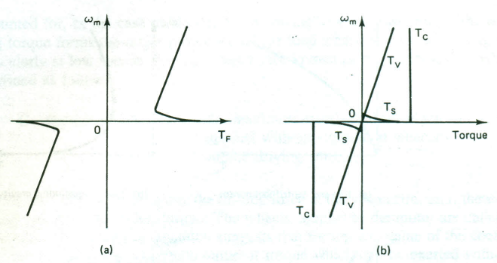

**3.**

It is interesting to know the speed-torque requirements of few specific applications. Figure shows speed-torque plots for some applications.

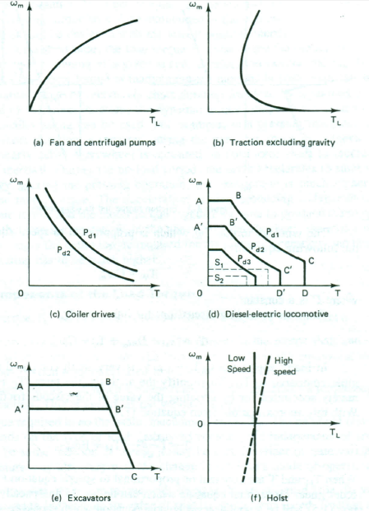

**(5M)**

In the case of centrifugal pumps, blowers, fans, and other loads involving the turbulent flow of fluid, the load-torque varies as the square of speed, as shown in figure a. The windage is also a predominant component at high speeds for trains, cars, and so on. The variation of the traction load torque with speed, excluding the torque due to gravity, is shown in figure b. It is applicable to electric trains and road vehicles. It is comprised of the windage, viscous friction, coulomb friction, and stiction. When deciding about the torque requirements of the driving motor, the torque components that are needed to provide acceleration and to overcome gravity must also be accounted for In the case of electric trains, owing to very large inertia, the accelerating torque forms the major proportion of the total torque in the accelerating range, particularly at low speeds. **(5M)**

**4. a.**

The basic arrangement of an electrical drive is shown in Fig. .The block diagram of this DC drive is shown in Fig. **(2M)**

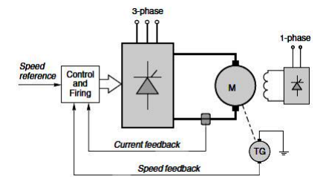

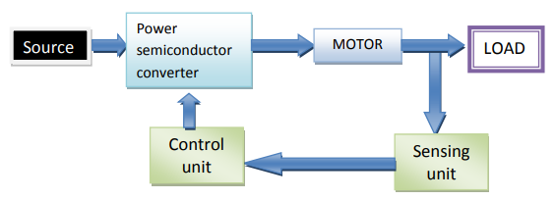

For motors up to a few kilowatts the armature circuit of the motor can be supplied from either single-phase or three-phase mains, but for larger motors three-phase is always used. A separate thyristor or diode rectifier is used to supply the field of the motor: the power is much less than the armature power, so the supply is often single-phase, as shown in Figure. An example of actual DC drive circuit with the armature of the motor supplied from a three-phase full-wave fully controlled rectifier is shown in fig.. **(2M)**

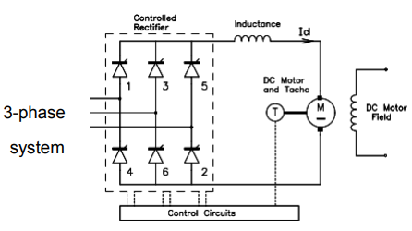

**(1M)**

**4. b.**

If the armature voltage of a separate or series excited dc motor running at a steadystate speed is reduced (by a small amount), , the armature current, and, therefore, the motor torque will decrease. As the motor torque will be less than the load torque, the motor will decelerate, causing speed and back emf to decrease. It, will finally settle at a lower speed at which its torque equals the load torque. If the armature voltage of a separately excited motor is reduced by a large amount, it may become less than the back emf. The armature current will then reverse and the motor will work as a generator producing negative torque. This operation will continue until the motor speed has fallen to a value at which the motor back emf becomes equal to the applied voltage. After that, deceleration will occur in the manner just explained. In the case of a series motor, even when the armature voltage is changed by a larger step, it does not work as a generator, and the deceleration occurs because the motor torque is lower than the load torque **(3M)**

The important feature of this method of speed control is that the nature and the slope of the speed-torque characteristics do not change with the change in speed. It provides a constant torque drive because the maximum permissible armature current, and, therefore, the maximum torque capability, of the motor remains constant at all the speeds. **(2M)**

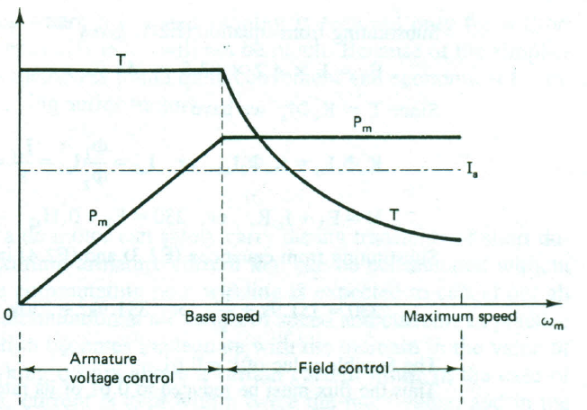

**5. a.**

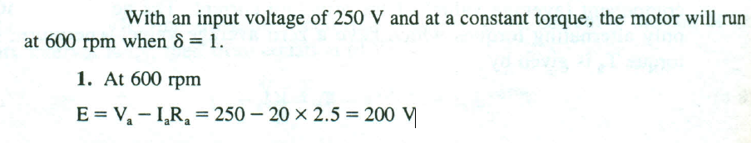

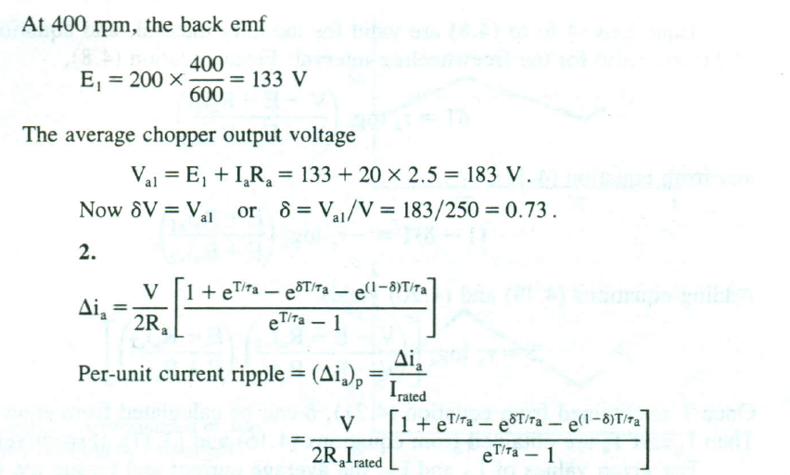

**(2M)**

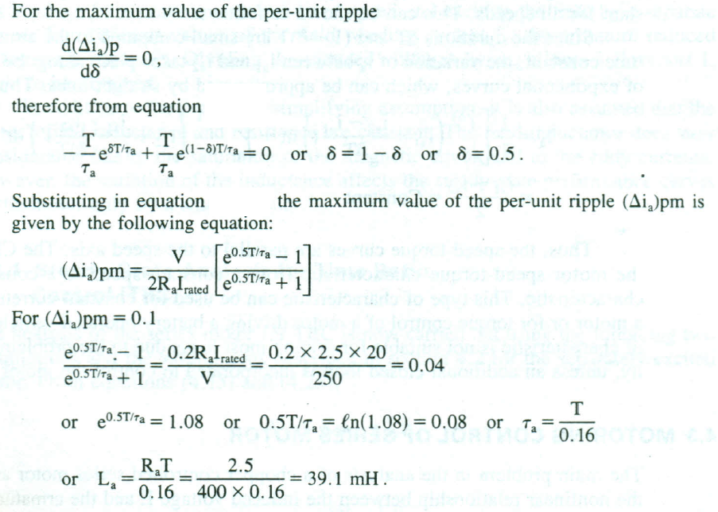

**(3M)**

**5.b.**

In closed loop system, the output of the system is feedback to the input. The closed loop system controls the electrical drive, and the system is self-adjusted. Feedback loops in an electrical drive may be provided to satisfy the following requirements.

Enhancement of speed of torque To improve steady-state accuracy. Protection

The main parts of the closed-loop system are the controller, converter, current limiter, current sensor, etc. The converter converts the variable frequency into fixed frequency and vice-versa. The current limiter limits the current to rise above the maximum set value. The different types of closed loop configuration are explained below. **(2M)**

Current Limit Control

This scheme is used to limit the converter and motor current below a safe limit during the transient operation. The system has a current feedback loop with a threshold logic circuit.

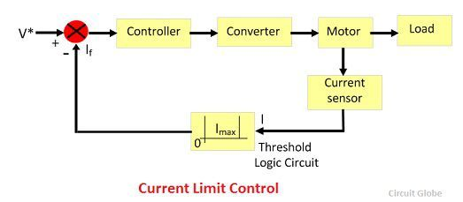

Closed-Loop Speed Control

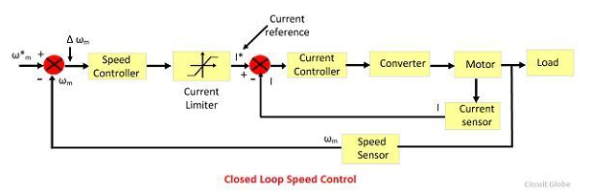The block diagram of the closed loop speed control system is shown in the figure below. This system used an inner control loop within an outer speed loop. The inner control loop controls the motor current and motor torque below a safe limit. **(3M)**

Consider a reference speed ω*m which produces a positive error Δ ω*m. The speed error is operated through a speed controller and applied to a current limiter which is overloaded even for a small speed error. The current limiter set current for the inner current control loop. Then, the drive accelerates, and when the speed of the drive is equal to the desired speed, then the motor torque is equal to the load torque. This, decrease the reference speed and produces a negative speed error. When the current limiter saturates, then the drive becomes de-accelerate in a braking mode. When the current limiter becomes desaturated, then the drive is transferred from braking to motoring.

**6.**

Dynamic Modelling of Induction Motor:

The derviation of equations for dynamic modeling of induction motor proceeds along following flowchart:

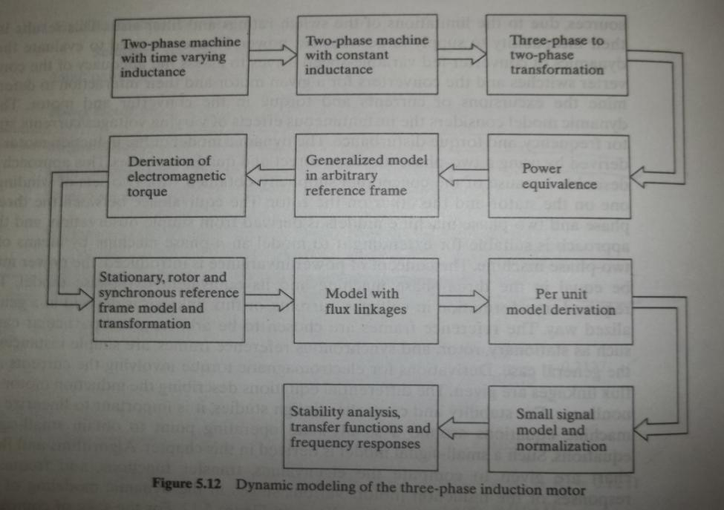

***Step -1 : Two Phase Induction Motor***

***Explanation for why modelling with a 2-phase Induction motor:***

Rotating magnetic field is the main component in induction machine, which is generated by stator and induced on the rotor and the interaction between the two results in torque which in turn results in rotation of the rotor. Now to generate a resultant rotating magnetic field in space a minimum of two field 90 degrees out of phase and positioned in quadrature are required. Hence the stator and the rotor rotating magnetic fields can be modelled by two fields each for the rotor and stator respectively.

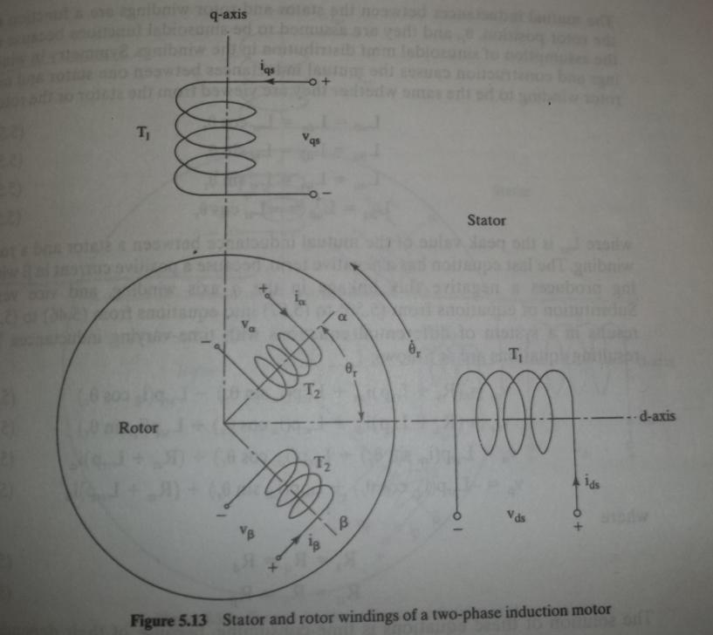

The KVL equations for the induction motor are as follows:(where p= d/dt)

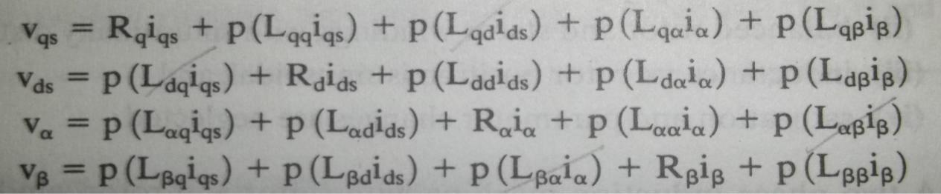

But the flux linkages between mutually perpendicular axes is zero. Also assuming the air gap flux to have uniform distribution, the self mutual inductances Lqd = Ldq and so on.

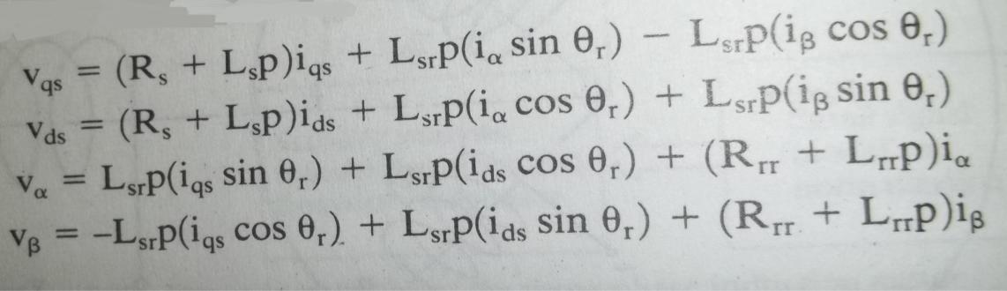

But if we derive equations for such a motor(see above) ,the flux linkages vary with position and result in equations with varying co-efficient which makes the analysis difficult. Hence we resolve the rotor about fictitious rotor windings placed along with the stator windings. Also we refer the equations to stator to remove the physical isolation between the coils. What we end up is a set of equations having constant co-efficient.

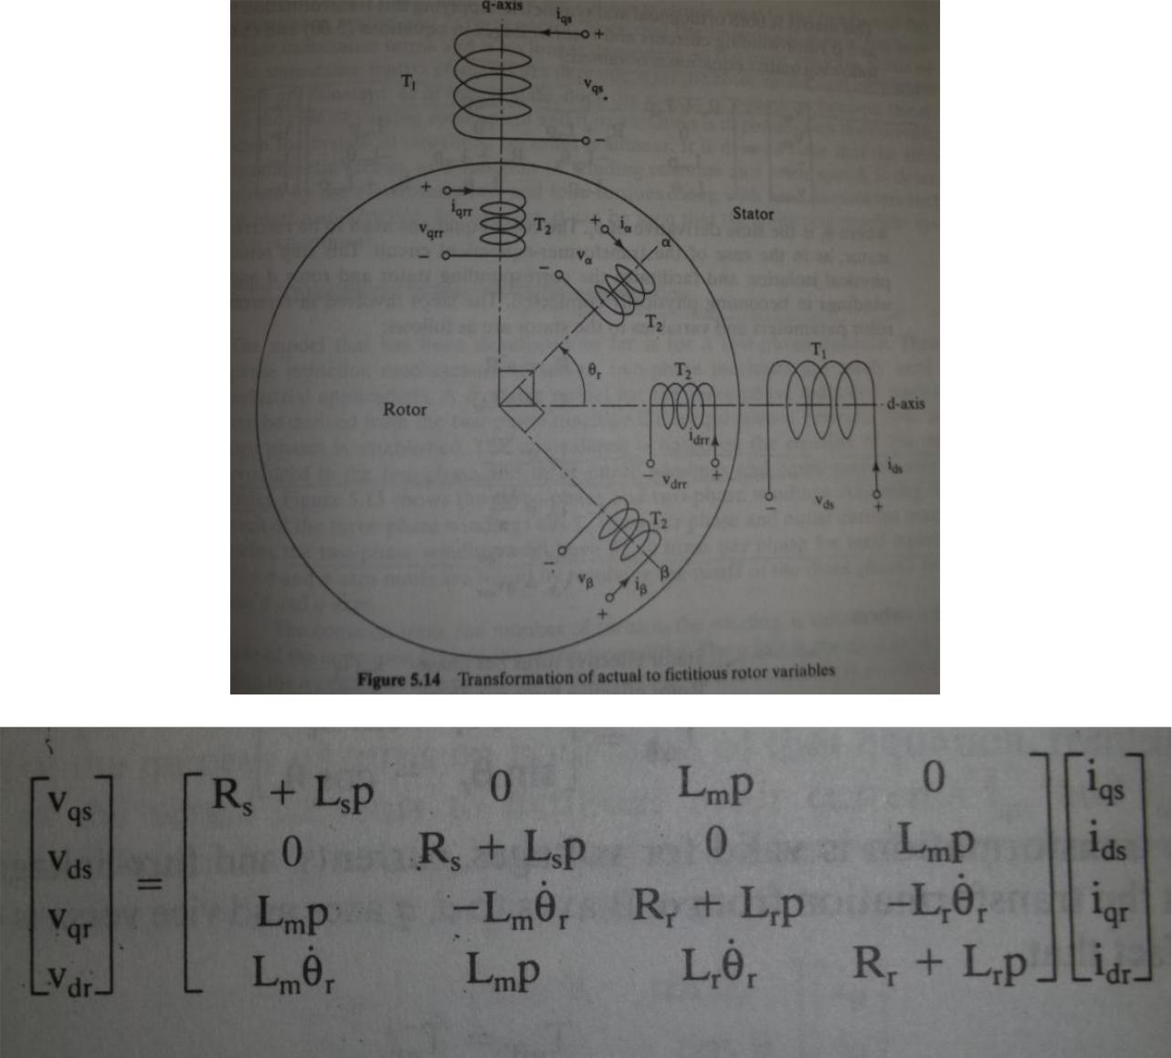

***Step 2 : Three Phase to two phase conversion***

Two points are to be meet when performing this conversion:

1. The net mmf produced in both the cases must be the same. Hence for the two phase model we need to increase the number turns of windings by 1.5 times.



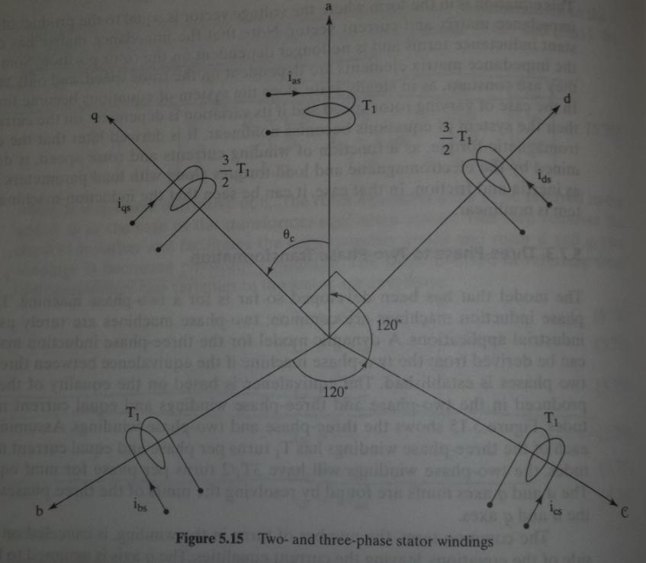The transformation matrix for 2 phase to 3 phase conversion is as follows(the transformation matrix is applicable to voltages ,currents and flux-linkages):

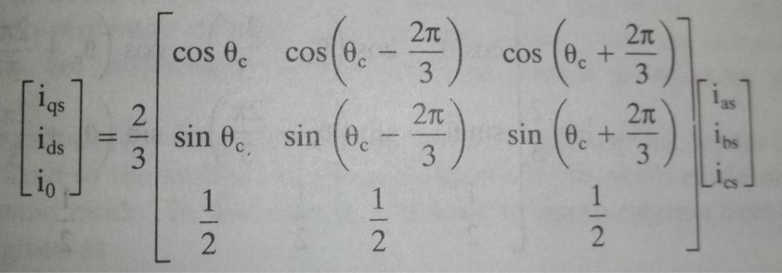

***Zero sequence current component:***

The component i0 is the zero sequence component. It results when the three phase voltages are not balanced. In balanced 3 phase system, the sum f the phase currents is zero and hence i0 is zero. **(4M)**

***Model in Arbitrary Rotating Reference Frame:***

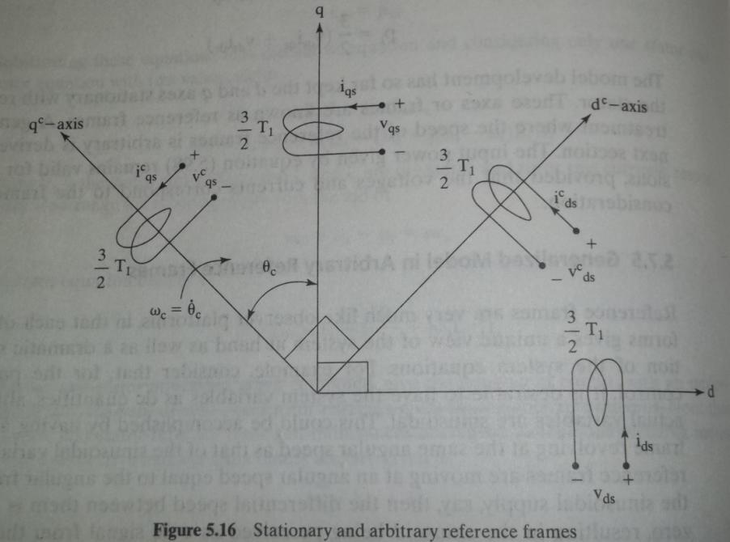

Resolving the d-q axes along different rotating reference frames gives us computational advantage depending of the electrical quantity of interest(will be discussed latter).Here the focus is to derive the equations for a frame rotating at arbitrary speed wc .

Particularly, for the deriving the equation of torque the equations in arbitrary reference frame come handy.

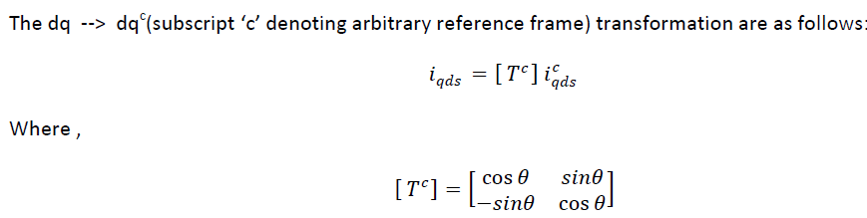

The impedance matrix thus obtained is:

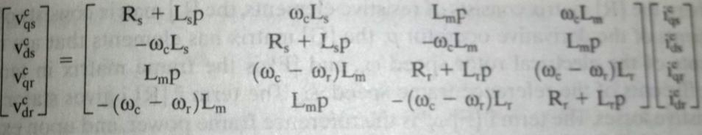

***Equation for torque :***

We can resolve the above matrix as :



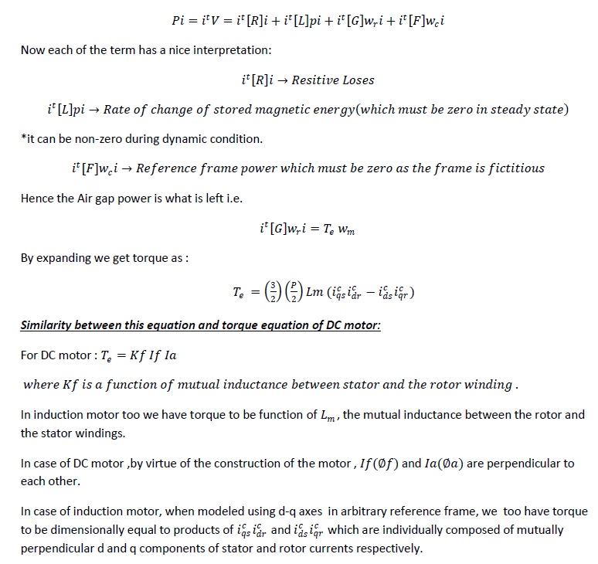

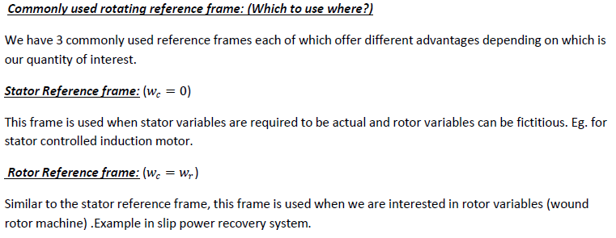

**(6M)**

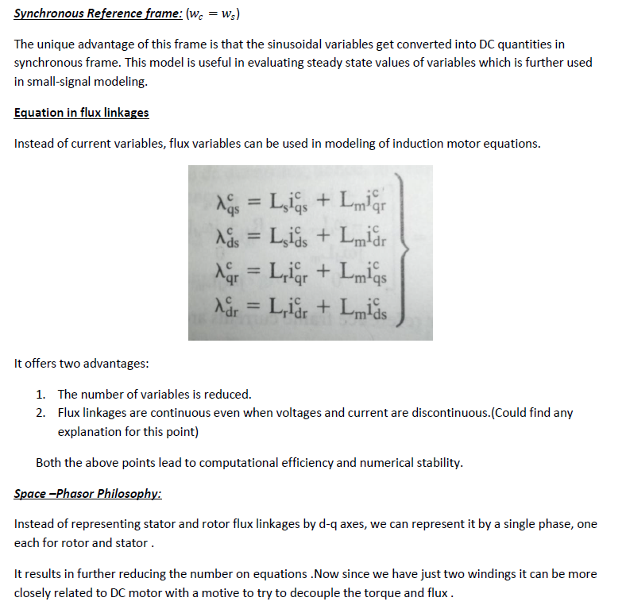

**7.a)**

Power Circuit and Gating

By having series-connected power switches in the induction motor, the instant of voltage application can be delayed. This is accomplished by controlling the gating I base drive signals to the power switches. A power-circuit configuration of stator- phase controlol methods is shown in Figure . The power switches can be SCRs, triacs, power transistors, or GTOs. The power switches are numbered to reflect the sequence of their gating control. The gating signals are synchronized to the phase voltages, and they can be delayed up to a maximum of 180 degrees. The angle of delay, ot, is termed the triggering angle. The gating signals are spaced at 60 degrees interval from each other. For sustained conduction, the gating signals are more than 60 degrees wide so that two power devices in two different phases conduct at a given time for current flow. The load is inductive, and the gating signals need to be maintained for the entire conduction time to ensure continued conduction (or until the current is higher than the latching current of the SCR). **(3M)**

Reversible Controller

For the phase controller shown in Figure, the power can flow only from the 3-phase supply to the machine, and it can run in only one direction for only one possible phase sequence of the output voltage. Thus, it has only one-quadrant torque speed performance

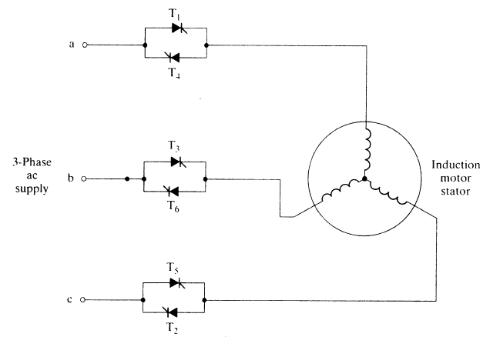

**(2M)**

**7.b)**

Regenerative braking is the most efficient method of braking to stop the motor. In previous method of rehostatic braking, the kinetic energy of all rotating parts is wasted

in external braking resistor and in case of plugging extra energy is drawn from the supply during braking period. But in this method of braking, no energy is drawn from the supply during the braking period and some of the energy is fed back to the supply system.

Regenerative braking can be applied to both DC and AC motors.

Regenerative braking applied to DC shunt motor

In case of DC shunt motor, energy can be fed back to the supply system whenever rotational emf is more than the supply voltage. During the braking period, the excitation and speed of DC shunt motor are suitably adjusted such that the rotational emf is more than the supply voltage (Eb > Vf). Since, back emf or rotational emf is directly proportional to the field flux and the speed of the rotation of the shaft of the machine.

Now, a motor acts as generator and the direction of current through armature is reversed so that, the torque developed by the armature is reversed.

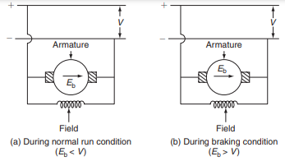

DC series motor

In case of DC series motor, it is not easy to apply regenerative braking as of DC shunt motor. The main reasons of the difficulty of applying regenerative braking to DC series motor are:

(i) During the braking period, the motor acts as generator by reversing the direction of current flowing through the armature, but at the same time, the current flowing through the field winding is also reversed; hence, there is no retarding torque. And, a short-circuit condition will set up both back emf and supply voltage will be added together. So that, during the braking period, it is necessary to reverse the terminals of field winding.

(ii) Some sort of compensating equipment must be incorporated to take care of large change in supply voltage. On doing some modifications during the braking period, the regenerative braking can be applied to DC series motor. Any one of the following methods is used.

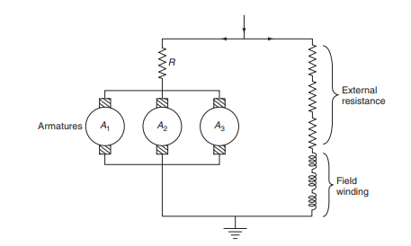

**8.a)**

**ANALYSIS OF QUADRILATERAL SPEED–TIME CURVE**

Quadrilateral speed–time curve for urban and suburban services for which the distance between two stops is less. The assumption for simplified quadrilateral speed–time curve is the initial acceleration and coasting retardation periods are extended, and there is no free-running period. Simplified quadrilateral speed–time curve is shown in Fig.

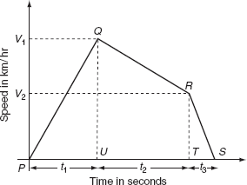

Quadrilateral speed–time curve

Let *V*1 be the speed at the end of accelerating period in km/h, *V*2 be the speed at the end of coasting retardation period in km/h, and *β*c be the coasting retardation in km/h/sec. **(3M)**

Time for acceleration, 

Time for coasting period, 

Time period for braking retardation period,  Total distance travelled during the running period *D*:

= the area of triangle *PQU* + the area of rectangle *UQRS* + the area of triangle *TRS*.= (the distance travelled during acceleration + the distance travelled during coasting retardation + the distance travelled during breaking retardation). But, the distance travelled during acceleration = average speed × time for Acceleration

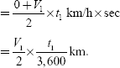

The distance travelled during coasting retardation =  

The distance travelled during breaking retardation = average speed × time for breaking retardation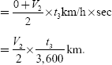

∴ Total distance travelled **(2M)**

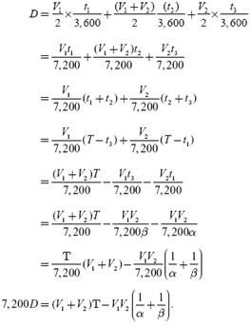

**8.b)**

The servo motor is most commonly used for high technology devices in the industrial application like automation technology. It is a self contained electrical device, that rotate parts of a machine with high efficiency and great precision. The output shaft of this motor can be moved to a particular angle. Servo motors are mainly used in home electronics, toys, cars, airplanes, etc.

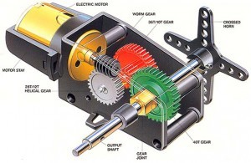

A unique design for servo motors are proposed in controlling the robotics and for control applications. They are basically used to adjust the speed control at high torques and accurate positioning. Parts required are motor position sensor and a highly developed controller. These motors can be categorized according the servo motor controlled by servomechanism. If DC motor is controlled using this mechanism, then it is named as a DC servo motor. Servo motors are available in power ratings from fraction of a watt to 100 watts.The rotor of a servo motor is designed longer in length and smaller in diameter so that it has low inertia. **(3M)**

The servo motor is small and efficient, but serious to use in some applications like precise position control. This motor is controlled by a pulse width modulator signal. The applications of servo motors mainly involve in computers, robotics, toys, CD/DVD players, etc. These motors are extensively used in those applications where a particular task is to be done frequently in an exact manner.

The servo motor is used in robotics to activate movements, giving the arm to its precise angle.

The Servo motor is used to start, move and stop conveyor belts carrying the product along with many stages. For instance, product labeling, bottling and packaging

The servo motor is built into the camera to correct a lens of the camera to improve out of focus images.

The servo motor is used in robotic vehicle to control the robot wheels, producing plenty torque to move, start and stop the vehicle and control its speed.

The servo motor is used in solar tracking system to correct the angle of the panel so that each solar panel stays to face the sun

The Servo motor is used in metal forming and cutting machines to provide specific motion control for milling machines

The Servo motor is used in Textiles to control spinning and weaving machines, knitting machines and looms

The Servo motor is used in automatic door openers to control the door in public places like supermarkets, hospitals and theatres **(2M)**