**Key Answer**

**PART – A: (Multiple Choice Questions)**

1. (i) Relieving excess pressure
2. (i) Preferably flow inside the tube for its easier internal cleaning
3. (ii) Density of the gas and inversely as viscosity of the gas
4. (i) It is used for high viscosity liquor having large rate of scaling
5. (iii) 10m
6. (i) 50-150
7. (i) elbow
8. (i) A vapor phase reactor
9. (iv) 10000

**PART – B: (Short Answer Questions)**

**a. What is meant by Piping and Instrument diagram**

The Piping and Instrument diagram (P and I diagram or PID) shows the engineering details of the equipment, instruments, piping, valves and fittings; and their arrangement. It is often called the Engineering Flow-sheet or Engineering Line Diagram.

**b. What are the factors to be considered for Plant Layout?**

The economic construction and efficient operation of a process unit will depend on how well the plant and equipment specified on the process flow-sheet is laid out. The principal factors to be considered are:

1. Economic considerations: construction and operating costs.

2. The process requirements.

3. Convenience of operation.

4. Convenience of maintenance.

5. Safety.

6. Future expansion.

7. Modular construction.

**c. Explain the role of Environmental impact, and effluent disposal on site selection Process?**

All industrial processes produce waste products, and full consideration must be given to the difficulties and cost of their disposal. The disposal of toxic and harmful effluents will be covered by local regulations, and the appropriate authorities must be consulted during the initial site survey to determine the standards that must be met. An environmental impact assessment should be made for each new project, or major modification or addition to an existing process.

**d. Give the Classification of Extraction equipment.**

Extraction equipment can be divided into two broad groups:

**1. Stage-wise extractors,** in which the liquids are alternately contacted (mixed) and then separated, in a series of stages. The “mixer-settler” contactor, is an example of this type. Several

mixer-settlers are often used in series to increase the effectiveness of the extraction.

**2. Differential extractors,** in which the phases are continuously in contact in the extractor and are only separated at the exits; for example, in packed column extractors

**e. What is AIChE method?**

The AIChE method is the most detailed method for predicting plate efficiencies. It takes into account all the major factors that are known to affect plate efficiency; this includes:

• The mass transfer characteristics of the liquid and vapour phases.

• The design parameters of the plate.

• The vapour and liquid flow-rates.

• The degree of mixing on the plate

**f. What are the types of heat exchangers?**

Direct contact heat exchangers

Recuperators or surface heat exchanger

Regenerators

**g. What is a heat exchanger? Mention some of its applications?**

A heat exchanger is any device used for effecting the process of heat exchange between two fluids that are at different temperatures.

Uses: Heat exchangers are useful in many engineering processes like those in:-

a) Refrigerating and air-conditioning systems

b) Power systems

c) Food processing systems

d) Chemical reactors

e) Space or aeronautical applications

**h. Give the general design considerations for internal pressure vessels**

For vessels under internal pressure, the design pressure is normally taken as the pressure at which the relief device is set. This will normally be 5 to 10 per cent above the normal working pressure, to avoid spurious operation during minor process upsets. When deciding the design pressure, the hydrostatic pressure in the base of the column should be added to the operating pressure, if significant.

**i. What is the purpose of pressure vessel codes and standards**

In all the major industrialised countries the design and fabrication of thin-walled pressure vessels is covered by national standards and codes of practice. In most countries the standards and codes are legally enforceable.

**j. Give the Classification of pressure vessels**

For the purposes of design and analysis, pressure vessels are sub-divided into two classes depending on the ratio of the wall thickness to vessel diameter:

➢ thin-walled vessels, with a thickness ratio of less than 1 : 10; and

➢ thick-walled above this ratio.

**PART – C: (Long Answer Questions) (15 x 4 = 60 Marks)**

**3. a. Discuss flow sheets of Metal extraction industries.**

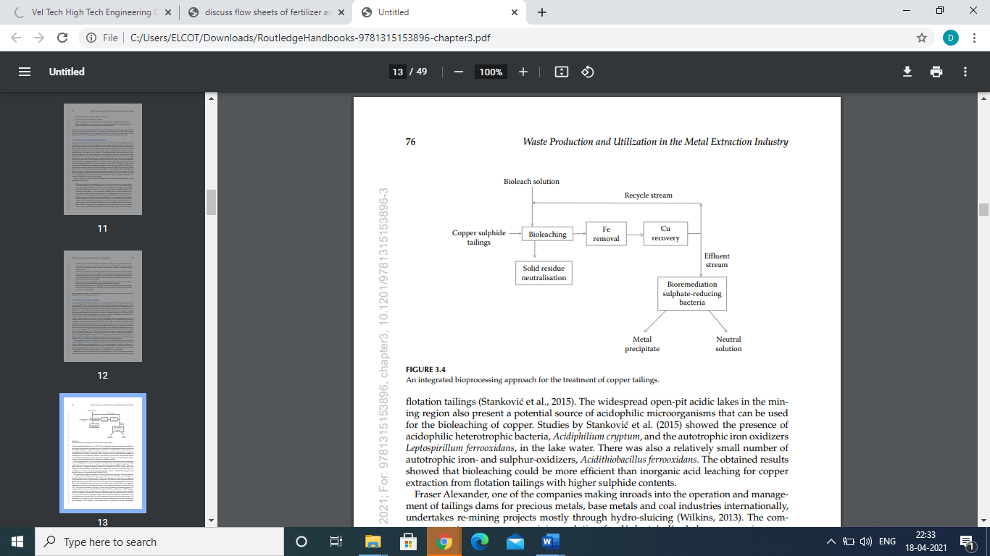

The growing interest towards metal recovery from wastes is due to the depletion of mineral resources in the most industrialized countries along with the rapid development of technologies enabling the beneficiation of ores even from the poorest deposits. For example, the processing of refractory sulphide and complex material has always presented a challenge in the minerals and metal extraction industry, resulting in most of the valuable metals being left behind in the tailings. The major problems that have existed in the past with regards to the reprocessing of such tailings have been the availability of more efficient, effective and economical processes for obtaining high metal recoveries at high production rates from the once-processed material.

However, advances in process technology has seen some of the challenges being overcome, leading to renewed interest in the processing of tailings in order to recover valuable metals. Reprocessing of such wastes brings potential financial and waste reduction benefits. In addition, higher metal prices and the stringent environmental regulations and associated penalties further justify the reprocessing of large volumes of tailings across the globe. For example, tailings that contain economic quantities of copper or gold, if reprocessed, could potentially have higher production rates than primary mining operations.

The reprocessing of gold bearing tailings in particular has increased in the recent past due to it being one of the few commodities that has maintained some semblance of price stability within the current prevailing harsh mining environment. The key drivers for the extraction and reprocessing of metal-bearing tailings can be summarized as follows: • Tailings are generally considered to require fewer resources when compared to conventional mining. The mining of raw ores requires a lot of capital investing and other related funding for mining of hard rock and crushing and grinding to achieve high metal recoveries, while waste dumps generally require just crushing and grinding as the treatment methods prior to metal extraction.

In most cases, some of the existing facilities for the treatment of raw ores can be utilized for the processing of waste materials. This reduces costs related to capital equipment, labour, fuel and maintenance. For example, despite differences in grade, the reprocessing of old, finely ground mill tailings is probably much more economic than treating most newly mined ores. The mining of raw ores requires a lot of capital investing and other related funding, mining of hard rock and crushing and grinding to achieve high metal recoveries, while waste dumps generally require just crushing and grinding as the treatment methods prior to metal extraction. In addition, in most cases, some of the existing facilities for the treatment of raw ores can be utilized for the processing of these secondary resources, thus lowering the capital investment costs significantly.

• Advances in processing technology result in changes in patterns of metal extraction from both primary sources and waste or secondary material.

As processing techniques become more cost-effective and efficient, it becomes more economically beneficial to recover valuable metals from discarded materials which were previously regarded as untreatable. The processing of tailings allows for additional production without increasing a mine’s footprint and without requiring additional land permits. According to Binnemans et al. (2013), the reprocessing of residues from waste can also positively influence the availability of metals and consequently stabilize their prices in the world market.

**3.b. Discuss the importance of heat and mass transfer operations.**

Heat and mass transfer is an important and consolidated branch of physics and engineering. Our research aims to extend the traditional experimental and numerical analysis into the so-called mesoscale, i.e. to understand the specific phenomena occurring at the fluid interfaces in a sub-micron scale.

Many macroscale physical processes in heat transfer, like boiling and condensation, have a strong influence on the phenomena linked to the chemistry and nano-morphology of surfaces. For example, the wettability effects on boiling, heat transfer and icing have only recently been investigated; new findings are enabling us to take further steps into unexplored phenomena. Our researchers, experienced in this new paradigm of heat transfer, are seeking ways in which to increase performance, understand heat fluxes, miniaturise components and simulate specific processes in microfluids. We concentrate on eight key areas:

* Heat pipes
* Design, simulation and experimental characterisation of fins
* Pool and flow boiling
* Condensation phenomena
* Wettability effect on heat transfer
* Droplet and spray impacts on complex surfaces
* Icing and frost mitigation
* VOF multi-phase simulations

**4.a.**

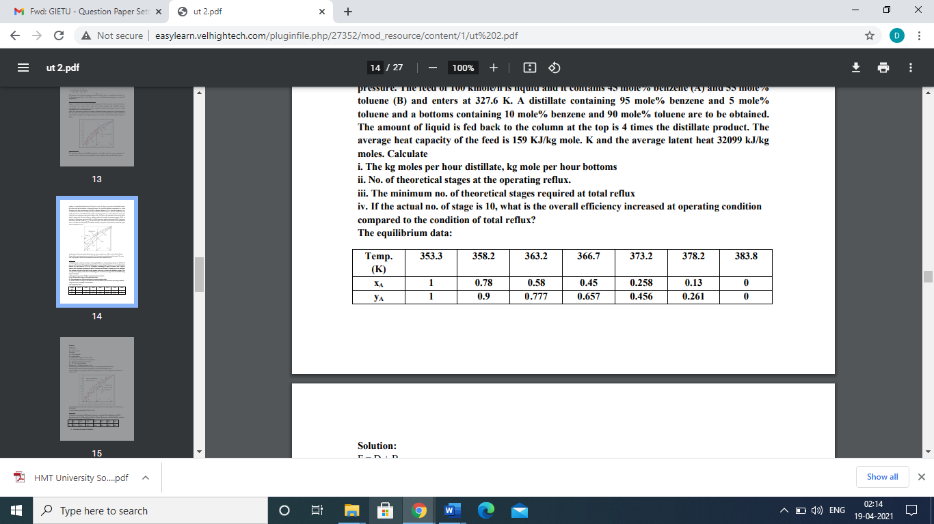

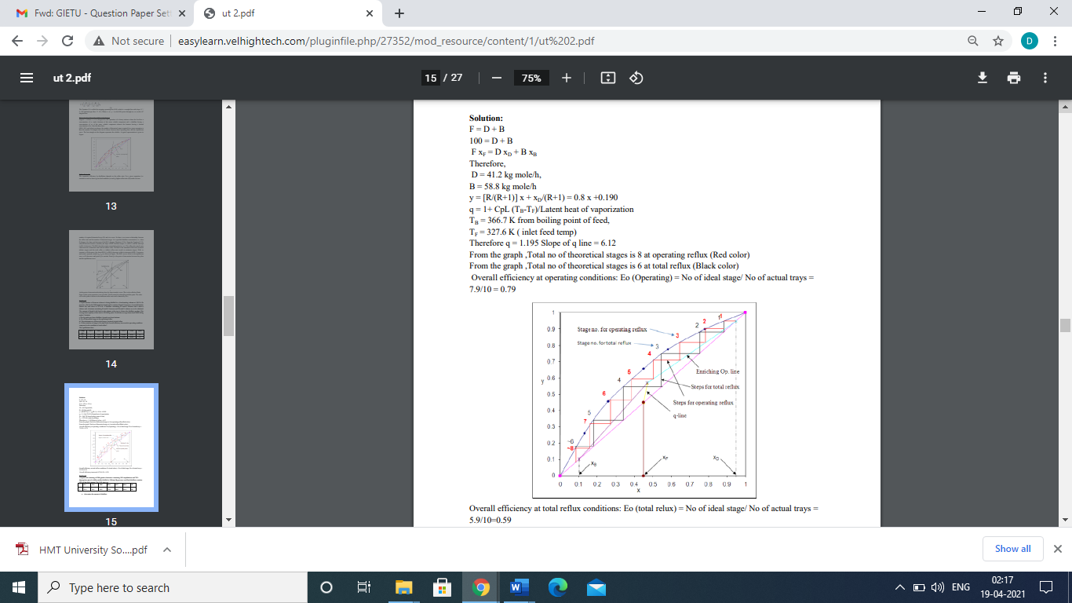

**4.b.**

A liquid feed consisting of 1200 gmoles of mixture containing 30% naphthalene and 70% dipropylene glycol is differentially distilled at 100 mm Hg pressure and final distillate contains 55% of the feed solution. The VLE data are

x 8.4 11.6 28.0 50.6 68.7 80.6 88

y 22.3 41.1 62.9 74.8 80.2 84.4 88

a. determine the amount of distillate

b. determine the napathalene and in residue and distillate.

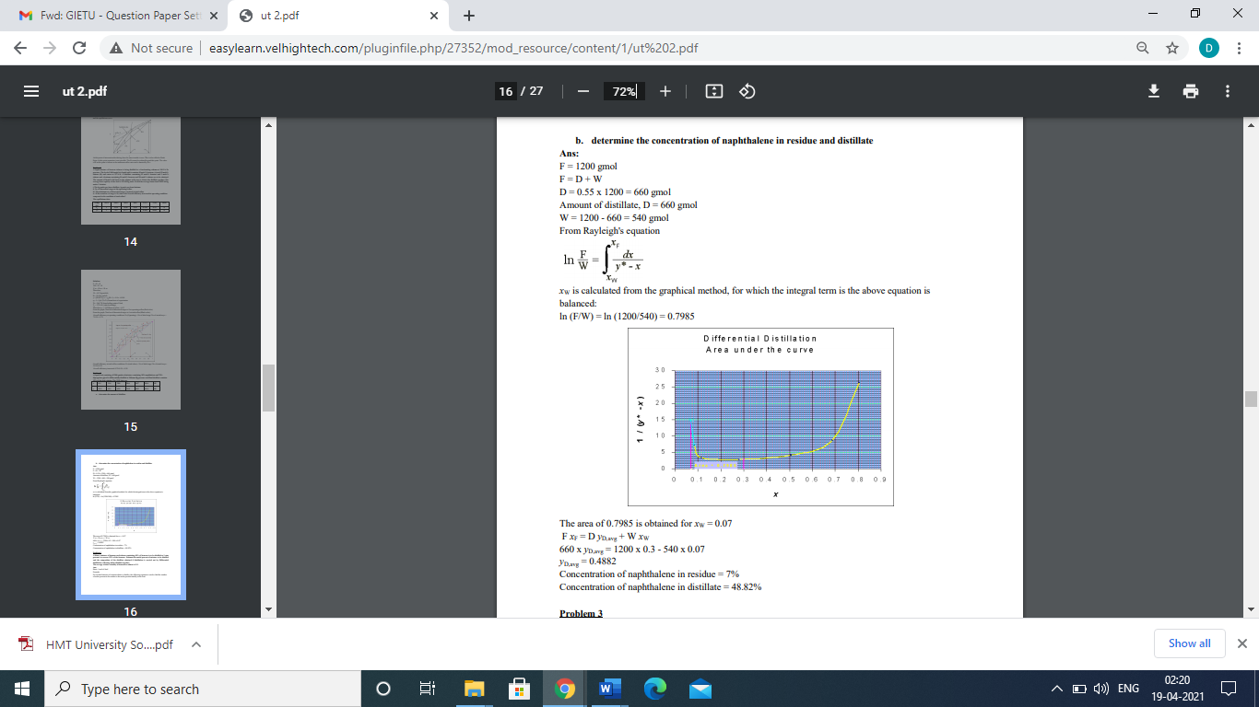

**5.a.**

A heat exchanger is to be designed to condense an organic vapour at a rate of 500 kg/min. Which is available at its saturation temperature of 355 K. Cooling water at 286 K is available at a flow rate of 60 kg/s. The overall heat transfer coefficient is 475 W/m2C Latent heat of condensation of the organic vapour is 600 kJ/kg. Calculate 1. The number of tubes required, if tubes of 25 mm otuer diameter, 2mm thick and 4.87m long are available, and

2. The number of tube passes, if cooling water velocity (tube side) should not exceed 2m/s 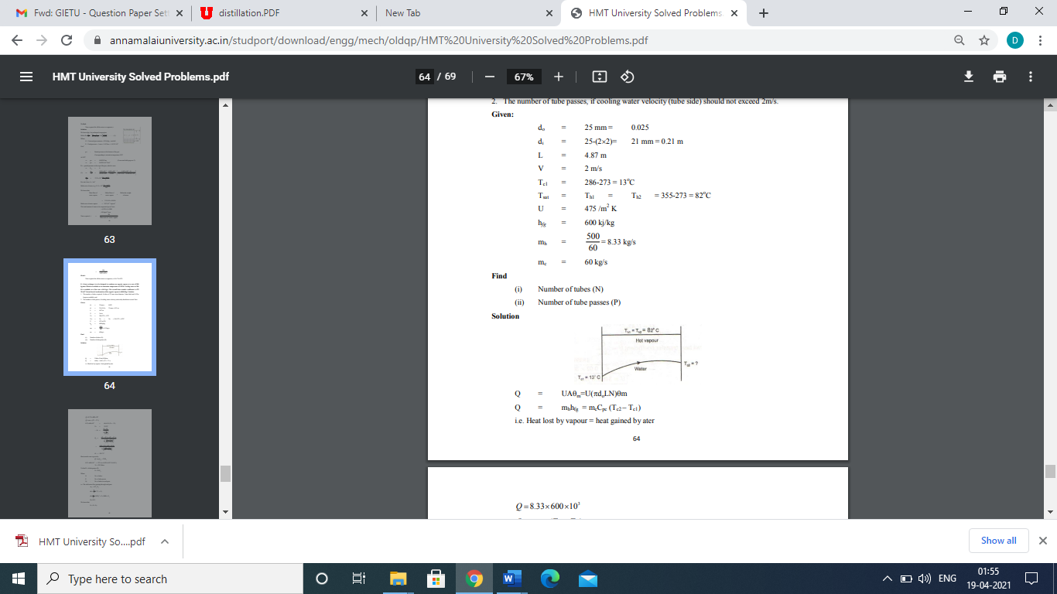

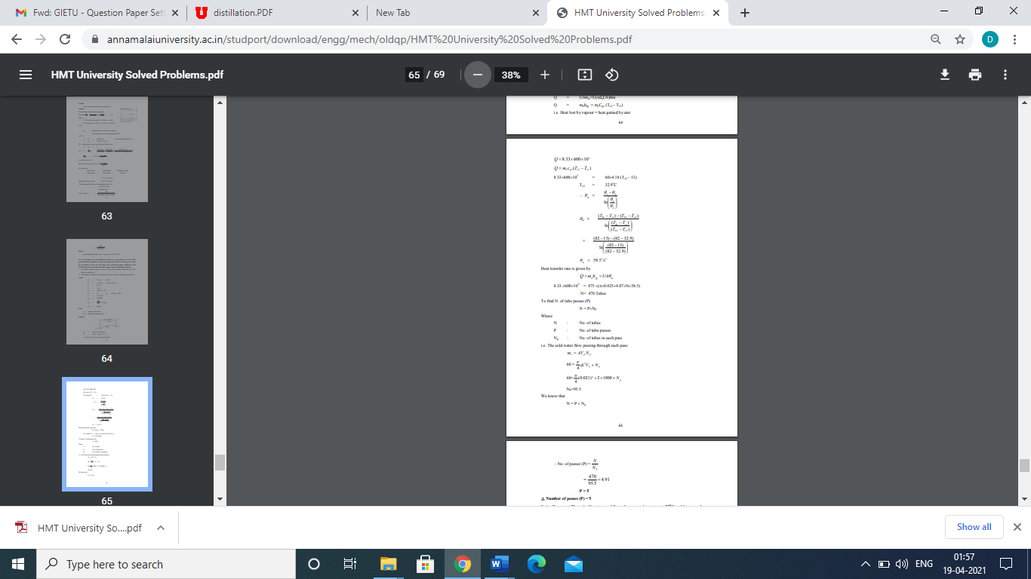

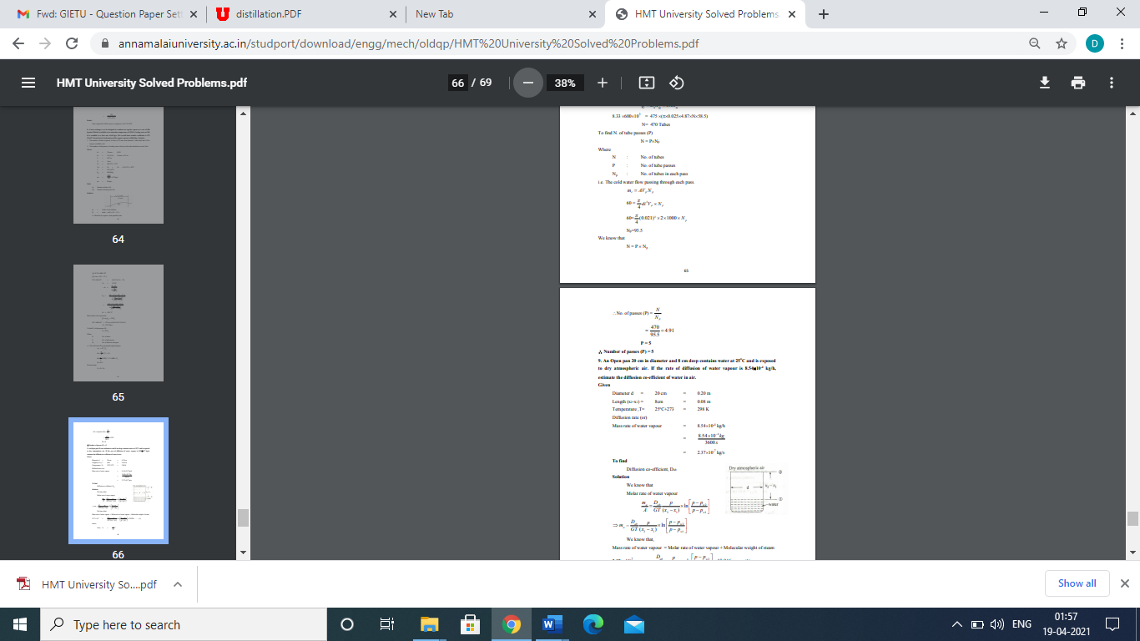

**5.b.A counter flow double pipe heat exchanger using super heated steam is used to heat water at the rate of 10500 kg/hr. The steam enters the heat exchanger at 180oC and leaves at 130oC. The inlet and exit temperature of water are 30oC and 80oC respectively. If the overall heat transfer coefficient from steam to water is 814 W/m2 K, calculate the heat transfer area. What would be the increase in area if the fluid flow were parallel?**

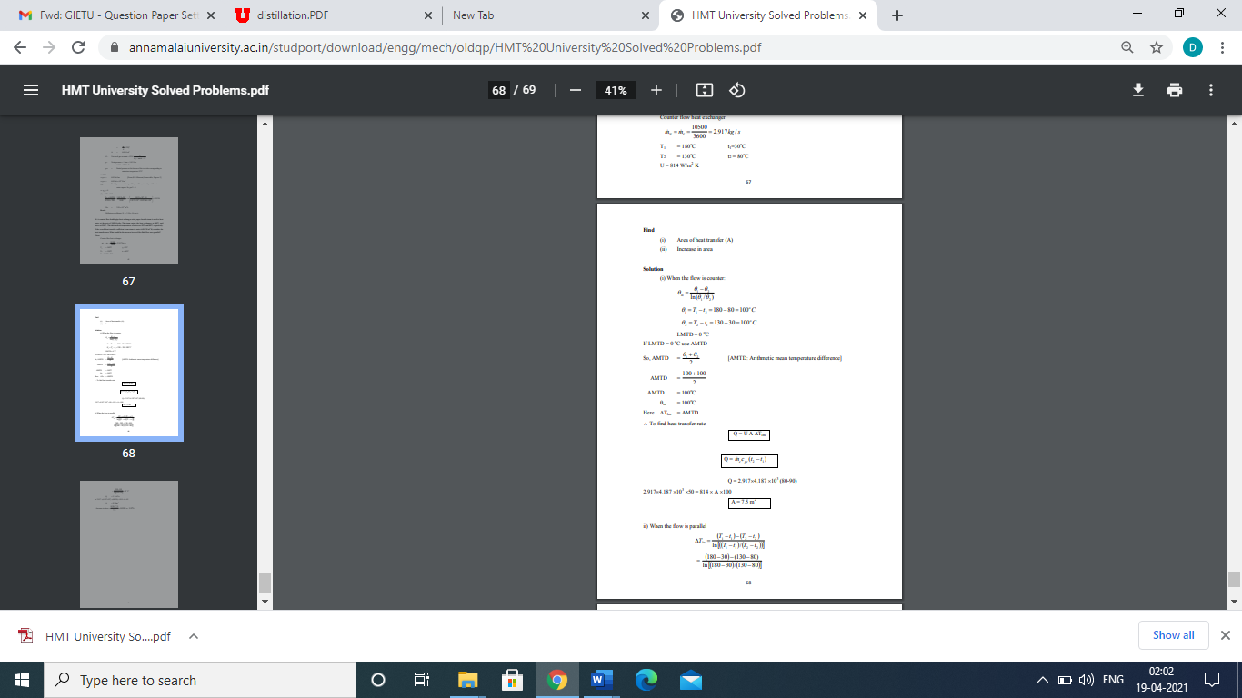

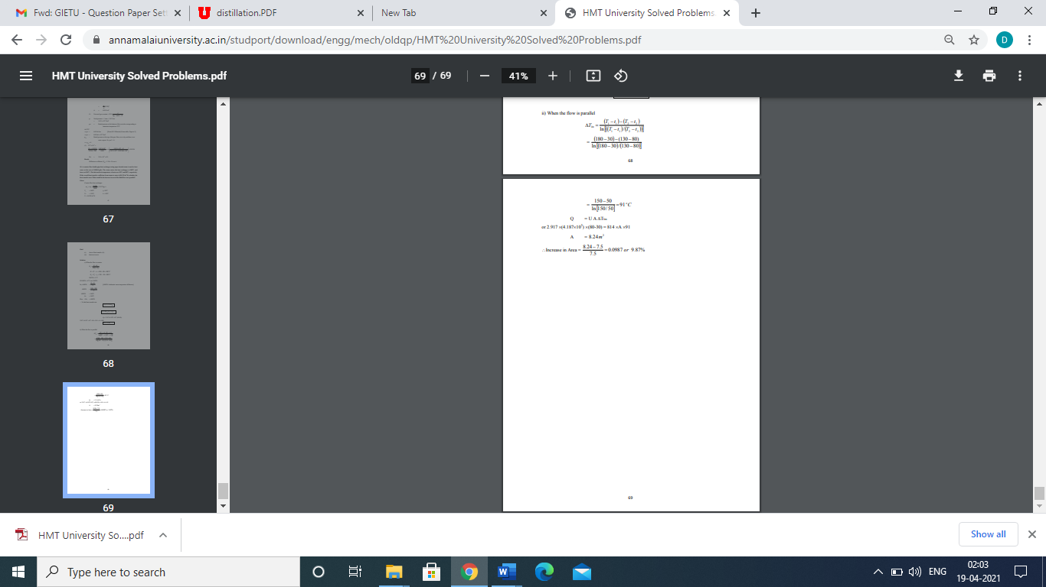

**6.a. Design of storage tank and its significance.**

Storage tanks are containers that hold liquids, compressed gases (gas tank; or in U.S.A "pressure vessel", which is not typically labeled or regulated as a storage tank) or mediums used for the short- or long-term storage of heat or cold. The term can be used for reservoirs (artificial lakes and ponds), and for manufactured containers. The usage of the word tank for reservoirs is uncommon in American English but is moderately common in British English. In other countries, the term tends to refer only to artificial containers.

In the USA, storage tanks operate under no (or very little) pressure, distinguishing them from pressure vessels. Storage tanks are often cylindrical in shape, perpendicular to the ground with flat bottoms, and a fixed frangible or floating roof. There are usually many environmental regulations applied to the design and operation of storage tanks, often depending on the nature of the fluid contained within. Above-ground storage tanks (ASTs) differ from underground storage tanks (USTs) in the kinds of regulations that are applied.

Above ground storage tanks can be used to hold materials such as petroleum, waste matter, water, chemicals, and other hazardous materials, all while meeting strict industry standards and regulations. Reservoirs can be covered, in which case they may be called covered or underground storage tanks or reservoirs. Covered water tanks are common in urban areas. Storage tanks are available in many shapes: vertical and horizontal cylindrical; open top and closed top; flat bottom, cone bottom, slope bottom and dish bottom. Large tanks tend to be vertical cylindrical, or to have rounded corners transition from vertical side wall to bottom profile, to easier withstand hydraulic hydrostatically induced pressure of contained liquid. Most container tanks for handling liquids during transportation are designed to handle varying degrees of pressure.

**6.b. Design of Pressure vessel and its significance**

