|  |  |
| --- | --- |
| D:\VK\GIET LOGO.jpg | **GIET UNIVERSITY, GUNUPUR – 765022**  B. Tech (Fourth Semester – Regular) Examinations, April / May – 2021  **BUILDING CONSTRUCTION AND COST ESTIMATION**  **(CIVIL ENGINEERING)** |
| Time: 3 hrs Maximum: 70 Marks | |

**Answer ALL Questions**

**The figures in the right hand margin indicate marks.**

**PART – A: (Multiple Choice Questions) (1 x 10 = 10 Marks)**

Paper-1 key

**PART – A: (Multiple Choice Questions)**

a)Ans: (i)  Timber

b)Ans: (ii) 1:2:4

c)Ans: (ii) Soft-glass

d)ANs: (iii) Raising of moisture from ground

e)Ans: (iii) Limestone

f)ANs: (iv) All of the above

g)Ans: (iv) Area of cantilevered porch

h)Ans: (i)  estimate

i)Ans: (i) Amplitude

j)Ans: (ii) 5%

**PART – B: (Short Answer Questions)**

a)Ans: 1.Digging, 2.heating, 3. Wedging, 4. Blasting

b)Ans: In this test a scratch is made on brick surface with the help of a finger nail. If no impression is left on the surface, brick is to be sufficiently hard.

c)Ans: 1. Lime is procured by burning one of the following materials:

1.Lime stones from stone hills

2. Boulders of lime stones from beds of old rivers

3. Kanker found below the ground

4. Shells of sea animals.

d) Ans:1. Acid-resistant cement

2. Blast furnance cement

3. Coloured cement

4. Expanding cement

e) Ans: Lime mortar contains equal volumes of lime and sand. The mixture is finely grained in a mortar mill.

f)Ans: It shall consist of 2 coats: the first coat shall be 12 mm thick of either lime **cement** mortar 1:1:5 or **cement** mortar 1:3. The second coat which is the finishing coat shall be at least 8 mm thick and made up of a mixture of **cement** and stone chips in specified proportions dashed over the freshly **plastered** first coat.

g) Ans: It is prepared on the basis of plinth area of a building multiplied by plinth area rate prevalent in the region. Plinth area rates are fixed from the cost of similar buildings constructed in the locality having similar finishing’s and amenities.

h) Ans: Total area floors between walls, verandas, corridors, passages, etc.. is known as floor areas. It is equal to plinth area minus area occupied by the walls and pillars.

i)Ans:  The SIR tells all stakeholders whether a project will be cash-flow-positive. It is calculated by dividing the projected energy cost **savings** over the finance term by the total installed cost of the project, including the cost of equipment, installation, and financing.

### **j) Ans:** Disadvantages of Payback Period

**1. Only Focuses on Payback Period**

**2. Short-Term Focused Budgets.**

**3. It Doesn’t Look at the Time Value of Investments.**

**4. Time Value of Money Is Ignored.**

**5. Payback Period Is Not Realistic as the Only Measurement.**

**PART – C: (Long Answer Questions)**

3) a) Ans: In modern [construction work](https://expertcivil.com/what-is-construction-in-civil-engineering/), Stones are used in a large amount as a huge demand. Following are uses:

[Stones](https://expertcivil.com/building-stones-and-quarrying-of-stones/) are used for the base preparation of different constructions and also they act as important Stones are used for general building works like in foundation, floors covering, masonry works etc.

Stones are used for the ornamental and architectural beauty of different types of [structures](https://expertcivil.com/what-is-construction-in-civil-engineering/).

Generally, they are used for railway ballast and as an aggregate in cement and lime concretes.

Stones are used in the manufacturing of iron.

Sometimes, Stones are used for making fireproof structures.

Generally, stones are used as a construction material of different structures likes dams, columns, bridges piers, harbors etc.

Limestone acts as a flux in the manufacturing cement and lime.

. Stones are used for the base preparation of different constructions and also they act as an important material in road manufacturing and footpath laying.

a stone layer may be used as a damp proof course (DPC) in structures made up of other structural units such as bricks, hollow blocks etc.

Stone may be used as stone dust in place of sand, where sand is not available.

3)b) ANs: The bricks should be table-moulded, well burnt in kilns, copper-coloured, free from cracks and with sharp and square edges. The colour should be uniform and bright.

The bricks should be uniform in shape and should be of standard size.

The bricks should give a clear metallic ringing sound when struck with each other.

The bricks when broken or fractured should show a bright homogeneous and uniform compact structure free from voids.

The brick should not absorbs water more than 20% by weight, for first class bricks and 22% by weight for second class bricks, when soaked in water for a period of 24 hours.

The bricks should be sufficiently hard. No impression should be left on brick surface, when it is scratched with finger nail.

3)c)Ans

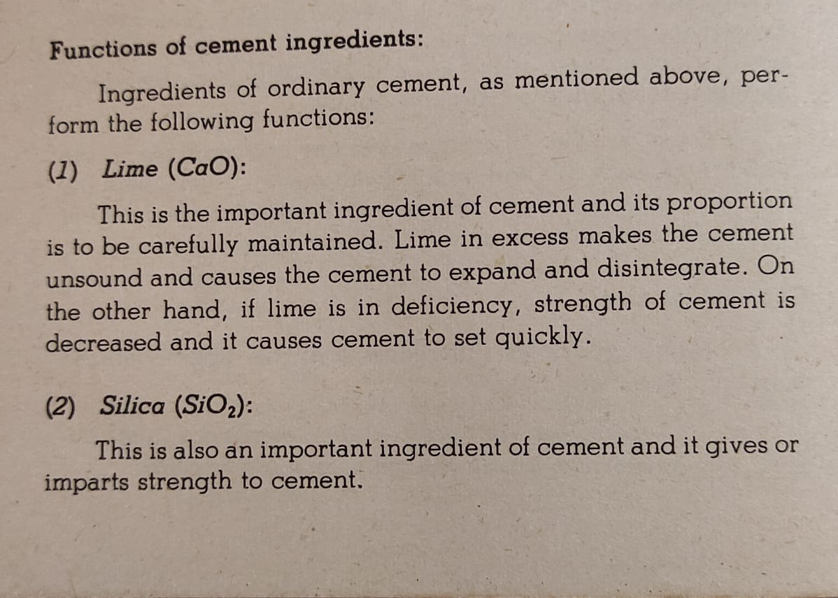

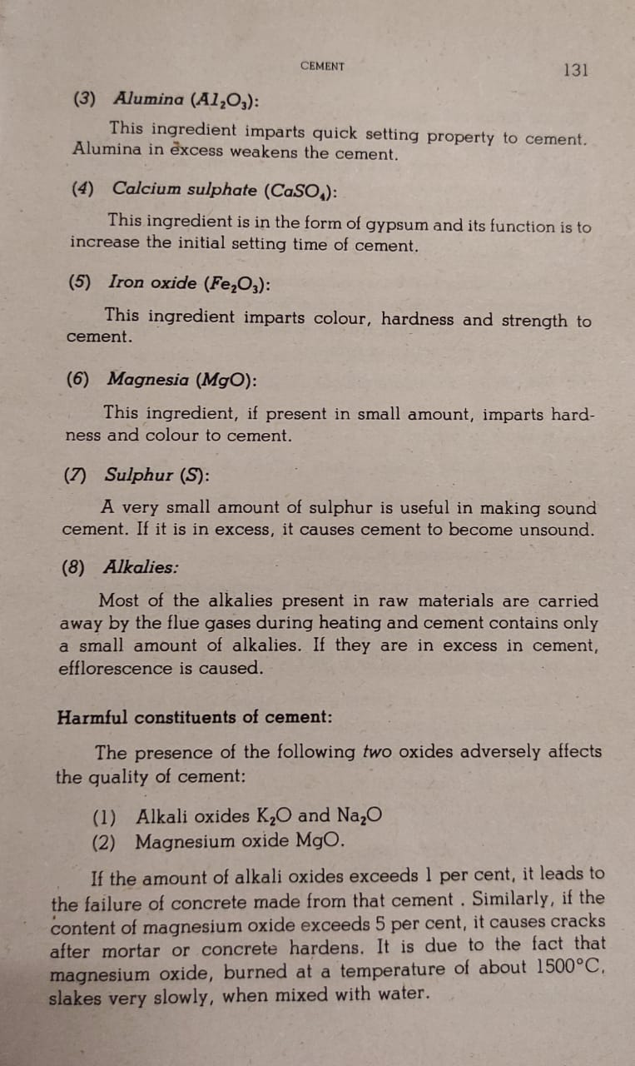

3)d) Ans: 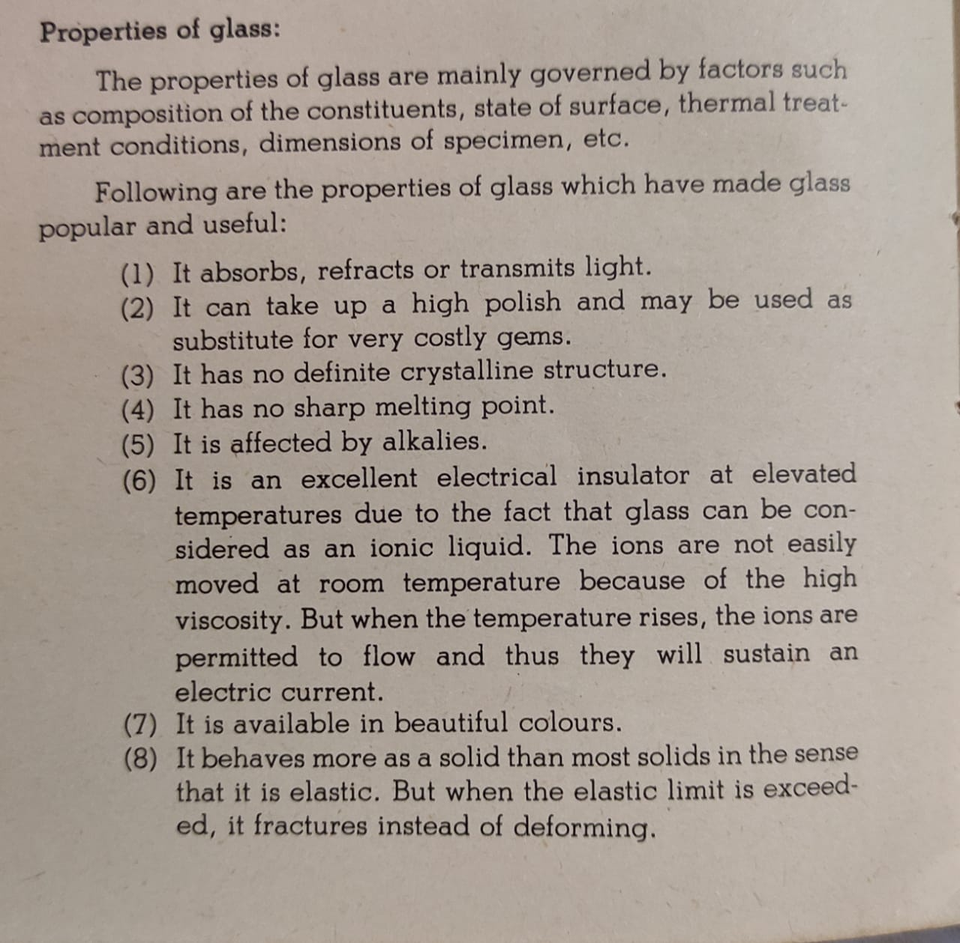

**4) a) Ans:**

1. **Membrane damp proofing**

In this method of damp proofing a [water](http://ecoursesonline.iasri.res.in/mod/page/view.php?id=118868) repellent membrane or damp proof course(D.P.C.) is introduced in between the source of dampness and the part of building adjacent to it. Damp proofing course may consist of flexible materials such as bitumen, mastic asphalt, bituminous felts, plastic or polythene sheets, metal sheets, [cement](http://ecoursesonline.iasri.res.in/mod/page/view.php?id=118860) concrete. Damp proofing course may be provided either horizontally or vertically in floors, walls etc. Provision of Damp Proofing Course in basement is normally termed as ‘Tanking’. The general principles to be followedwhile providing damp proof course are:

* 1. The damp proofing course should cover the full thickness of walls, excluding rendering.
  2. The [mortar](http://ecoursesonline.iasri.res.in/mod/page/view.php?id=118811) bed supporting damp proof course should be leveled and even, and should be free from projections, so that damp proof course is not damaged.
  3. Damp proof course should be laid in such a way that a continuous projection is provided.
  4. At junctions and corners of walls, the horizontal damp proof course should be laid continuous.
  5. When a horizontal damp proof course (i.e. that of a floor) is continued to a vertical face, a [cement](http://ecoursesonline.iasri.res.in/mod/page/view.php?id=118860) concrete fillet of 7.5 cm radius should be provided at the junction.
  6. Each damp proof course should be placed in correct relation to other damp proof course, so as to ensure a complete and continuous barrier to the passage of [water](http://ecoursesonline.iasri.res.in/mod/page/view.php?id=118868) from floors, walls or roof.
  7. Damp proof course should not be kept exposed on the wall surface otherwise it may get damaged during finishing work.

1. **Integral damp proofing**

In the integral damp proofing method certain [water](http://ecoursesonline.iasri.res.in/mod/page/view.php?id=118868) proofing compounds are added to the concrete mix, so that it becomes impermeable. The common [water](http://ecoursesonline.iasri.res.in/mod/page/view.php?id=118868) proofing compounds may be in the following three forms.

* 1. Compounds made from chalk, talc, fullers earth, which may fill the voids of concrete under the mechanical action principle.
  2. Compounds like alkaline silicates, aluminum sulphate, calcium chlorides, etc. which react chemically with concrete to produce [water](http://ecoursesonline.iasri.res.in/mod/page/view.php?id=118868) proof concrete.
  3. Compounds like soap, petroleum, oils, fatty acid compounds such as stearates of calcium, sodium, ammonia etc. work on [water](http://ecoursesonline.iasri.res.in/mod/page/view.php?id=118868) repulsion principle. When these are mixed with concrete, the concrete becomes [water](http://ecoursesonline.iasri.res.in/mod/page/view.php?id=118868) repellent.
  4. Commercially available compounds like Publo, Permo, and Silka etc.

The quantity of [water](http://ecoursesonline.iasri.res.in/mod/page/view.php?id=118868) proofing compound to be added to [cement](http://ecoursesonline.iasri.res.in/mod/page/view.php?id=118860) depends upon the manufacturer’s recommendations. In general one kilogram of [water](http://ecoursesonline.iasri.res.in/mod/page/view.php?id=118868) proofing compound is added with one bag of [cement](http://ecoursesonline.iasri.res.in/mod/page/view.php?id=118860) to render the [mortar](http://ecoursesonline.iasri.res.in/mod/page/view.php?id=118811) or concrete [water](http://ecoursesonline.iasri.res.in/mod/page/view.php?id=118868) proof.

1. **Surface treatment**

Moisture finds its way through the pores of material used in finishing. In order to check the entry of the moisture into the pores, they must be filled up. In the surface treatment method a layer of [water](http://ecoursesonline.iasri.res.in/mod/page/view.php?id=118868) repellent substances or compounds are applied on these surfaces through which moisture enters. The use of [water](http://ecoursesonline.iasri.res.in/mod/page/view.php?id=118868) repellent metallic soaps such as calcium and aluminum oletes and stearates are much effective against rain [water](http://ecoursesonline.iasri.res.in/mod/page/view.php?id=118868) penetration. [Pointing](http://ecoursesonline.iasri.res.in/mod/page/view.php?id=119029) and plastering of the exposed surfaces must be done carefully, using [water](http://ecoursesonline.iasri.res.in/mod/page/view.php?id=118868) proofing agents like sodium or potassium silicates, aluminum or zinc sulphates, barium hydroxide and magnesium sulphates etc. Surface treatment is effective only when the moisture is superficial and is not under pressure. Sometimes, exposed stone or brick wall face may be sprayed with [water](http://ecoursesonline.iasri.res.in/mod/page/view.php?id=118868) repellent solutions. The walls plastered with [cement](http://ecoursesonline.iasri.res.in/mod/page/view.php?id=118860), lime and sand mixed in proportions of 1:1:6 is found to serve the purpose of preventing dampness in wall due to rain effectively.

1. **Cavity wall construction**

Cavity wall construction is an effective method of damp prevention. In this method the main wall of a building is shielded by an outer skin wall, leaving a cavity between the two. The cavity prevents the moisture from travelling from the outer to the inner wall.

1. **Guniting**

In this method of damp proofing, an impervious layer of rich [cement](http://ecoursesonline.iasri.res.in/mod/page/view.php?id=118860) [mortar](http://ecoursesonline.iasri.res.in/mod/page/view.php?id=118811) is deposited under pressure over the exposed surfaces for [water](http://ecoursesonline.iasri.res.in/mod/page/view.php?id=118868) proofing or over pipes, cisterns etc. for resisting the [water](http://ecoursesonline.iasri.res.in/mod/page/view.php?id=118868) pressure. The operation is carried out by use of a machine known as [cement](http://ecoursesonline.iasri.res.in/mod/page/view.php?id=118860) gun. The [cement](http://ecoursesonline.iasri.res.in/mod/page/view.php?id=118860) gun consists of a machine having arrangements for mixing materials and a compressor for forcing the mixture under pressure through a 50 mm dia flexible hose pipe. The hose pipe has nozzle at its free end to which [water](http://ecoursesonline.iasri.res.in/mod/page/view.php?id=118868) is supplied under pressure through a separate connection. The surface to be treated is first thoroughly cleaned of dirt, dust, grease or loose particles and wetted properly. [Cement](http://ecoursesonline.iasri.res.in/mod/page/view.php?id=118860) [mortar](http://ecoursesonline.iasri.res.in/mod/page/view.php?id=118811) consists of 1: 3 [cement](http://ecoursesonline.iasri.res.in/mod/page/view.php?id=118860) sand mix, is shot on the cleaned surface with the help of a [cement](http://ecoursesonline.iasri.res.in/mod/page/view.php?id=118860) gun, under a pressure of 2 to 3 kg/cm2. The nozzle of the machine is kept at a distance about 75 to 90 cm from the surface to be gunited. The [mortar](http://ecoursesonline.iasri.res.in/mod/page/view.php?id=118811) mix of desired consistency and thickness can be deposited to get an impervious layer. The layer should be properly cured at least for 10 days. Since the material is applied under pressure,it ensures dense compaction and better adhesion of the rich [cement](http://ecoursesonline.iasri.res.in/mod/page/view.php?id=118860) [mortar](http://ecoursesonline.iasri.res.in/mod/page/view.php?id=118811) and hence the treated surface becomes [water](http://ecoursesonline.iasri.res.in/mod/page/view.php?id=118868) proof.

1. **Pressure grouting**

This consists of forcing [cement](http://ecoursesonline.iasri.res.in/mod/page/view.php?id=118860) grout under pressure, into cracks, voids, fissures and so on present in the structural components of the building, or in the ground. Thus the structural components and the foundations which are liable to moisture penetration are consolidated and are thus made [water](http://ecoursesonline.iasri.res.in/mod/page/view.php?id=118868)-penetration-resistant. This method is quite effective in checking the seepage of raised ground [water](http://ecoursesonline.iasri.res.in/mod/page/view.php?id=118868) through foundations and sub-structure of a building:

4)b) Ans: Plastering is a method that is used to increase the durability of the wall. The purpose of plastering is to decorate the structures of the walls. Plastering of external walls refers to the process of covering the uneven surface and rough walls with the help of a plastic material named as plaster.

The plaster is prepared by mixing sand and lime or cement concrete along with water. There are various requirements of a plaster that must be fulfilled while doing plastering of external walls.

So you need to consider these requirements to get a perfect plastering on your wall. The plaster should be economical. The durability of the plaster should be high and it should be hard in nature.

The plaster must adhere during all the changes occurred in climate. The plaster is prepared wisely in such a way that it can be applied during all the weather conditions The work ability possessed by plaster must be good

First of all, the alignment and fixing of level pegs on the wall should be done with the help of surveying instruments. After completing the level pegs on walls, projections on the wall surface will be clipped off and cleaned.

After this, the first coat mortar filing is applied which is required up to 15mm on the surface. To improve the bonding of plaster to the concrete surface, cement paste on concrete surfaces will be applied.

After plastering the wall surface, a width of a groove between beams and walls will be formed by cutting with the help of grinders which is filled with weather sealant. After following this method, the plastering of the external wall will be finished but doing it yourself is very difficult.

Therefore, you need to hire a plasterer and high quality materials used in this task. By doing the [residential plastering](http://brisbaneplasterpro.com.au/) on your external wall, you will get various opportunities to enhance the decoration with the help of various natures of finishes.

The plastering walls provide you better longevity. The walls will get highly durable after accomplishing the task of plastering. They can protect your walls from humidity, heat, rain and other conditions of climate.. The nature of plastering walls is pollution free.

## 4)c)Ans: Types of Pointing

### 1. Flush Pointing

In this type, mortar is pressed hard in the raked joints and by finishing off flush with the edge of masonry units. The edges are neatly trimmed with trowel and straight edge. It does not give good appearance. But, flush pointing is more durable because of resisting the provision of space for dust, water etc., due to this reason, this method is extensively used.

### 2. Recessed Pointing

In this case, mortar is pressing back by 5mm or more from the edges. During placing of mortar the face of the pointing is kept vertical, by a suitable tool. This type gives very good appearance.

### 3. Beaded Pointing

It is formed by a steel or ironed with a concave edge. It gives good appearance, but it will damage easily when compared to other types.

### 4. Struck Pointing

This is a modification of flush pointing in which the face the pointing is kept inclined, with its upper edge pressed inside the face by 10mm which drains water easily.

### 5. Rubbed, Keyed or Grooved Pointing

This is also a modification of flush pointing in which groove is formed at its mid height, by a pointing tool. It gives good appearance.

### 6. Tuck Pointing

In this case mortar is pressed in the raked joint first and finishing flush with the face.

While the pressed mortar is green, groove or narrow channel is cut in the center of groove which is having 5mm width and 3mm depth. This groove is then filled with white cement putty, kept projecting beyond the face of the joint by 3 mm. if projection is done in mortar, it is called bastard pointing or half tuck pointing.

### 7. V- Pointing

This is formed by forming V-groove in the flush-finishing face.

### 8. Weathered Pointing

This is made by making a projection in the form of V-shape.

4)d) Ans: Painting is done to protect the surface from the effects of weathering, to prevent wood from decay and metal from corrosion, to provide a decorative finish and to obtain a clean, hygienic and healthy living atmosphere. Painting work procedure is the finishing item in any construction. Painting affects the total appearance of building from inside and outside. Therefore, it should be carried out with the great skill of workmanship.

### 5)a) ANs: 1. Condition of the Site

Depending on the condition of the construction site, construction costs can increase or decrease. Wetlands, conflicting utilities, poor soil conditions, infected materials, overhead lines, river or stream crossings, ground water, buried storage tanks, endangered species habitat, and archaeological sites are some of the conditions that influence the cost of building a house.

The location of the site will also affect the overall expense. For instance, if you are building your house in a high value area, you will most likely want to construct a high value property that will be more expensive than putting up a low value property in an average or low value area.

2. Materials

Are the raw materials required in the construction process available close to construction site? If they are within easy reach of the site, the cost of construction will be low, but if they are available at farther distance from the site, then you will have to spend more money.

3. Choice of Architect

Architects not only design enchanting buildings, they also make sure that the buildings are constructed according to the specified plans. While amateur architects will try to cut corners in order to lower the costs of construction, this isn’t the case with reliable and experienced architects.

The experienced professionals will meticulously follow the construction process and ensure that everything is done perfectly. The motive behind their superior attention is to protect their brand. This means that if you hire a reputable professional, you will perhaps have to splurge more money.

3. Labor Costs

The amount of money that you pay to the labor working on the site fluctuates from one place to another. Usually,the labor costs are found to be more in the urban areas as compared to the rural areas. This is because of the fact that the cost of living is much higher in the urban areas.

4. Project Schedule

The time that the contractor is expected to finish the job greatly affects the [house construction cost estimates](https://www.contractorlocalquotes.com/pros-join-here/). An unpredicted delay in project duration raises the construction costs due to increase in indirect costs.

5)b) ANs: The following are the major reasons:

1. To get rough idea about total construction cost
2. Get beforehand information regarding the major material required
3. Helps in quick planning and initial execution of project
4. Helps in managing the project budget and costs
5. Allows the clients to choose the best contractor

Contractors normally give the unit cost (like cost per square foot) to the client and it can be multiplied by the whole footprint of building to compute the preliminary estimate. For multi-story buildings, the cost per floor is multiplied by the total number of floors.

5)c) Ans: Types of [cost plan](https://www.designingbuildings.co.uk/wiki/Cost_plans) include:

* [Initial cost appraisal](https://www.designingbuildings.co.uk/wiki/Initial_cost_appraisal) (studies of options prepared during the [feasibility study](https://www.designingbuildings.co.uk/wiki/Feasibility_study) stage).
* [Elemental cost plan](https://www.designingbuildings.co.uk/wiki/Elemental_cost_plan) (prepared during the [project brief](https://www.designingbuildings.co.uk/wiki/Project_brief) stage and carried through to [detailed design](https://www.designingbuildings.co.uk/wiki/Detailed_design)).
* [Approximate quantities cost plan](https://www.designingbuildings.co.uk/wiki/Approximate_quantities_cost_plan) (from the end of [detailed design](https://www.designingbuildings.co.uk/wiki/Detailed_design) through to [tender](https://www.designingbuildings.co.uk/wiki/Tender)).
* [Pre-tender estimate](https://www.designingbuildings.co.uk/wiki/Pre-tender_estimate) (prepared alongside [tender documentation](https://www.designingbuildings.co.uk/wiki/Tender_documentation)).
* [Tender pricing document](https://www.designingbuildings.co.uk/wiki/Tender_pricing_document) (strictly speaking this is not a [priced](https://www.designingbuildings.co.uk/wiki/Priced) [document](https://www.designingbuildings.co.uk/wiki/Document), but is part of the [tender documentation](https://www.designingbuildings.co.uk/wiki/Tender_documentation) issued to the [contractor](https://www.designingbuildings.co.uk/wiki/Contractors) for [pricing](https://www.designingbuildings.co.uk/wiki/Pricing)).
* [Contract sum](https://www.designingbuildings.co.uk/wiki/Contract_sum) (agreed with the [contractor](https://www.designingbuildings.co.uk/wiki/Contractors) during the [tender](https://www.designingbuildings.co.uk/wiki/Tender) period and adjusted during the [construction period](https://www.designingbuildings.co.uk/wiki/Construction_period)).
* [Contract sum analysis](https://www.designingbuildings.co.uk/wiki/Contract_sum_analysis) (a break down of the [contract sum](https://www.designingbuildings.co.uk/wiki/Contract_sum) prepared by the [contractor](https://www.designingbuildings.co.uk/wiki/Contractors) on [design and build](https://www.designingbuildings.co.uk/wiki/Design_and_build) [projects](https://www.designingbuildings.co.uk/wiki/Project)).
* [Final account](https://www.designingbuildings.co.uk/wiki/Final_account) (agreed during the [defects liability period](https://www.designingbuildings.co.uk/wiki/Defects_liability_period)).

[Cost reporting](https://www.designingbuildings.co.uk/wiki/Cost_reporting) is the process of providing a [client](https://www.designingbuildings.co.uk/wiki/Client) (or other party) with [information](https://www.designingbuildings.co.uk/wiki/Information) about the magnitude of a [project’s](https://www.designingbuildings.co.uk/wiki/Project) predicted, or actual [cost](https://www.designingbuildings.co.uk/wiki/Cost). This can be expressed either in absolute terms or as a variance compared to the [project budget](https://www.designingbuildings.co.uk/wiki/Project_budget). [Cost reports](https://www.designingbuildings.co.uk/wiki/Cost_report) are typically prepared by a [cost consultant](https://www.designingbuildings.co.uk/wiki/Cost_consultants) (such as a [quantity surveyor](https://www.designingbuildings.co.uk/wiki/Quantity_surveyor)) and updated regularly (perhaps monthly), to keep the [client](https://www.designingbuildings.co.uk/wiki/Client) informed and to help them and the [project team](https://www.designingbuildings.co.uk/wiki/Project_team) control [costs](https://www.designingbuildings.co.uk/wiki/Cost).

#### 5)d) ANs: Functions of Cost Estimation:

The important functions of estimation are as follows:

(i) To work out material cost after taking into consideration various allowances given for different manufacturing operations.

(ii) To work out labour cost after considering labour time involved with the help of prevailing wage rates.

(iii) To determine the cost of tooling’s, equipment and accessories etc. to be procured from outside.

(iv) To determine different overhead charges including packing transportation, marketing and selling etc.

(v) To determine the selling price of the product after considering profit to be realized,

vi) To perform lime and motion study.

(vii) Help to get in touch with modem methods of manufacturing and equipment used.

(viii) To maintain the previous records of estimates in a systematic manner for future reference.

(ix) Helps to keep contact with other departments regarding quality of input materials and products along with methods of manufacture.

(x) To work out most economical procedure for the design and manufacture of products.

(xi) To help in product design modification.

6)a) Ans: The basic principle underlying the decision for accepting and selecting investment projects is that if an organization can lend or borrow as much money as it wishes at the MARR, the goal of profit maximization is best served by accepting all independent projects whose net present values based on the specified MARR are nonnegative, or by selecting the project with the maximum nonnegative net present value among a set of mutually exclusive proposals. The net present value criterion reflects this principle and is most straightforward and unambiguous when there is no budget constraint. Various methods of economic evaluation, when properly applied, will produce the same result if the net present value criterion is used as the basis for decision. For convenience of computation, a set of tables for the various compound interest factors is given in Appendix A.

**Net Present Value Method**

Let BPVx be the present value of benefits of a project x and CPVx be the present value of costs of the project x. Then, for MARR = i over a planning horizon of n years,

|  |  |
| --- | --- |
| (6.2) | https://www.cmu.edu/cee/projects/PMbook/images/eq6_2.jpg |

|  |  |
| --- | --- |
| (6.3) | https://www.cmu.edu/cee/projects/PMbook/images/eq6_3.jpg |

where the symbol (P|F,i,t) is a discount factor equal to (1+i)-t and reads as follows: "To find the present value P, given the future value F=1, discounted at an annual discount rate i over a period of t years." When the benefit or cost in year t is multiplied by this factor, the present value is obtained. Then, the net present value of the project x is calculated as:

|  |  |
| --- | --- |
| (6.4) | https://www.cmu.edu/cee/projects/PMbook/images/eq6_4.jpg |

or

|  |  |
| --- | --- |
| (6.5) | https://www.cmu.edu/cee/projects/PMbook/images/eq6_5.jpg |

If there is no budget constraint, then all independent projects having net present values greater than or equal to zero are acceptable. That is, project x is acceptable as long as

|  |  |
| --- | --- |
| (6.6) | https://www.cmu.edu/cee/projects/PMbook/images/eq6_6.jpg |

For mutually exclusive proposals (x = 1,2,...,m), a proposal j should be selected if it has the maximum nonnegative net present value among all m proposals, i.e.

|  |  |
| --- | --- |
| (6.7) | https://www.cmu.edu/cee/projects/PMbook/images/eq6_7.jpg |

provided that NPVj https://www.cmu.edu/cee/projects/PMbook/images/ge.gif 0.

6)b) Ans: Valid when: a) There is a single cost occurring at time zero (first cost). b) Annual Benefits = Net annual benefits after subtracting any annual costs c) Net Annual Benefits are uniform

### 6)c) Ans: Benefit-Cost Ratio Method

The benefit-cost ratio method is not as straightforward and unambiguous as the net present value method but, if applied correctly, will produce the same results as the net present value method. While this method is often used in the evaluation of public projects, the results may be misleading if proper care is not exercised in its application to mutually exclusive proposals.

The *benefit-cost ratio* is defined as the ratio of the discounted benefits to the discounted cost at the same point in time. In view of Eqs. (6.4) and (6.6), it follows that the criterion for accepting an *independent* project on the basis of the benefit-cost ratio is whether or not the benefit-cost ratio is greater than or equal to one:

|  |  |
| --- | --- |
| (6.10) | https://www.cmu.edu/cee/projects/PMbook/images/eq6_10.jpg |

However, a project with the maximum benefit-cost ratio among a group of *mutually exclusive* proposals generally does not necessarily lead to the maximum net benefit. Consequently, it is necessary to perform incremental analysis through pairwise comparisons of such proposals in selecting the best in the group. In effect, pairwise comparisons are used to determine if incremental increases in costs between projects yields larger incremental increases in benefits. This approach is not recommended for use in selecting the best among mutually exclusive proposals.

6)d) Ans: The IRR is used more for private sector projects, but it is important to know.

IRR is different than our other project evaluation criteria. In our previous formula, i was a known and we solved for the discounted cash flows. With IRR,i is the unknown. IRR is the annual earnings rate of the project.

To find IRR we want to know: Awhat is the discount rate (i) that will equate a time series of benefits and costs?@ Or, otherwise stated: PVB = PVC; or where PVB - PVC = 0

https://cals.arizona.edu/classes/rnr485/Image10.gif

or 

https://cals.arizona.edu/classes/rnr485/Image11.gif

Once the unknown Ai@ has been determined, you can compare i to the best available alternative rate of return. If the calculated i (IRR) is greater than the minimum acceptable rate of return (MARR) (i.e., you won=t accept an earning rate less than the MARR) then you will Ago@ with your project. Note: Calculated Ai@ = internal rate of return; MARR = external rate of return.

A word on computational difficulties: One problem with IRR is that it cannot be solved for in a direct algebraic fashion. Why? Recall from algebra, you need one equation for each unknown in order to solve. With IRR you have more unknowns than equations. Thus, you cannot solve for i.

Hence, IRR must be solved for in iterative Atrial-and-error@ fashion.

Procedure for trial and error:

1) set-up your annual benefits and costs separately

2) put in an initial discount rate, discount all benefits and cost,

3) examine to see if B=C

4) if not, repeat calculations with a new discount rate,

5) repeat calculations with a new i until B–C (to first decimal place).