**Part A (1 x 10 = 10 marks)**

**Q.1.**

a. (ii) 1

b. (i) fs ≥ 2fm

c. (iii) 1.09

d. (iv) Phase reversal

e. (ii) SSB-SC

f. (iii) video signals

g. (ii) integrating

h. (ii) 50

i. (iii) high frequency components

j. (iv) shot noise

**Part B (2 x 10 = 20 Marks)**

**Q.2.**

**a) What is modulation? What is the need of it in communication systems? (2 marks)**

Modulation is defined as the process by which some characteristics (i.e. amplitude, frequency, and phase) of a carrier is varied in accordance with instantaneous value of modulating signal

Need for modulation:

1)Multiplexing

2)Practicability of antenna- to reduce the size

3) Narrowbanding

**b. What is diagonal clipping? (2 marks)**

If RC is too high, the discharge curve becomes approximately horizontal. In this case, negative peaks of the detected envelope may be completely (or) partially missing. This is known as diagonal clipping.

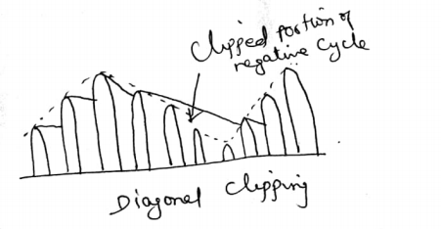

**c) Draw the frequency spectrum and phase representation of SSB-SC signal. (2 Marks)**

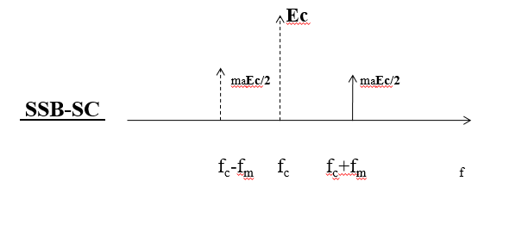

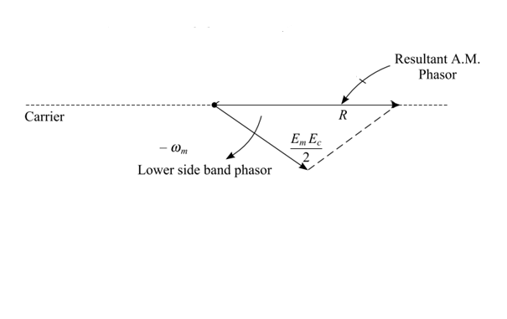

**d). What are the disadvantages of single side band transmission? (2marks)**

* Complex receivers: Single side band systems require more complex and expensive receivers than conventional AM transmission.
* Tuning difficulties: Single side band receivers require more complex and precise tuning than conventional AM receivers.

**e) Draw the filter characteristics of VSB modulation scheme. (2 marks)**

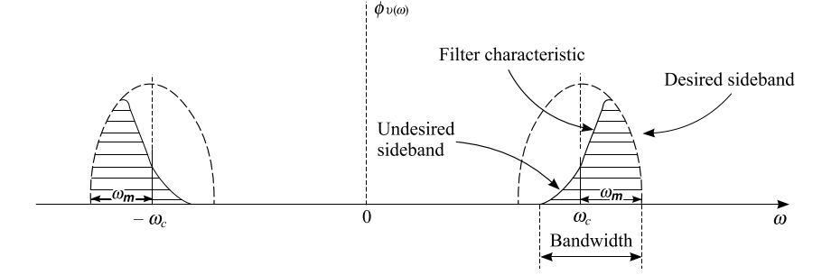

**f) Compare NBFM and WBFM. (2 marks)**

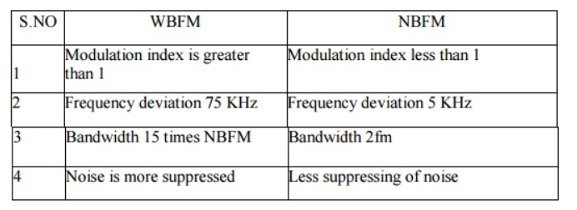

**g) What is frequency discriminator? (2 marks)**

A **frequency discriminator** is defined as a converter of **frequency** changes into amplitude changes. **Discriminators** are used in various applications, one of which is the direct demodulation of frequency modulated signals. The Foster Seeley FM discriminator, detector or demodulator enabled audio to be recovered from frequency modulated signals using a relatively simple circuit.

**h) Define noise and give its classification. (2 marks)**

Undesired electrical signals which are introduced with a message signal during the transmission or processing of the latter are called noise.

Types:

1.External noise

2. Internal noise

**i) What is noise quieting effect in FM? (2 marks)**

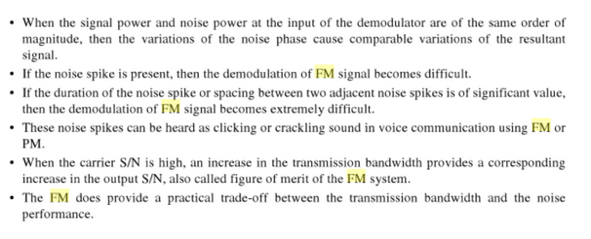

**j) Write short notes on Thermal noise. (2 marks)**

Thermal noise will always arise in any component due to the inherent DC resistance in the system. In general, cooling your system or using components with lower parasitic resistance will reduce the thermal noise intensity. Thermal noise has the following characteristics:

* **Uncorrelated (i.e., white)**: Thermal noise has an autocorrelation function that is a delta function. This means that thermal noise is uncorrelated over time; the thermal noise you measure does not depend on thermal noise measured at all previous times. Note that this also applies in circuits with feedback (e.g., amplifiers).
* **Power spectral density**: As a result of the uncorrelated nature of thermal noise, power is uniformly distributed at all frequencies below some limit, i.e., it has a flat power spectral density function at sufficiently low frequencies and high temperatures.

**Part C (10 x 4 = 40 Marks)**

**3.a). Derive the total power radiated by Amplitude Modulated Full carrier signal. (6 Marks)**

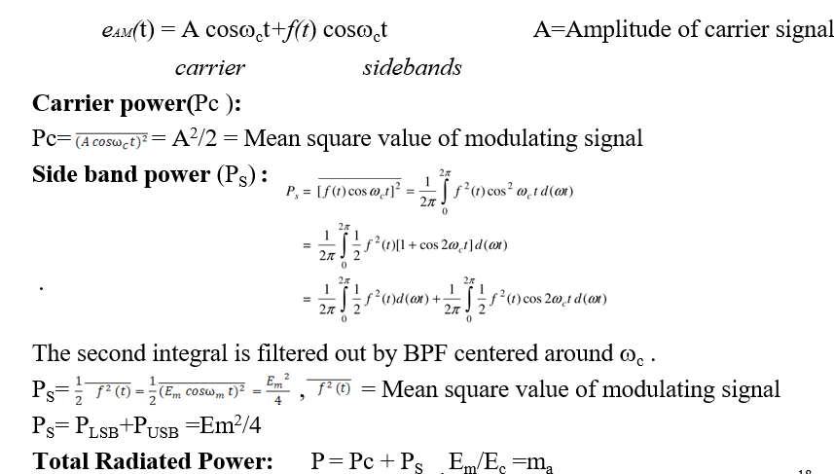

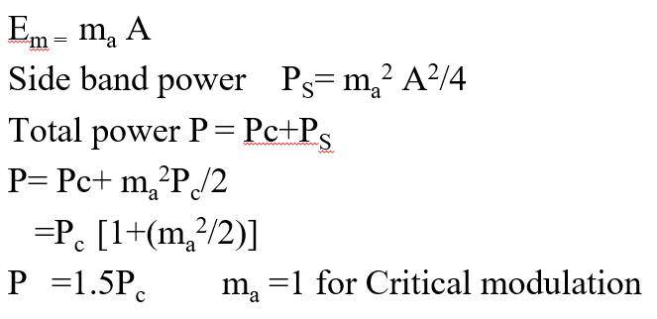

**3.b) An amplitude modulated wave 10[1+0.6cos2π103t]cos2 π106t is to be detected by a linear diode detector. Find the time constant. (4 marks)**

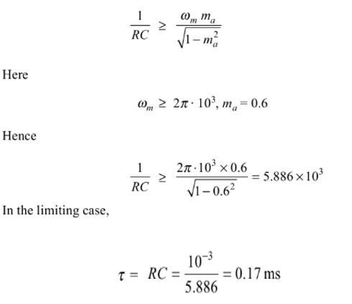

**OR**

**C) Explain how amplitude modulation performed in switching modulator. (10 Marks)**

Block Diagram:

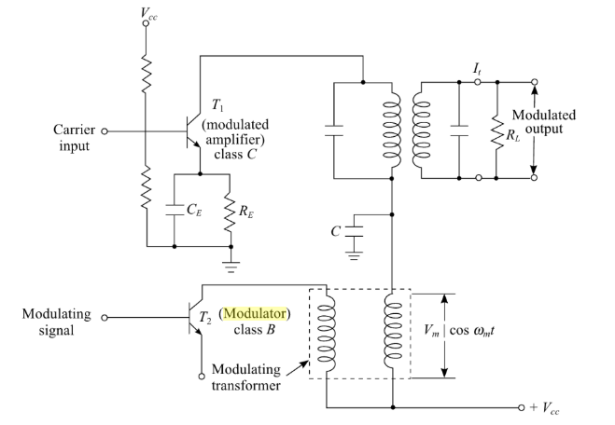

* The diode modulator does not provide Amplification.
* Amplifying device like Transistor and FET can provide amplification. It can be used for amplitude modulation by varying their Gain parameter, if Transistor is used then it is called as collector modulator.
* Transistor ---T1---Class c Amplifier---Carrier signal is applied,Vcc is collector supply used for biasing
* Transistor---T2--- Class B Amplifier---Message signal is applied,after amplification modulating signal appears across the modulating transformer
* Capacitor C offer low path to carrier(prevents carrier to flow in modulating transformer)

Principle of operation

* The output voltage is replica of input voltage
* The amplitude of output voltage is equal to Vcc ,When there is no message signal(fig a)
* When Message signal is applied,the net effect is slow variation in output(fig b)
* The slow varying supply voltage Vc is given by



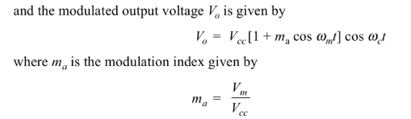

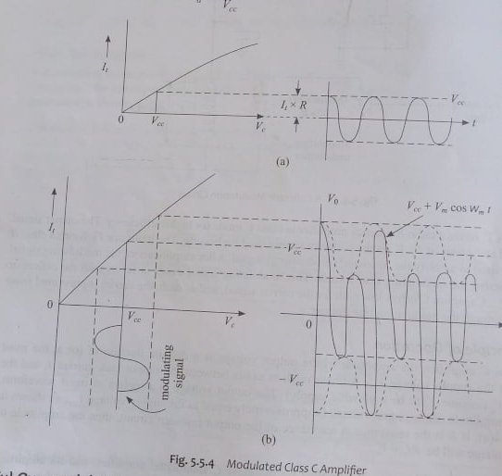

**4. a) Explain the generation and synchronous detection of SSB signal. (10 marks)**

Generation pf SSB signal:The phase shift method of SSB generation uses two balanced modulators and 90° phase shiftier but avoids the requirement for filters. The audio is shifted a total of 90° either by a pair of ± 45° phase shiftier or a single 90° phase shifter. A simplified block diagram of phase-shift method of SSB generation is as shown in Figure.

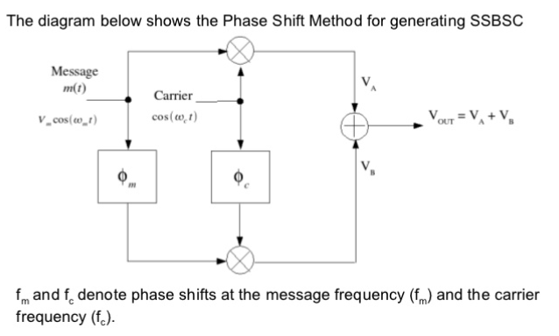

Detection of SSSB Signal: The product modulator is a type of coherent SSB demodulator . To recover the modulating signal from the SSB-SC signal, we require a phase coherent or synchronous demodulator .

The block diagram of the coherent SSB-SC demodulator is shown in fig.

The received SSB signal is first multiplied with a locally generated carrier signal . The locally generated carrier should have exactly the same frequency as that of the suppressed carrier .

The product modulator multiplies the two signals at its input and the product signal is passed through a low pass filter with a bandwidth equal to fm. At the output of the filter, we get the modulating signal back .

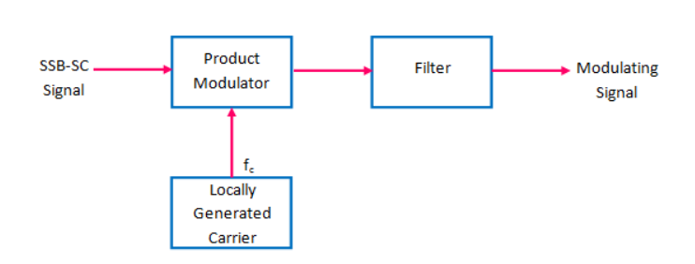

**OR**

**c) Narrate the procedure to obtain DSB SC signal using Ring modulator. (10 Marks)**

In this diagram, the four diodes *D*1,*D*2,*D*3 and *D*4 are connected in the ring structure. Hence, this modulator is called as the **ring modulator**. Two center tapped transformers are used in this diagram. The message signal *m*(*t*) is applied to the input transformer. Whereas, the carrier signals *c*(*t*) is applied between the two center tapped transformers. For positive half cycle of the carrier signal, the diodes *D*1 and *D*3 are switched ON and the other two diodes *D*2 and *D*4 are switched OFF. In this case, the message signal is multiplied by +1. For negative half cycle of the carrier signal, the diodes *D*2 and *D*4 are switched ON and the other two diodes *D*1 and *D*3 are switched OFF. In this case, the message signal is multiplied by -1. This results in 1800 phase shift in the resulting DSBSC wave. From the above analysis, we can say that the four diodes *D*1 , *D*2, *D*3 and *D*4 are controlled by the carrier signal

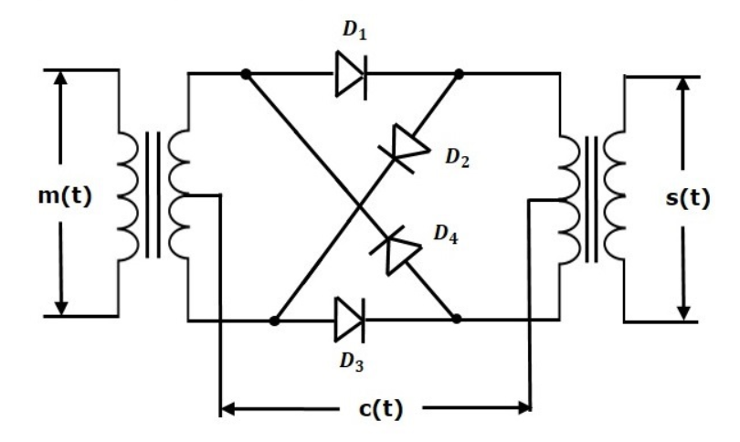

. If the carrier is a square wave, then the Fourier series representation of *c*(*t*) is represented as

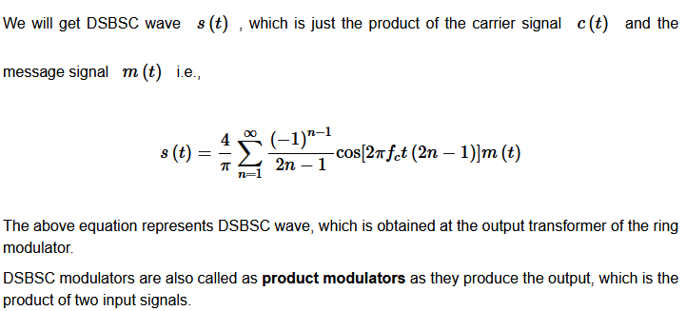

**5.a) List the difference between FM and PM. (6 marks)**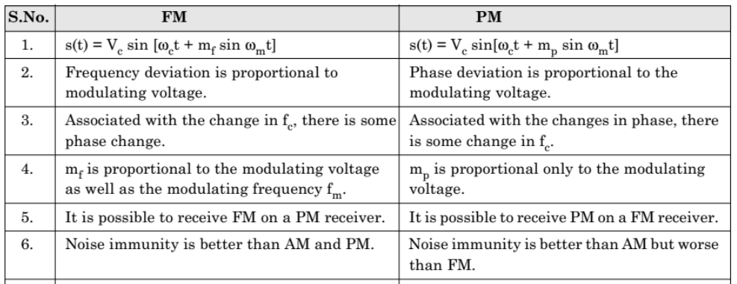

**b) Write the expression for bandwidth of FM with example. (4marks)**

The Bandwidth of an FM Signal:

The following formula, known as Carson’s rule is often used as an estimate of the FM signal bandwidth:

BT= 2(∆f+fm) Hz

where ∆fis the peak frequency deviation and

fm is the maximum baseband message frequency component.

Example:

Commercial FM signals use a peak frequency deviation of ∆f= 75 kHz and a maximum baseband message frequency of fm= 15 kHz. Carson’s rule estimates the FM signal bandwidth as

BT= 2(75 + 15) = 180 kHz which is six times the 30 kHz bandwidth that would be required for AM modulation.

**OR  
5.C) Elucidate the function of building blocks of super heterodyne receiver. (10 Marks)**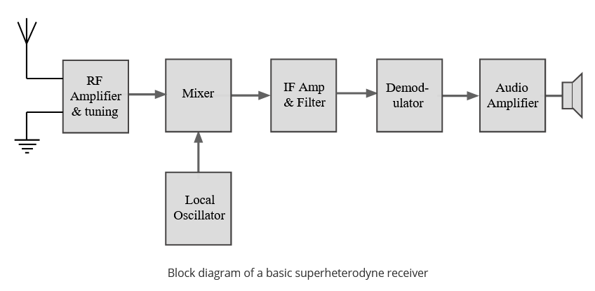

***RF tuning & amplification:***   This RF stage within the overall block diagram for the receiver provides initial tuning to remove the image signal. It also provides some amplification. There are many different approaches used within the RF circuit design for this block dependent its application.

***Local oscillator:***   Like other areas of the RF circuit design, the local oscillator circuit block within the superhet radio can take a variety of forms.

***Mixer:***   The mixer can be one of the key elements within the overall RF design of the receiver. Ensuring that the mixer performance matches that of the rest of the radio is particularly important.

***IF amplifier & filter:***   This superheterodyne receiver block provides the majority of gain and selectivity. Often comparatively little gain will be provided in the previous blocks of the RF circuit design of the radio. The IF stages are where the main gain is provided. Being fixed in frequency, it is much easier to achieve high levels of gain and overall performance.

***Demodulator:***   The superheterodyne receiver block diagram only shows one demodulator, but in reality many radio RF designs may have one or more demodulators dependent upon the type of signals being receiver. Those radios used for professional radio communications applications and monitoring may need to be able to demodulate a variety of modulation schemes and waveforms and this may require a number of different demodulators that can be switched in as appropriate.

***Automatic Gain Control, AGC:***   An automatic gain control is incorporated into most superhet radio block diagrams. The function of this circuit block is to reduce the gain for strong signals so that the audio level is maintained for amplitude sensitive forms of modulation, and also to prevent overloading.

***Audio amplifier:***   Once demodulated, the recovered audio is applied to an audio amplifier block to be amplified to the required level for loudspeakers or headphones. Alternatively the recovered modulation may be used for other applications whereupon it is processed in the required way by a specific circuit block.

**6. a) Derive the expression for figure of merit of AM receiver using envelope detection. ( 10 marks)**

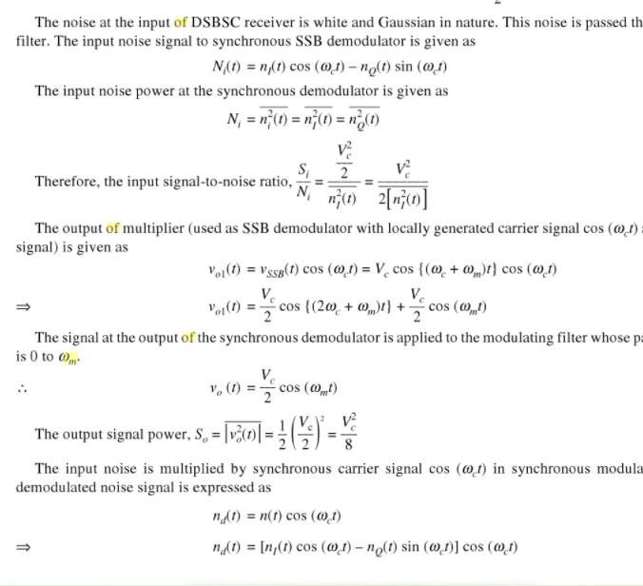

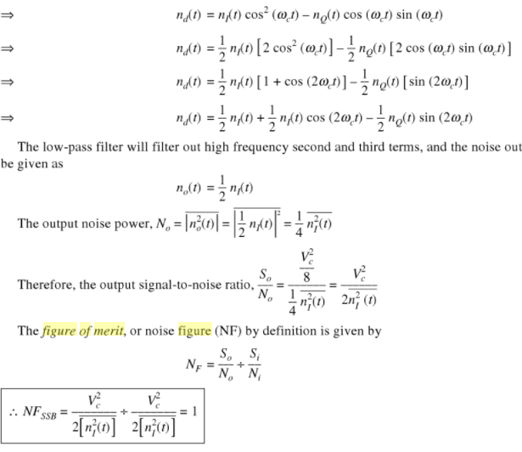

**OR**

**6.c) Explain in detail about various sources of noise. (10 Marks)**

Various sources of noise:

* Noise is a general term which is used to describe an unwanted signal which affects a wanted signal. These unwanted signals arise from a variety of sources which may be considered in one of two main categories:-
* *Interference, usually from a human source (man made)*
* *Naturally occurring random noise*

Types:

External noise:

* Created outside the circuit

* Man made noise

Internal noise: Created by active and passive components withn the communication circuit itseld

(i) shot noise

(ii) thermal noise

Additional sources of noise.