 | GIET UNIVERSITY, GUNUPUR – 765022  B. Tech (Fourth Semester – Regular) Examinations, April / May – 2021  Sub. Code – Sub. Name  (Branch or Common to -------------)
Time: 3 hrs SCHEME OF VALUATION Maximum: 70 Marks
Answer ALL Questions
The figures in the right hand margin indicate marks.
PART – A: (Multiple Choice Questions) (1 x 10=10 Marks)

Q.1. Answer ALL questions |  |  | [CO#] | [PO#]
a. | Which of the following is made in connection with the construction of streets, water supply systems, sewers? |  | CO1
 | (i) Traverse surveying | (ii) Hydrographic surveying
 | (iii) Cadastral surveying | (iv) City surveying
b. | Pacing is difficult in _______ |  | CO2
 | (i) Smooth surfaces | (ii) Plain areas
 | (iii) Rough ground | (iv) Plateaus
c. | Length of base line in primary triangulation is given as____________ |  | C03
 | (i) 1.5 -5 km | (ii) 0.5 – 10 km
 | (iii) 0.5 – 3 km | (iv) 5 – 15 km
d. | Covering whole survey area with primary triangulation but filling the gaps with secondary and tertiary triangulation involves in which among the following processes? |  | C03
 | (i) Central system | (ii) Quaternary triangulation
 | (iii) Grid iron system | (iv) Well conditioned system
e. | Which of the following curves helps in avoiding overturning of vehicles? |  | C04
 | (i)Simple curve | (ii) Transition curve
 | (iii) Compound curve | (iv) Reverse curve
f. | The optical square is used to measure angles by |  | C02
 | (i)Refraction | (ii)Reflection
 | (iii) double refraction | (iv) double reflection
g. | The lines of earth’s magnetic field run from |  | C03
 | (i) south to north | (ii) north to south
 | (iii) east to west | (iv) west to east
h. | The latitude and departure of a traverse line are both positive when the whole circle bearing of the line lies in the |  | C01
 | (i) first quadrant | (ii)second quadrant
 | (iii) third quadrant | (iv)fourth quadrant
i. | . Which of the following area calculation methods is mostly used? |  | C04
 | (i)Area of double meridian | (ii)Area by co-ordinates
 | (iii)Area by planimeter | (iv)Area by Simpson’s rule
j. | The formula for difference in elevation can be given as__________ |  | C03
 | (i) D = V + (I-R) | (ii) D = V + (I+R)
 | (iii) D = V – (I-R) | (iv) D = V * (I-R)

SET-I- KEY
a | b | c | d | e | f | g | h | i | j
D | C | D | C | B | B | B | A | A | A

PART – B: (Short Answer Questions) (2 x 10=20 Marks)

Q.2. Answer ALL questions
a. | How can you divide the surveying?  Ans: 1. Plane Surveying, - 1M  2. Geodetic surveying - 1M
b. | Write main types of projections used in drawing?  Ans: Each 1 M  Mainly two types of projections are used i.e., Parallel and perspective projections.  The parallel projections are further divided into Orthographic and Oblique projections.
c. | Describe different kinds of chains used for linear measurements  Ans: Types of chains in common use: - 2M  - Metric chains  - Gunter’s chain or surveyor’s chain  - Engineer’s chain  - Revenue chain  - Steel band or band chain
d. | Explain various methods of linear measurements  Ans:  - Direct measurements  - Measurements by optical means - 2M  - Electro-magnetic methods
e. | Differentiate the prismatic compass and surveyors compass?  Ans: Prismatic compass - 1 M  Surveyors compass – 1 M
f. | List out the methods for measuring horizontal angles using theodolite and differentiate them?
g. | Explain about the basic principles of remote sensing?  Ans: following principles - 2M  - Electromagnetic energy  - Electromagnetic spectrum  - Wave length regions and their applications in remote sensing  - Characteristics of solar radiation  - Basic radiation laws  - EM radiation and the atmosphere  - Interaction of EM radiation with earth’s surface
h. | Define G.I.S. and describe about the Four M’s?  Ans: Definition - 1M  Four M’s -1M  - Measurement  - Mapping  - Monitoring and  - Modelling termed, as key activities which can be enhanced by the using information systems technologies through G.I.S.
i. | Mention about types of EDM instruments?  Ans:  Electro-magnetic distance measurement can be classified under three heads:  a.Microwave instruments  b.Visible light instruments - 2M  c.Infrared instruments.
j. | - Describe about the classification of Photogrammetry?  Ans: Introduction  Terrestrial photogrammetry: which can be divided into two branches –1M  i. Plane-table photogrammetry  ii. Terrestrial stereophotogrammetry  Aerial photogrammetry: -1M

PART – C: (Long Answer Questions) (10 x 4=40 Marks)

 |  | Answer ALL questions | Marks
3. a. | I | Explain about fundamental principles of surveying  Ans: 1. Location of a point by measurement from two points of reference- 3M  2. Working from whole to part -2M | 5
b. |  | Write down various types of scales? Describe any one of the scale ?  Ans:  - Plain scale -1M  - Diagonal scale - 1M  - Vernier scale -1M  - Scale of chords -1M  - Isometric scales -1M | 5
 |  | (OR)
c. |  | Describe about sources and kinds of errors? Explain any one of the kinds of errors?  Ans: Errors may arise from three sources:  - Instrumental  - Personal 3M  - Natural  Kinds of Errors:  - Mistakes  - Systematic errors (cumulative errors) 2M  - Accidental errors compensating errors) | 5
d. |  | How can you explain the general Classification of Surveying, Explain in any one of instrument used survey  Ans: 1. Classification based upon the nature of the field survey -- 2M  - Land surveying : i. Topographical surveys, ii. Cadastral Surveys,  iii. City Surveying.  - Marine or Hydrographic Survey  - Astronomical Survey.  2. Classification based on the object of survey --2M  a. Engineering survey  b. Military survey  c. Mine Survey  d. Geological survey  3. Classification based on instruments used ----1M  - Chain Survey  - Theodolite survey  - Traverse survey  - Triangulation survey  - Tacheometric survey  - Plane table survey  - Photogrammetric survey  - Aerial survey | 5
4. a. | II | Differentiate between permanent and temporary adjustments of level?  Ans: Each surveying instrument needs two types of adjustments.  - Temporary adjustments: --3M  Temporary adjustments are those which have to be performed at every instrument setting and are done before the observations are taken with the instrument.  These consist of the two operations:  - Leveling by Legs  - Leveling by Foot Screws:  - Focusing  - Focusing the eye - Piece  - focussing the object-Glass:  - Permanent adjustments: ----2M  Permanent adjustments are made when the fixed relationship between the fundamental lines of an instrument is disturbed. Once these adjustments are made, they last for a long time. | 5
b. |  | Explain the types of Levels? Describe any one of the level in detail?  Ans: the following types of levels are in use. –5M  - Dumpy level  - Wye level  - Reversible level  - Tilting level  Automatic or adjusting level | 5
 |  | (OR)
c. |  | Discuss the effects of curvature and refraction in leveling. Find the correction due to each and the combined correction. Why are these effects ignored in ordinary leveling?  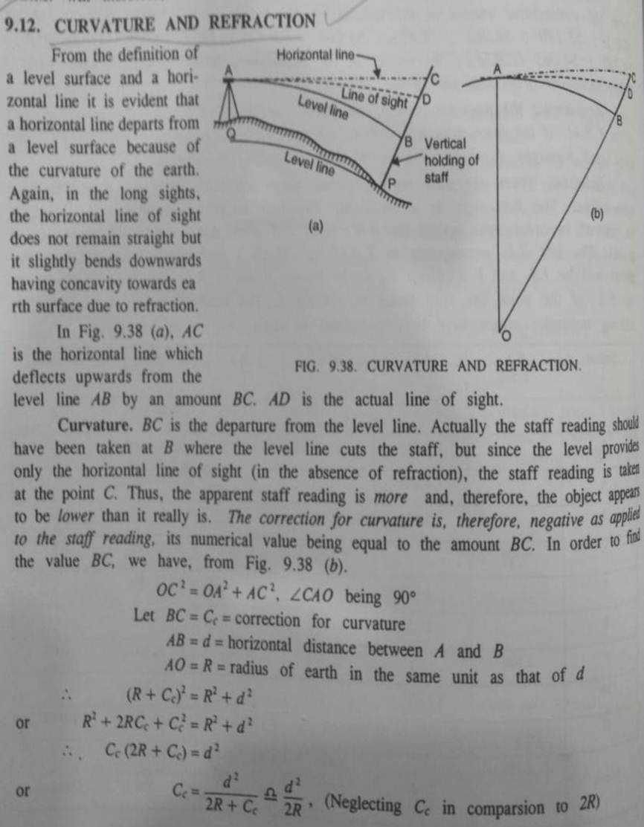  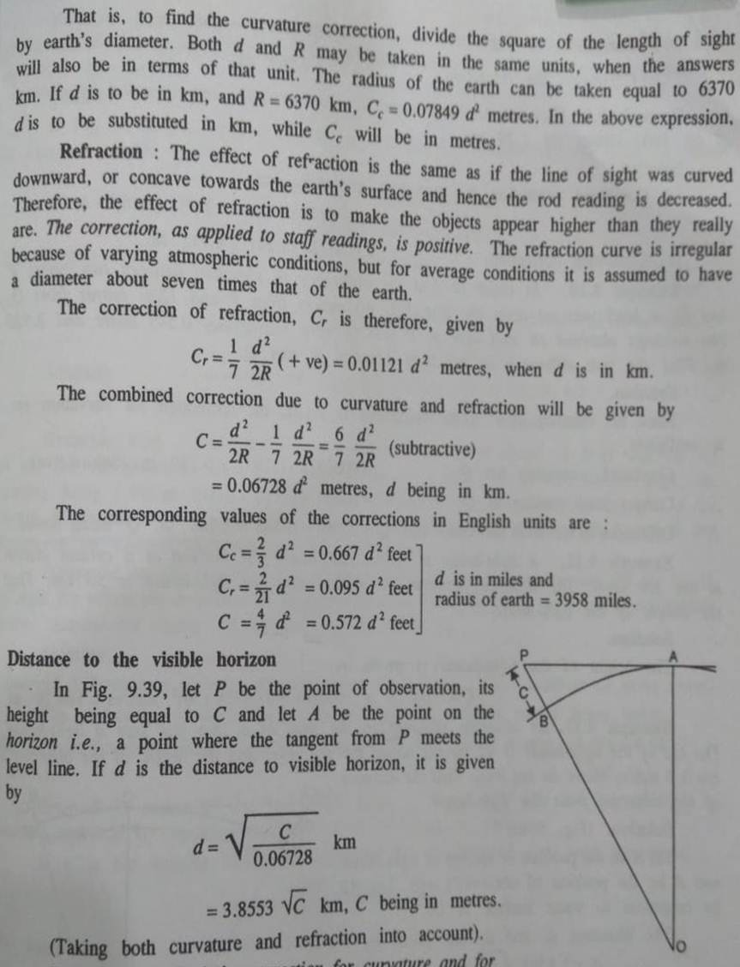 | 5
d. |  | In order to find the difference in elevation between two points P and Q, a level was set upon the line PQ, 0 metres from P and 1280 metres from Q. the readings obtained on staff kept at P and Q were respectively 0.545 metre and 3.920 m. Find the true difference in elevation between P and Q.  Ans:  Since the distance of P from instrument is small, the correction for curvature etc. is negligible.  Combined correction for Q = 0.06728 (1.280)² = 0.110 m (Subtractive)  Correct staff reading at Q = 3.920 – 0.110= 3.810 m  Difference in elevation between P and Q = 3.810 – 0.545 = 3.265 m. Q being lower. | 5
5. a. | III | Explain the basic features of a total station?  Ans: Introduction  A Total station is a combination of an electronic theodolite and an electronic distance meter (EDM)  Fundamental measurements: When aimed at an appropriate target, a total station measures three parameters  - The rotation of the instruments optical axis from the instrument north in a horizontal plane: i.e. Horizontal angle –2 M  - The inclination of the optical axis from the local vertical i.e., Vertical angle.—2M  - The distance between the instrument and the target i.e. Slope Distance – 1M  All the numbers that may be provided by the total station are derived from these Three fundamental measurements. | 5
b. |  | Describe about the essentials of the transit theodolite?  Ans: Any following 5 , Each 5 x 1M  - The telescope  - The vertical circle  - The index frame  - The standards  - The leveling head  - The two spindles  - The lower plate  - The upper plate  - The plate levels  - Tripod  - The plumb bob | 5
 |  | (OR)
c. |  | Explain about instruments used for linear and angular measurements and explain any one of the Linear measurements?  The instruments used for Linear measurements are: --2M  - Chain  - Tape  - Level  - Offset rod  - Tacheometer including electronic tacheometers or total stations  - Electronic distance measuring (EDM) devices  Instruments used commonly for taking Angular measurements are :----3M  - Compass: Field work in surveying becomes quicker, more efficient and versatile by  employing an angle measuring instrument along with the chain or tape and cross-staff.  Surveying in which a compass is used to determine direction of survey line in a traverse is known as Compass surveying.  The angles at stations are measured with the help of a compass.  The prismatic compass is the one most commonly used by engineers.  Bearing of a line:  Designation of bearings: i) Whole circle system  ii) Quadrantal system  Field work with compass:  - Prismatic compass with tripod stand  - Chain and arrows  - Tape  - Ranging rods and  - Pegs  - Theodolites  - Clinometer | 5
d. |  | The following interior angles were measured with a sextant in a closed traverse. The bearing of the line AB was measured as 60⁰ 00’ with prismatic compass. Calculate the bearings of all other line if └^{A}=140⁰ 10’ ; └^{B} =99⁰ 8’; └^{C} =60⁰ 22’; └^{D}=69⁰ 20’.  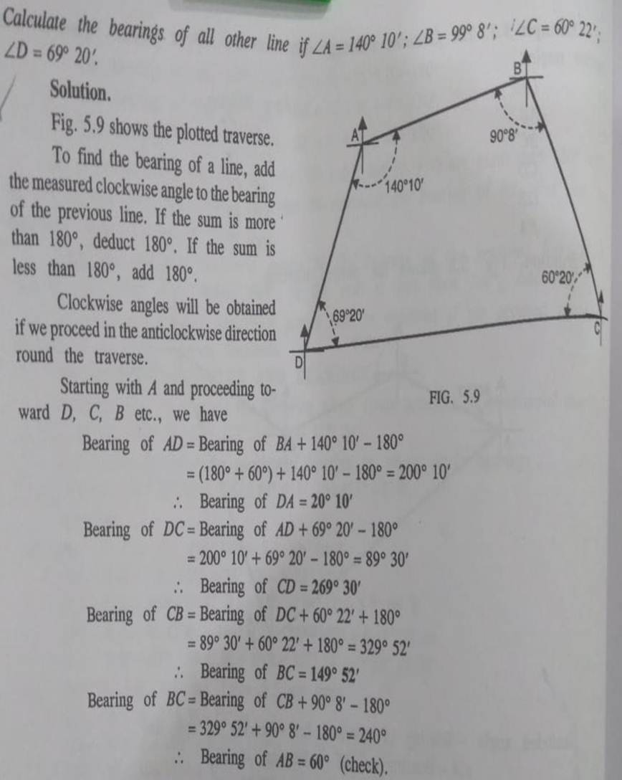 | 5
6. a. | IV | Define sensors, classify the sensors and write a note on various types of sensors used for remote sensing in India?  Ans: Introduction of Sensors: - 1M  Remote sensing sensors are designed to record radiations in one or more parts of the EM spectrum. Sensors are electronic instruments that receive EM radiation and generate an electric signal that correspond to the energy variation of different earth surface features. The signal can be recorded and displayed as numerical data or an image. The strength of the signal depends upon  Following Description --4M  - Energy flux  - Altitude  - Spectral band width  - Instantaneous field of view and  - Dwell time.  A scanning system employs detectors with a narrow field of view which sweeps across the terrain to produce an image. When photons of EM energy radiated or reflected from earth surface feature encounter the detector, an electrical signal is produced that varies in proportion to the number of photons.  Sensors on board of Indian remote sensing satellites (IRS)  - Linear Imaging and Self Scanning Sensors (LISS I)  - Linear Imaging and Self Scanning Sensor (LISS II)  - Linear Imaging and Self Scanning Sensor (LISS III)  - Panchromatic Sensor (PAN)  - Wide Field Sensor (WiFS)  - Modular Opto-Electronic Scanner MOS)  - Ocean Colour Monitor (OCM)  - Multi Scanning Microwave Radiometer (MSMR) | 5
b. |  | Classify the different curves and Explain the various components of a compound curve  Ans:  a.Circular: --3M  Simple  Compound  Reverse  b.Parabolic: --2M | 5
 |  | (OR)
c. |  | Explain the term ‘visual image interpretation? Give notes on various elements of visual interpretation?  Ans:  - Visual image interpretation: - 4M  Tone, Texture, Shape, Size, Shadows, Association, Pattern  and  - Digital image processing (DIP) - 1M | 5
d. |  | Explain about the remote sensing process?  Ans: Any 5, Each 5 x 1 M  - Radiation by energy source  - Interaction with the earth’s atmosphere  - Interaction with the target  - Recording of energy by the sensor  - Transmission, reception and processing  - Interpretation and analysis  - Application | 5

--- End of Paper ---

