GIET MAIN CAMPUS AUTONOMOUS GUNUPUR – 765022
B. Tech Degree Examinations, April / May – 2021
(Fourth Semester)
BECES4050 - SIGNALS & SYSTEM – ANSWER KEY

PART – A: (Multiple Choice Questions) (10 x 2=20 Marks)

Qn | 1a | 1b | 1c | 1d | 1e | 1f | 1g | 1h | 1i | 1j
Ans | (iii) | (iv) | (iii) | (ii) | (iv) | (ii) | (i) | (iv) | (iii) | (i)

PART – B: (Short Answer Questions) (10 x 2 = 20 Marks)
2. | Answer
a. | 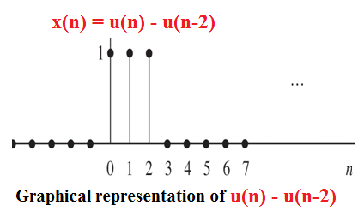
b. | 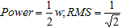
c. | (i)Over any period of x(t) must be absolutely integrable  (ii) x(t) has finite number of minima, maxima and discontinuities in any finite interval.
d. | $$X(e^{\text{jw}})=\frac{1}{1−3e^{−\text{jw}}}$$
e. | Minimum sampling rate f_{s} = 2f_{max} = 2*25 = 50 Hz
f. | $$\sum_{n=−∞}^{∞}{{\left|x(n)\right|}^{2}=\frac{1}{2π}}\int_{2π}{{\left|X(e^{\text{jw}})\right|}^{2}\text{dw}}$$
g. | $$X(s)=\frac{1}{s}−\frac{e^{−5s}}{s}$$
h. | $$H(s)=\frac{2s−3}{s^{2}+3s+2}$$
i. | 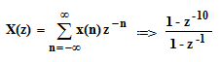
j. | Relationship between Z-T and DTFT is z = e^{jw}
PART – C: (Long Answer Questions) (4 x 15 = 60 Marks)

- (a) (1) Periodic , (2) Non periodic (3 + 3 mark)
(b) (1) Energy, (2) Energy (3) Power ( 3+3+3 mark) [OR]
(c) (1) Non Linear, Time Invariant, Unstable (3 mark)
(2) Linear, Time Variant, Stable ( 3 mark)
(3) Non Linear, Time Invariant Stable (3 mark)
(d) To determine even signal ( 3 mark)
$\begin{aligned}x_{e}[t]=\frac{x[t]+x[−t]}{2} \\ x_{e}[t]=\frac{\text{cost}+\text{sint}+\text{cost sint}+\text{cos}(−t)+\text{sin}(−t)+\text{cos}(−t)\text{sin}(−t)}{2} \\ x_{e}[t]=\frac{\text{cost}+\text{sint}+\text{cost sint}+\text{cost}−\text{sint}−\text{costsint}}{2} \text{wkt} \text{cos}(−t)=\text{cost;} \text{sin}(−t)=−\text{sint} \\ x_{e}[t]=\frac{\text{2cost}}{2} \\ x_{e}[t]=\text{cost}\end{aligned}$
To determine odd signal ( 3 mark)
$$\begin{aligned}x_{o}[t]=\frac{x[t]\text{-x}[−t]}{2} \\ x_{o}[t]=\frac{\text{cost}+\text{sint}+\text{cost sint-cos}(−t)\text{-sin}(−t)\text{-cos}(−t)\text{sin}(−t)}{2} \\ x_{o}[t]=\frac{\text{cost}+\text{sint}+\text{cost sint-cost}+\text{sint}+\text{costsint}}{2} \text{wkt} \text{cos}(−t)=\text{cost;} \text{sin}(−t)=−\text{sint} \\ x_{o}[t]=\frac{\text{2sint}+\text{2costsint}}{2} \\ x_{o}[t]=\text{sint}+\text{cost} \text{sint}\end{aligned}$$

- (a) Using convolution property of DTFT, find the inverse DTFT of $X(\text{jw})=\frac{1}{(1−{αe}^{−\text{jw}})^{2}},\left|α\right|<1$ (4 mark)
$\begin{aligned}X(\text{jw})=\frac{1}{(1−{\text{αe}}^{−\text{jw}})^{2}} \\ \text{The} \text{above} \text{equation} \text{can} \text{be} \text{written} \text{as,} \\ X(e^{\text{jw}})=\frac{j}{α}e^{\text{jw}}\frac{d}{\text{dw}}\left(\frac{1}{1−{\text{αe}}^{−\text{jw}}}\right)−−−(1) \\ \text{we} \text{know} \text{that,} \text{by} \text{using} \text{frequency} \text{differentiation} \text{property,} \\ α^{n}u(n)\overset{\text{FT}}{⇔}\frac{1}{1−{\text{αe}}^{−\text{jw}}} \\ {\text{nα}}^{n}u(n)\overset{\text{FT}}{⇔}j\frac{d}{\text{dw}}\left(\frac{1}{1−{\text{αe}}^{−\text{jw}}}\right) \\ \text{we} \text{know} \text{that,} \text{by} \text{using} \text{time} \text{shifting} \text{property,} \\ x(n+1)\overset{\text{FT}}{⇔}e^{\text{jw}}X\left(e^{\text{jw}}\right) \\ \text{by} \text{using} \text{the} \text{above} \text{two} \text{property,} \\ (n+1)α^{n+1}u(n+1)\overset{\text{FT}}{⇔}{\text{je}}^{\text{jw}}\frac{d}{\text{dw}}\left(\frac{1}{1−{\text{αe}}^{−\text{jw}}}\right) \\ \text{substituting} \text{the} \text{above} \text{equation} \text{in} \text{equation}(1), \text{then} \\ x(n)=\frac{1}{α}(n+1)α^{n+1}u(n+1) \\ \text{Ans:x}(n)=(n+1)α^{n}u(n+1)\end{aligned}$ (3 mark)
4. (b) Properties of DTFT
Differentiation in Frequency (2 mark)
$$\begin{aligned}\text{if} x(n)⇔X(e^{\text{jw}}) \\ \text{then} \\ \text{nx}(n)⇔j\frac{\text{dX}(e^{\text{jw}})}{\text{dw}}\end{aligned}$$
Proof:
$\begin{aligned}X(e^{\text{jw}})=\sum_{n=−∞}^{∞}{x(n)e^{−\text{jwn}}} \\ \text{differentiate} \text{with} \text{respect} \text{to} 'w ' \text{then} \\ \frac{\text{dX}(e^{\text{jw}})}{\text{dw}}=\sum_{n=−∞}^{∞}{x(n)\frac{d}{\text{dw}}e^{−\text{jwn}}} \\ \frac{\text{dX}(e^{\text{jw}})}{\text{dw}}=\sum_{n=−∞}^{∞}{x(n)−{\text{jne}}^{−\text{jwn}}} \\ \frac{\text{dX}(e^{\text{jw}})}{\text{dw}}=−j\sum_{n=−∞}^{∞}{\text{nx}(n)e^{−\text{jwn}}} \\ \text{multiply} b\text{oth} \text{sides} \text{by} j,\text{then} \\ j\frac{\text{dX}(e^{\text{jw}})}{\text{dw}}=\sum_{n=−∞}^{∞}{\text{nx}(n)e^{−\text{jwn}}} \\ L\text{.}H\text{.}S=R\text{.}H\text{.}S\end{aligned}$ ( 2 mark)

Time Reversal (2 mark)
$$\begin{aligned}\text{if} x(n)⇔X(e^{\text{jw}}) \\ \text{then} \\ x(−n)⇔X\left(e^{−\text{jw}}\right)\end{aligned}$$
Proof:
$\begin{aligned}L\text{.}H\text{.}S=\sum_{n=−∞}^{∞}{x(n)e^{−\text{jwn}}} \\ \text{by} \text{replacing} x(n)=x(−n),\text{then} \\ L\text{.}H\text{.}S=\sum_{n=−∞}^{∞}{x(−n)e^{−\text{jwn}}} \\ \text{sub} −n=k,\text{then} \\ \text{LHS}=\sum_{n=−∞}^{∞}{x(k)e^{\text{jwk}}} \\ \text{LHS}=\sum_{n=−∞}^{∞}{x(k)e^{−(−\text{jw})k}} \\ L\text{.}H\text{.}S=X(e^{−\text{jw}}) \\ L\text{.}H\text{.}S=R\text{.}H\text{.}S\end{aligned}$ ( 2 mark)

[OR]
- (c) Determine the discrete time Fourier transform of x(n) = a^{|n|} , |a| < 1 (4)
$$\begin{aligned}X(e^{\text{jw}})=\sum_{n=−∞}^{∞}{x(n)e^{−\text{jwn}}} \\ X(e^{\text{jw}})=\sum_{n=−∞}^{∞}{a^{\left|n\right|}e^{−\text{jwn}}} \\ X(e^{\text{jw}})=\sum_{n=0\text{.}\text{.}\text{.}}^{∞}{a^{n}e^{−\text{jwn}}}+\underset{\text{subs} −n=m \text{above} \text{summation}}{\sum_{n=−∞\text{.}\text{.}\text{.}}^{−1}{a^{−n}e^{−\text{jwn}}}} \\ X(e^{\text{jw}})=\sum_{n=0\text{.}\text{.}\text{.}}^{∞}{a^{n}e^{−\text{jwn}}}+\sum_{m=1\text{.}\text{.}\text{.}}^{∞}{a^{m}e^{\text{jwm}}} \\ X(e^{\text{jw}})=\sum_{n=0\text{.}\text{.}}^{∞}{{\left({\text{ae}}^{−\text{jw}}\right)}^{n}+\sum_{n=1\text{.}\text{.}}^{∞}{{\left({\text{ae}}^{\text{jw}}\right)}^{m}+}} \\ X(e^{\text{jw}})=\left[1+\left({\text{ae}}^{−\text{jw}}\right)+{\left({\text{ae}}^{−\text{jw}}\right)}^{2}+\text{.}\text{.}\text{.}\text{.}\right]+\underset{\text{take} {\text{ae}}^{\text{jw} }\text{commonly} \text{out}}{\left[\left({\text{ae}}^{−\text{jw}}\right)+{\left({\text{ae}}^{−\text{jw}}\right)}^{2}+\text{.}\text{.}\text{.}\text{.}\right]} \\ X(e^{\text{jw}})=\frac{1}{1−{\text{ae}}^{−\text{jw}}}+{\text{ae}}^{\text{jw}}\left[1+\left({\text{ae}}^{−\text{jw}}\right)+{\left({\text{ae}}^{−\text{jw}}\right)}^{2}+\text{.}\text{.}\text{.}\text{.}\right] \\ X(e^{\text{jw}})=\frac{1}{1−{\text{ae}}^{−\text{jw}}}+\frac{{\text{ae}}^{\text{jw}}}{1−{\text{ae}}^{\text{jw}}} \\ X(e^{\text{jw}})=\frac{1−{\text{ae}}^{\text{jw}}+(1−{\text{ae}}^{−\text{jw}}){\text{ae}}^{\text{jw}}}{\left(1−{\text{ae}}^{−\text{jw}}\right)\left(1−{\text{ae}}^{\text{jw}}\right)} \\ X(e^{\text{jw}})=\frac{1−{\text{ae}}^{\text{jw}}+{\text{ae}}^{\text{jw}}−a^{2}e^{−\text{jw}}e^{\text{jw}}}{1−{\text{ae}}^{−\text{jw}}−{\text{ae}}^{\text{jw}}+a^{2}e^{−\text{jw}}e^{\text{jw}}} \text{wkt} e^{\text{jw}}e^{−\text{jw}}=1; \\ X(e^{\text{jw}})=\frac{1−a^{2}}{1−a(e^{\text{jw}}+e^{−\text{jw}})+a^{2}} \text{wkt} e^{\text{jw}}+e^{−\text{jw}}=2\text{cos}w \\ X(e^{\text{jw}})=\frac{1−a^{2}}{1−2a\text{cos}w+a^{2}} \end{aligned}$$
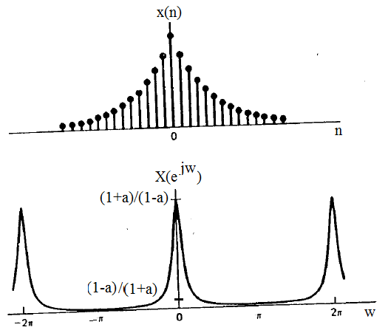 (3 mark)
Fig: signal x(n) and its Spectrum of X(e^{jw}) for 0 < a < 1
4. (d) Express the Fourier transforms of the following signals in terms of X(e^{jw})
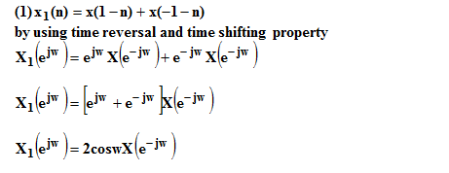 (4 mark)
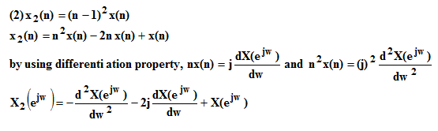
( 4 mark)

5. (a) Step (i) Take Laplace Transform of x(t) and h(t) (2 mark)
$$\begin{aligned}\text{Laplace} \text{transforms} \\ h(t)=e^{−\text{3t}}u(t)\overset{\text{LT}}{⇔}H(s)=\frac{1}{s+3} \\ u(\text{t-3})\overset{\text{LT}}{⇔}=\frac{e^{\text{-3s}}}{s} \\ u(\text{t-5})\overset{\text{LT}}{⇔}=\frac{e^{\text{-5s}}}{s} \\ x(t)=u(t−3)−u(t−5)\overset{\text{LT}}{⇔}X(s)=\frac{e^{\text{-3s}}−e^{−\text{5s}}}{s}\end{aligned}$$
Step (ii) Using convolution, response of the system Y(s) (2 mark)
$$\begin{aligned}Y(s)=X(s)H(s) \\ Y(s)=\frac{e^{\text{-3s}}−e^{−\text{5s}}}{s(s+3)}=\left[e^{\text{-3s}}−e^{−\text{5s}}\right]\frac{1}{s(s+3)} \\ Y(s)=R(s)\left[e^{\text{-3s}}−e^{−\text{5s}}\right]−−−−(A)\end{aligned}$$
Step (iii) by partial fraction,
$\begin{aligned}R(s)=\frac{1}{s(s+3)} \\ R(s)=\frac{A}{s}+\frac{B}{s+3}−−−(1) \\ 1=A(s+3)+\text{Bs} \\ \text{substitute} s=\text{0,} \\ 1=A(0+3)⇒A=\frac{1}{3} \\ \text{substitute} s=−3, \\ 1=B(−3)⇒B=−\frac{1}{3} \\ \text{Substitute} \text{A&} B \text{value} \text{in} \text{eqn} (1) \\ R(s)=\left(\frac{1}{3}\right)\frac{1}{s}−\left(\frac{1}{3}\right)\frac{1}{s+3} \\ \text{Subs} R(s)\text{in} \text{eqn }(A)\text{ &Take} \\ \text{Laplace} \text{inverse} \text{transform} \\ y(t)=\left[\frac{{\text{1-e}}^{\text{-3t}}}{3}\right]u(\text{t-3})−\left[\frac{{\text{1-e}}^{\text{-3t}}}{3}\right]u(\text{t-5})\end{aligned}$ (3 mark)

5.(b) by using partial fraction, (6 mark)
$\begin{aligned}X(s)=\frac{3s^{2}+8s+\text{23}}{(s+3)(s^{2}+2s+\text{10})} \\ \text{the} \text{roots} \text{of} \text{the} \text{deno}\text{min}\text{ator} \text{is} −1±3i \\ X(s)=\frac{3s^{2}+8s+\text{23}}{(s+3)(s+1+3i)(s+1−3i)} \\ \text{by} u\text{sin}g \text{partial} \text{fraction}, \\ \frac{3s^{2}+8s+\text{23}}{(s+3)(s+1+3i)(s+1−3i)}=\frac{A}{(s+3)}+\frac{B}{(s+1+3i)}+\frac{C}{(s+1−3i)} \\ 3s^{2}+8s+\text{23}=A(s^{2}+2s+\text{10})+B(s+3)(s+1−3i)+C(s+3)(s+1+3i) \\ \text{substitute} s=−3, \text{then} \\ 3(−3)^{2}+8(−3)+\text{23}=A(9−6+\text{10}) \\ \text{27}−\text{24}+\text{23}=A(\text{13}) \\ \text{26}=A(\text{13}) \\ A=2 \\ \text{substitute} s=−1+3i, \text{then} \\ 3(−1+3i)^{2}+8(−1+3i)+\text{23}=C(−1+3i+3)(−1+3i+1+3i) \\ 3(1−9−6i)−8+\text{24}i+\text{23}=C(2+3i)(6i) \\ 3(−8−6i)+\text{15}+\text{24}i=C(\text{12}i−\text{18}) \\ −\text{24}−\text{18}i+\text{15}+\text{24}i=C(−\text{18}+\text{12}i) \\ −9+6i=C(−\text{18}+\text{12}i) \\ C=0\text{.}5 \\ \text{simillarly} B=0\text{.}5 \left[ \text{sin}\text{ce} \text{complex} \text{conjugate} \text{of} C^{}=B\right] \\ X(s)=\frac{2}{s+3}+\frac{0\text{.}5}{(s+1+3i)}+\frac{0\text{.}5}{(s+1−3i)} \\ X(s)=\frac{2}{s+3}+\frac{0\text{.}5(s+1−3i)+0\text{.}5(s+1+3i)}{(s+1)^{2}+3^{2}} \\ X(s)=\frac{2}{s+3}+\frac{0\text{.}5s+0\text{.}5−0\text{.}5∗3i+0\text{.}5s+0\text{.}5+0\text{.}5∗3i}{(s+1)^{2}+{\left(3\right)}^{2}} \\ X(s)=\frac{2}{s+3}+\frac{s+1}{(s+1)^{2}+{\left(3\right)}^{2}} \\ \text{Take} \text{laplace} \text{inverse} \text{transform},\text{then} \\ x(t)=2e^{−3t}u(t)+e^{−t}\text{cos}3t u(t)\end{aligned}$ (2 mark)
[OR]
5. (c) by using partial fraction, (3 mark)
$\begin{aligned}X(s)=\frac{1}{(s+5)(s−3)} \\ \text{by} u\text{sin}g \text{partial} \text{fraction}, \\ \frac{1}{(s+5)(s−3)}=\frac{A}{s+5}+\frac{B}{s−3} \\ 1=A(s−3)+B(s+5) \\ \text{substitute} s=3, \text{then} 1=B(3+5)⇒B=\frac{1}{8} \\ \text{substitute} s=−5,\text{then} 1=A(−5−3)⇒A=−\frac{1}{8} \\ \frac{1}{(s+5)(s−3)}=\frac{−\frac{1}{8}}{s+5}+\frac{\frac{1}{8}}{s−3} \\ X(s)=\frac{1}{8}\left[\frac{1}{s−3}−\frac{1}{s+5}\right] \\ \text{take} \text{laplace} \text{inverse} \text{transform}, \\ x(t)=\frac{1}{8}\left[e^{3t}u(t)−e^{−5t}u(t)\right] \text{ROC} \text{for} \text{Re}\left\{s\right\}>3 \\ x(t)=\frac{1}{8}\left[−e^{3t}u(−t)−e^{−5t}u(t)\right] \text{ROC} \text{for} −5<\text{Re}\left\{s\right\}<3\end{aligned}$ (4 mark)
5. (d) Step (i) Draw the graphical representation of e^{-at} u(t), e^{-bt} u(t) and find the overlapping region limit (4 mark)
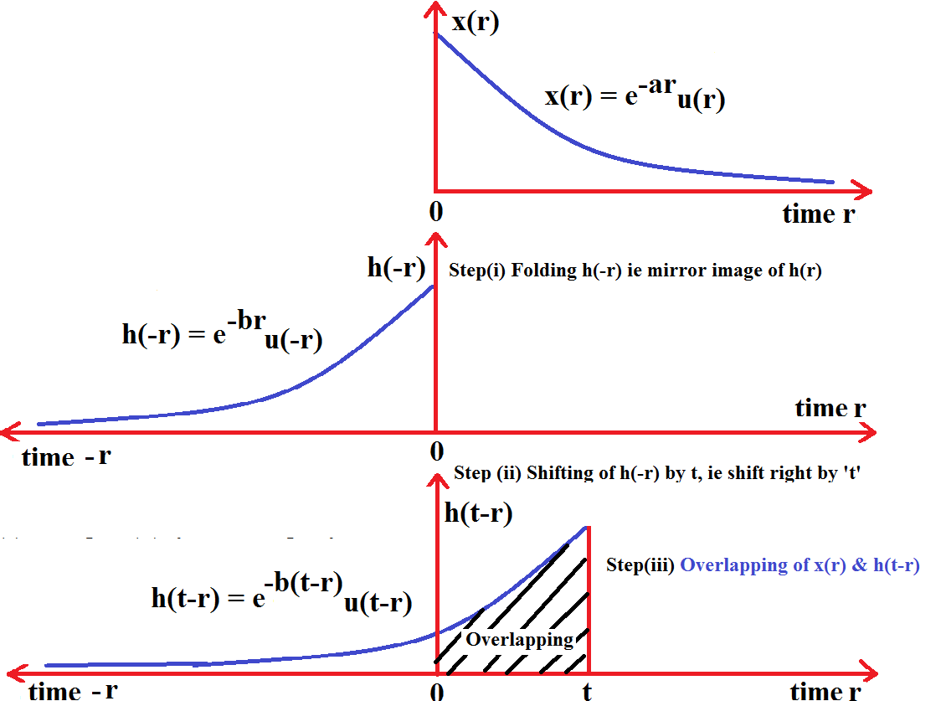
Step (2) To find the convolution between x(t) and h(t) gives y(t) = x(t)*h(t) (4 mark)
$$\begin{aligned}y(t)=\int_{−∞}^{∞}{x(τ ) h(t−τ)\text{dτ}} \\ y(t)=\int_{0}^{t}{e^{−\text{aτ}}e^{−b(t−τ)}}\text{dτ} \\ y(t)=\int_{0}^{t}{e^{−\text{aτ}}e^{−\text{bt}}e^{\text{bτ}}}\text{dτ} \\ \end{aligned}$$
$$\begin{aligned}y(t)=e^{−\text{bt}}\int_{0}^{t}{e^{−\text{aτ}}e^{\text{bτ}}}\text{dτ} \\ y(t)=e^{−\text{bt}}\int_{0}^{t}{e^{(b−a)τ}}\text{dτ} \\ y(t)=e^{−\text{bt}}{\left[\frac{e^{(b−a)τ}}{b−a}\right]}_{0}^{t}=e^{−\text{bt}}\left[\frac{e^{(b−a)t}}{b−a}−\frac{e^{(b−a)0}}{b−a}\right] \\ y(t)=e^{−\text{bt}}\left[\frac{e^{\text{bt}}e^{−\text{at}}}{b−a}−\frac{1}{b−a}\right]=\frac{1}{b−a}\left[e^{−\text{bt}}e^{\text{bt}}e^{−\text{at}}−e^{−\text{bt}}\right] \\ y(t)=\frac{1}{b−a}\left[e^{−\text{at}}−e^{−\text{bt}}\right]\end{aligned}$$
6. (a) Step (i) Find Z Transform of x(n), h(n) (5 mark)

$$\begin{aligned}X(z)=\sum_{n=−∞}^{∞}{x(n) z^{−n}} \\ = \sum_{n=0}^{∞}{α^{n} z^{−n}}=\sum_{n=0}^{∞}{(α z^{−1})^{n}} \\ = 1+(α z^{−1})+(α z^{−1})^{2}+\text{.}\text{.}\text{.}\text{.}\text{.}\text{.}\text{.} \\ =\frac{1}{1−α z^{−1}}(\text{or}) \frac{z}{z−α}\end{aligned}$$
$$\begin{aligned}H(z)=\sum_{n=−∞}^{∞}{h(n) z^{−n}} \\ = \sum_{n=0}^{∞}{β^{n} z^{−n}}=\sum_{n=0}^{∞}{(β z^{−1})^{n}} \\ = 1+(β z^{−1})+(β z^{−1})^{2}+\text{.}\text{.}\text{.}\text{.}\text{.}\text{.}\text{.} \\ =\frac{1}{1−β z^{−1}}(\text{or})\frac{z}{z−β}\end{aligned}$$

We know that Transfer function of the system $H(z)=\frac{Y(z)}{X(z)}\text{=>}Y(z)=\text{ H}(z)X(z)$
Step(ii) Use partial fraction method to find y(n) when α ≠ β (5 mark)
$$\begin{aligned}Y(z)=\text{ H}(z)X(z)=\frac{z}{\text{z-α}}∗\frac{z}{z−β}⇒\frac{z^{2}}{(z−α)(z−β)} \\ \frac{Y(z)}{z}=\frac{z}{(z−α)(z−β)} \\ \frac{Y(z)}{z}=\frac{A}{z−α}+\frac{B}{z−β} \\ z = A(z−β)+B(z−α) \\ \text{sub} z=α \text{in} \text{the} \text{above} \text{equation,} \text{subs} z=\text{β,then} \\ α=A(α−β) β=B(β−α) \\ A=\frac{α}{α−β} B=\frac{β}{β−α}(\text{or})−\frac{β}{α−β}\end{aligned}$$
Substitute A and B values in Y(z),
$$\begin{aligned}\frac{Y(z)}{z}=\frac{A}{z−α}+\frac{B}{z−β} \\ Y(z)=\frac{α}{α−β}∗\frac{z}{z−α}−\frac{β}{α−β}∗\frac{z}{z−β} \\ \text{Take} \text{inverse} Z−\text{Transform,} \text{then} \\ y(n)=\frac{1}{α−β}\left[{\text{α*α}}^{n}−{\text{β*β}}^{n}\right] u(n) \\ \text{Answer} \\ y(n)=\left[\frac{α^{n+1}−β^{n+1}}{α−β}\right]u(n)\end{aligned}$$
6. (b) The response y[n] when α = β $y(n)=\frac{1}{α}(n+1)α^{n+1}u(n+1)$ (5 mark)

[OR]

6. (c) To determine the difference equation (5mark)
$$\begin{aligned}H(z)=\frac{{\text{1-z}}^{\text{-1}}}{1−0\text{.}{\text{2z}}^{−1}−0\text{.}\text{15z}} \\ \frac{Y(z)}{X(z)}=\frac{{\text{1-z}}^{\text{-1}}}{1−0\text{.}{\text{2z}}^{−1}−0\text{.}\text{15z}} \\ Y(z)\left(1−0\text{.}{\text{2z}}^{−1}−0\text{.}\text{15z}\right)=X(z)\left({\text{1-z}}^{\text{-1}}\right) \\ Y(z)−0\text{.}{\text{2z}}^{−1}Y(z)−0\text{.}{\text{15z}}^{−2}Y(z)=X(z)−z^{−1}X(z) \\ \text{Take} \text{inverse} Z−\text{Transform,} \\ y(n)−0\text{.}\text{2y}(n−1)−0\text{.}\text{15y}(n−2)=x(n)−x(n−1)\end{aligned}$$
6. (d) Pole Zero diagram (5 mark)
$\begin{aligned}H(z)=\frac{{\text{1-z}}^{\text{-1}}}{1−0\text{.}{\text{2z}}^{−1}−0\text{.}\text{15z}} \\ \text{rewrite} \text{in} \text{positive} \text{power} \text{of} z,\text{then} \\ H(z)=\frac{z^{2}\text{-z}}{z^{2}−0\text{.}\text{2z}−0\text{.}\text{15}} \\ H(z)=\frac{z(z−1)}{(z−0\text{.}5)(z+0\text{.}3)} \\ \text{Transfer} \text{function} \text{has} \\ \text{zeros} z=\text{0,z}−1 \\ \text{poles} p=0\text{.}\text{5,p}=−0\text{.}3\end{aligned}$
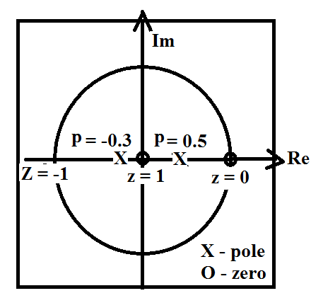
Figure: Pole Zero diagram of H(z)

6. (d) (ii) To find the impulse response (5 mark)
By using partial fraction,
$$\begin{aligned}H(z)=\frac{{\text{1-z}}^{\text{-1}}}{\left(1−0\text{.}5z^{−1}\right)\left(1+0\text{.}3z^{−1}\right)} \\ H(z)=\frac{A}{1−0\text{.}5z^{−1}}+\frac{B}{1+0\text{.}{\text{3z}}^{−1}} \\ {\text{1-z}}^{−1}=A\left(1+0\text{.}{\text{3z}}^{−1}\right)+B\left(\text{1-0}\text{.}{\text{5z}}^{\text{-1}}\right) \\ \text{subs} z^{−1}=2 \\ \text{1-2}=A(1+0\text{.}\text{3*2})+B(\text{1-0}\text{.}\text{5*2}) \\ \text{-1}=A(1\text{.}6)+B(\text{1-1}) \\ \text{-1}=A(1\text{.}6) \\ A=\frac{\text{-1}}{1\text{.}6} (\text{or}) −\frac{5}{8}=−0\text{.}\text{625} \\ \text{subs} z^{−1}=−\frac{1}{0\text{.}3} \\ 1+\frac{1}{0\text{.}3}=B\left(1−0\text{.}5∗\frac{\text{-1}}{0\text{.}3}\right) \\ \frac{1\text{.}3}{0\text{.}3}=B\left(1+\frac{5}{3}\right) \\ 4\text{.}\text{33}=B\left(\frac{8}{3}\right) \\ B=1\text{.}\text{62} \\ \text{substitute A and B values, then} \\ H(z)=\frac{\text{-0}\text{.}\text{625}}{1−0\text{.}{\text{5z}}^{−1}}+\frac{1\text{.}\text{62}}{1+0\text{.}{\text{3z}}^{−1}} \\ H(z)=\frac{\text{-0}\text{.}\text{625}}{1−0\text{.}{\text{5z}}^{−1}}+\frac{1\text{.}\text{62}}{\text{1-}(\text{-0}\text{.}3)z^{−1}} \\ \text{Take} \text{inverse} Z−\text{transform,} \\ \text{the} \text{impulse} \text{response} h(n) \text{is} \\ h(n)=(−0\text{.}\text{625})(0\text{.}5)^{n}u(n)+1\text{.}\text{62}(−0\text{.}3)^{n}u(n)\end{aligned}$$

