**Key Answer**

**PART – A: (Multiple Choice Questions) (1 x 10 = 10 Marks)**

1. (ii) [F/L2]
2. (i) 1 to 20 µm
3. (i ) ultra fine grinder
4. (i) Surface area created
5. (i) Rittingers law
6. (i) High
7. (ii) back washing
8. (iii) String discharge
9. (ii) Cakes of increased porosity
10. (i)laminar

**PART – B: (Short Answer Questions) (2 x 10 = 20 Marks)**

1. **Differentiate screening and sieving.**

Screening and sieving are important mineral processing operations. They rely on separation of particles according to their size. The difference between them is that screening is a continuous operation while sieving is a batch action and is usually performed as lab tests.

1. **Define volume-surface mean diameter**.

It is defined as the diameter of sphere that has same volume/surface area ratio of particle of interest.

1. **Define Sphericity of a particle.**

Sphericity is defined as the ratio of the surface area of a spherical particle having the same

volume as the particle to the surface area of the particle. (ɸs)=(6/Dp)/(Sp/Vp). For Spherical Particles, the value of sphericity is 1. For non-spherical, the sphericity value lies in the range, having maximum value of 0.99.

1. **Give the ratio of the area of the opening in any one screen based on Taylor standard screen series.**

In Taylor standard screen series, area of openings in any one screen in series is exactly

twice that of the openings in next smaller screen. Ratio of actual mesh dimensions in any screen to that of next smaller screen is √2.

**e. Define thickener.**

Equipment works based on sedimentation process whose desired product is the concentrated sludge.

**f. Define froth flotations**

Froth flotation is a process for selectively separating hydrophobic materials from hydrophilic. This is used in mineral processing, paper recycling and waste-water treatment industries.

1. **Design variables for any agitation process with examples.**

Diameter of the impeller, Speed of the impeller, Density of the solution, Viscosity of the solution and Power consumption.

1. **Write the factors that influence “Rate of Mixing”**

* Mixing Tank configurations.
* Physical state of reactants
* Speed of the impeller
* Power consumption

1. **List the selection characteristics of filter:**

The filter medium for industrial filtration must fulfill the following requirements;

• It must retain the solids to be filtered, giving a reasonably clear filtrate.

• It must not – plug or blind – reduces or slow down the filtration rate.

• It must be resistant chemically and strong enough physically to withstand the process conditions.

• It must permit the cake formed to discharge cleanly and completely.

• It must not be prohibitively expensive. Some widely used filter media are twill or duck-weave heavy cloth, other types of woven heavy cloth, woolen cloth, glass cloth, paper, felted pads of cellulose, metal cloth, nylon cloth, Dacron cloth, and other synthetic cloths.

1. **Define the Superficial velocity in filtration.**

The superficial velocity is the velocity of the fluid moving through the packed bed as if it was the only phase.

**PART – C: (Long Answer Questions) (10 x 4 = 40 Marks)**

**3.a. Discuss in detail for the determination of Nature of the material to be crushed.**

The choice of a machine for a given crushing operation is influenced by the nature of the product required and the quantity and size of material to be handled. The more important properties of the feed apart from its size are as follows:

***Hardness*.** The hardness of the material affects the power consumption and the wear on the machine. With

hard and abrasive materials it is necessary to use a low-speed machine and to protect the bearings from the

abrasive dusts that are produced. Pressure lubrication is recommended. Materials are arranged in order of increasing hardness in the *Mohr* scale in which the first four items rank as soft and the remainder as hard.

**The Mohr Scale of Hardness is:**

1. Talc 5. Apatite 8. Topaz

2. Rock salt or gypsum 6. Felspar 9. Carborundum

3. Calcite 7. Quartz 10. Diamond.

4. Fluorspar

***Structure*.** Normal granular materials such as coal, ores and rocks can be effectively crushed employing

the normal forces of compression, impact, and so on. With fibrous materials a tearing action is required.

***Moisture content***. It is found that materials do not flow well if they contain between about 5 and 50 per

cent of moisture. Under these conditions the material tends to cake together in the form of balls. In general, grinding can be carried out satisfactorily outside these limits.

***Crushing strength*.** The power required for crushing is almost directly proportional to the crushing strength of the material.

**Friability.** The friability of the material is its tendency to fracture during normal handling. In general, a

crystalline material will break along well-defined planes and the power required for crushing will increase

as the particle size is reduced.

**Stickiness.** A sticky material will tend to clog the grinding equipment and it should therefore be ground in

a plant that can be cleaned easily.

**Soapiness.** In general, this is a measure of the coefficient of friction of the surface of the material. If the

coefficient of friction is low, the crushing may be more difficult. Explosive materials must be ground wet or in the presence of an inert atmosphere. Materials yielding dusts that are harmful to the health must be ground under conditions where the dust is not allowed to escape.

**3.b. Discuss with neat sketch and explain the working of the ball mill.**

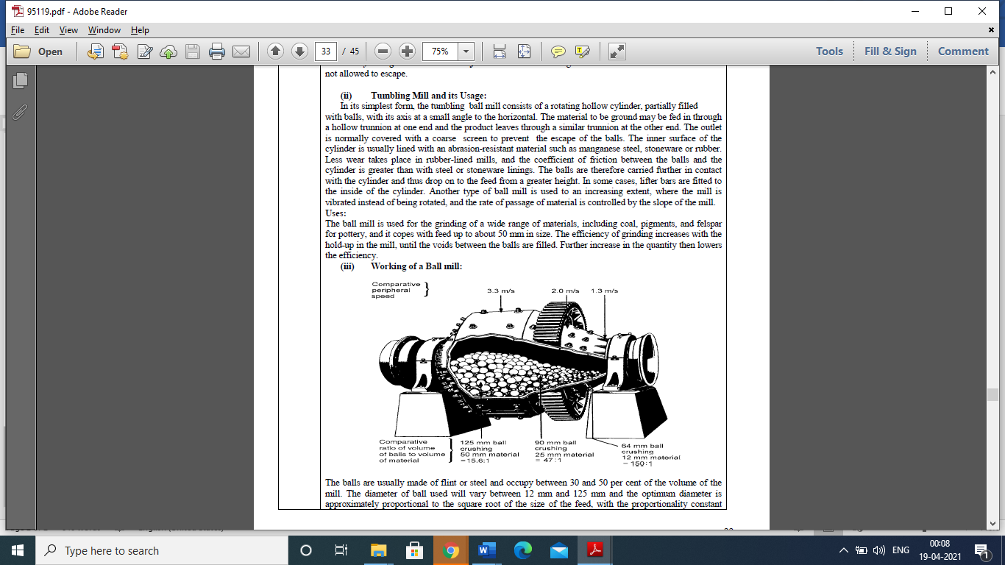

The balls are usually made of flint or steel and occupy between 30 and 50 per cent of the volume of the mill. The diameter of ball used will vary between 12 mm and 125 mm and the optimum diameter is approximately proportional to the square root of the size of the feed, with the proportionality constant being a function of the nature of the material.

During grinding, the balls wear and are constantly replaced by new ones so that the mill contains balls of various ages, and hence of various sizes. This is advantageous since the large balls deal effectively with the feed and the small ones are responsible for giving a fine product. The maximum rate of wear of steel balls, using very abrasive materials, is about 0.3 kg/Mg of material for dry grinding, and 1–1.5 kg/Mg for wet grinding. The normal charge of balls is about 5 Mg/m3. In small mills where very fine grinding is

required, pebbles are often used in place of balls.

In the compound mill, the cylinder is divided into a number of compartments by vertical perforated plates. The material flows axially along the mill and can pass from one compartment to the next only when its size has been reduced to less than that of the perforations in the plate. Each compartment is supplied with balls of a different size. The large balls are at the entry end and thus operate on the feed material, whilst the small balls come into contact with the material immediately before it is discharged. This results in economical operation and the formation of a uniform product. It also gives an improved residence time

distribution for the material, since a single stage ball mill approximates closely to a completely mixed

system.

In ***wet grinding*** the power consumption is generally about 30 per cent lower than that for dry grinding and, additionally, the continuous removal of product as it is formed is facilitated. The rheological properties of the slurry are important and the performance tends to improve as the apparent viscosity increases, reaching an optimum at about 0.2 Pa.s. At very high volumetric concentrations (50 volume per cent), the fluid may exhibit shear-thickening behaviour or have a yield stress, and the behaviour may then be adversely affected.

**4.a. Derive the expression for screen effective ness.**

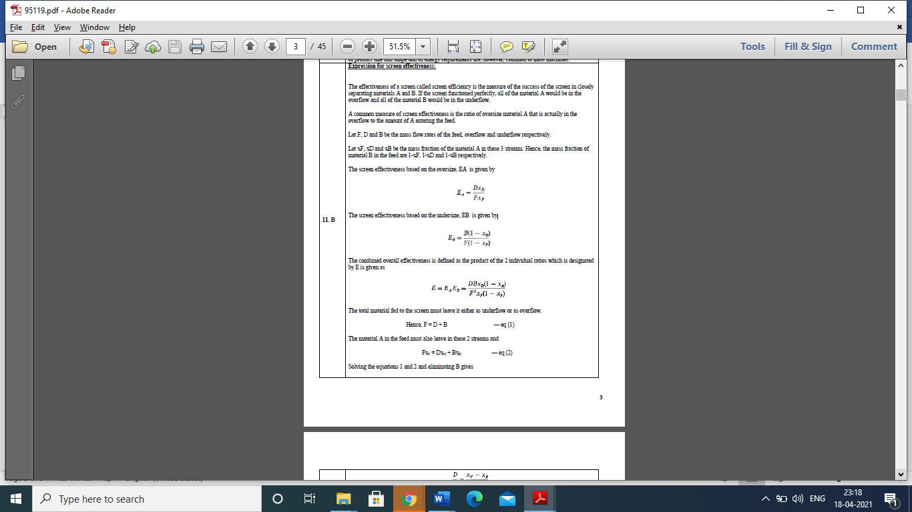

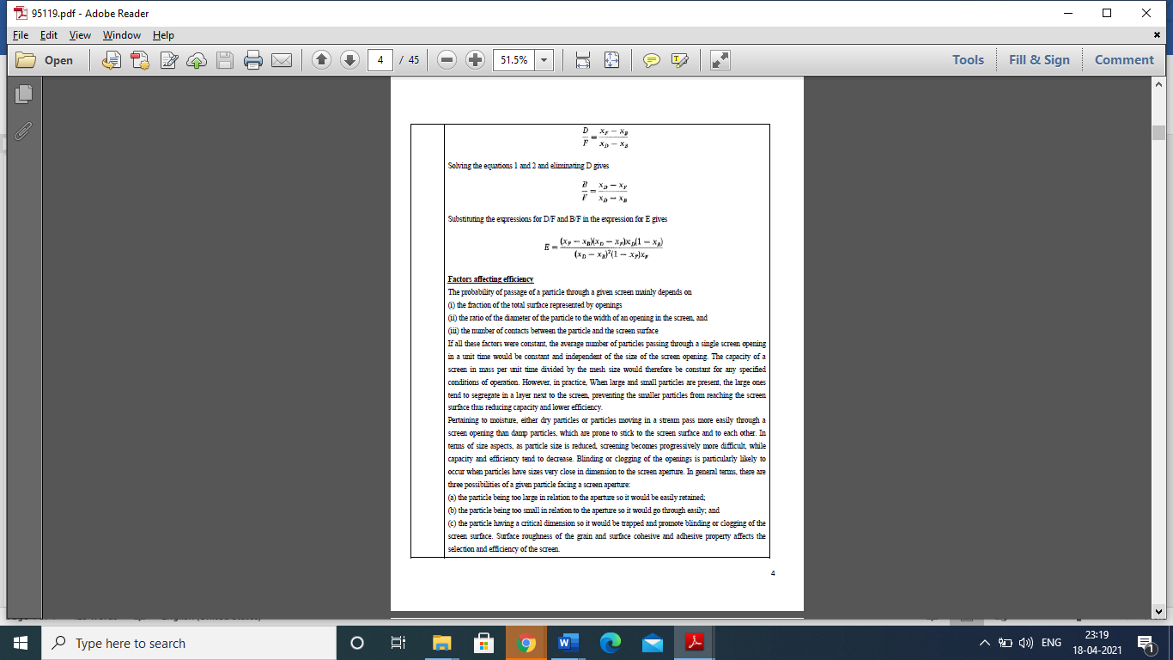

**4.b. Discuss briefly about the Electrostatic Separators.**

An electrostatic separator is a device for separating particles by mass in a low energy charged beam.

An example is the electrostatic precipitator used in coal-fired power plants to treat exhaust gas, removing small particles that cause air pollution.

Electrostatic separation is a process that uses electrostatic charges to separate crushed particles of material. An industrial process used to separate large amounts of material particles, electrostatic separating is most often used in the process of sorting mineral ore. This process can help remove valuable material from ore, or it can help remove foreign material to purify a substance. In mining, the process of crushing mining ore into particles for the purpose of separating minerals is called beneficiation.

Generally, electrostatic charges are used to attract or repel differently charged material.[1] When electrostatic separation uses the force of attraction to sort particles, conducting particles stick to an oppositely charged object, such as a metal drum, thereby separating them from the particle mixture. When this type of beneficiation uses repelling force, it is normally employed to change the trajectory of falling objects to sort them into different places. This way, when a mixture of particles falls past a repelling object, the particles with the correct charge fall away from the other particles when they are repelled by the similarly charged object.

An electric charge can be positive or negative — objects with a positive charge repel other positively charged objects, thereby causing them to push away from each other, while a positively charged object would attract to a negatively charged object, thereby causing the two to draw together.

Experiments showing electrostatic sorting in action can help make the process more clear. To exhibit electrostatic separation at home, an experiment can be conducted using peanuts that are still in their shells. When the shells are rubbed off of the peanuts and gently smashed into pieces, an electrostatically charged device, like a comb rubbed quickly against a wool sweater, will pick up the peanut shells with static electricity. The lightweight crushed shells that are oppositely charged from the comb easily move away from the edible peanut parts when the comb is passed nearby.

The electrostatic separation of conductors is one method of beneficiation; another common beneficiation method is magnetic beneficiation. Electrostatic separation is a preferred sorting method when dealing with separating conductors from electrostatic separation non-conductors. In a similar way to that in which electrostatic separation sorts particles with different electrostatic charges magnetic beneficiation sorts particles that respond to a magnetic field. Electrostatic beneficiation is effective for removing particulate matter, such as ash from mined coal, while magnetic separation functions well for removing the magnetic iron ore from deposits of clay in the earth.

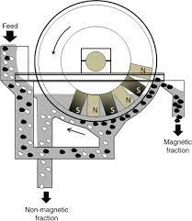

**5.a. With neat sketch detailly elaborate the cyclone separator**

Cyclone separators or simply cyclones are separation devices (dry scrubbers) that use the principle of inertia to remove particulate matter from flue gases. Cyclone separators is one of many air pollution control devices known as precleaners since they generally remove larger pieces of particulate matter

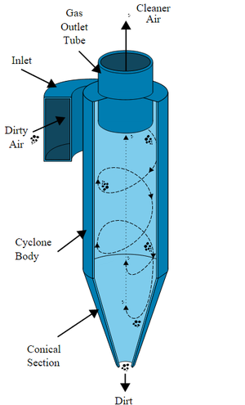

This prevents finer filtration methods from having to deal with large, more abrasive particles later on. In addition, several cyclone separators can operate in parallel, and this system is known as a multicyclone.[3]

It is important to note that cyclones can vary drastically in their size. The size of the cyclone depends largely on how much flue gas must be filtered; thus, larger operations tend to need larger cyclones. For example, several different models of one cyclone type can exist, and the sizes can range from a relatively small 1.2-1.5 meters tall (about 4-5 feet) to around 9 meters (30 feet)—which is about as tall as a three-story building.

Cyclone separators work much like a centrifuge, but with a continuous feed of dirty air. In a cyclone separator, dirty flue gas is fed into a chamber. The inside of the chamber creates a spiral vortex, similar to a tornado. This spiral formation and the separation is shown in Figure 1. The lighter components of this gas have less inertia, so it is easier for them to be influenced by the vortex and travel up it. since these larger particles have difficulty following the high-speed spiral motion of the gas and the vortex, the particles hit the inside walls of the container and drop down into a collection hopper. These chambers are shaped like an upside-down cone to promote the collection of these particles at the bottom of the container. The cleaned flue gas escapes out the top of the chamber.

Most cyclones are built to control and remove particulate matter that is larger than 10 micrometers in diameter. However, there do exist high efficiency cyclones that are designed to be effective on particles as small as 2.5 micrometers. As well, these separators are not effective on extremely large particulate matter. For particulates around 200 micrometers in size, gravity settling chambers or momentum separators are a better option.

Out of all of the particulate-control devices, cyclone separators are among the least expensive. They are often used as a pre-treatment before the flue gas enters more effective pollution control devices. Therefore, cyclone separators can be seen as "rough separators" before the flue gas reaches the fine filtration stages.

**5.b. Calculate the terminal settling velocity for quartz spheres in water at 20ºC as a function of particle diameter for the range from 0.01 to 10mm. The density of quartz is 2.65 g/cc. Viscosity of water is 0.01 poise.**

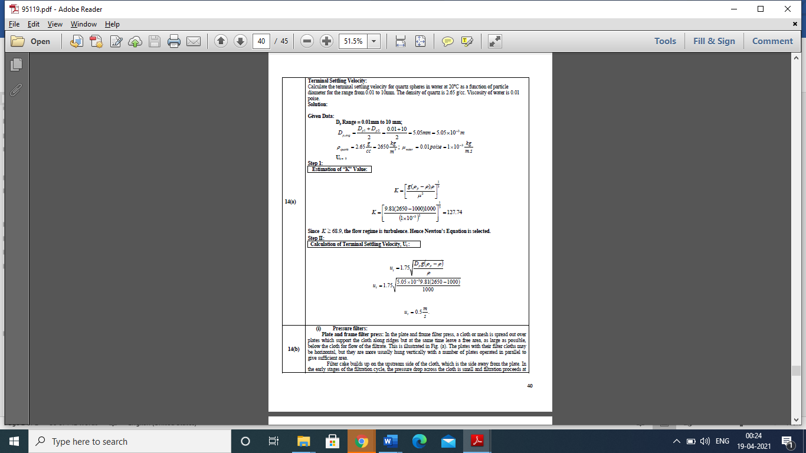

**6.a. Discuss briefly about the Flocculation, Filter Aids and filter Media and Kneaders and Masticators**

**(i) Flocculation**

Flocculation, a gentle mixing stage, increases the particle size from submicroscopic microfloc to visible suspended particles. The microflocs are brought into contact with each other through the process of slow mixing. Collisions of the microfloc particles cause them to bond to produce larger, visible flocs called pinflocs. The floc size continues to build through additional collisions and interaction with inorganic polymers formed by the coagulant or with organic polymers added. Macroflocs are formed. High molecular weight polymers, called coagulant aids, may be added during this step to help bridge, bind, and strengthen the floc, add weight, and increase settling rate. Once the floc has reached it optimum size and strength, the water is ready for the sedimentation process. Design contact times for flocculation range from 15 or 20 minutes to an hour or more. Flocculation requires careful attention to the mixing velocity and amount of mix energy. To prevent the floc from tearing apart or shearing, the mixing velocity and energy input are usually tapered off as the size of the floc increases. Once flocs are torn apart, it is difficult to get them to reform to their optimum size and strength.

**(ii) Filter Aids and filter Media**

Filter Aids‖ is a group of inert materials that can be used in filtration pretreatment. There are two objectives related to the addition of filter aids. One is to form a layer of second medium which protects the basic medium of the system. This is commonly referred to as ―precoat‖. The common filter aids are diatomaceous earth (DE), perlite, cellulose and others. Diatomaceous earth (DE) is the skeleton of ancient diatoms. They are mined from ancient seabed, processed, and classified to make different grade of filter aids. DE is the most commonly used filter aid today. However, the crystalline type DE is a suspicious carcinogen and inhalation needs to be avoided during handling. The filter medium for industrial filtration must fulfill the following requirements;

• It must retain the solids to be filtered, giving a reasonably clear filtrate.

• It must not – plug or blind – reduces or slow down the filtration rate.

• It must be resistant chemically and strong enough physically to withstand the process conditions.

• It must permit the cake formed to discharge cleanly and completely.

• It must not be expensive.

Some widely used filter media are twill or duck-weave heavy cloth, other types of woven heavy cloth, woolen cloth, glass cloth, paper, felted pads of cellulose, metal cloth, nylon cloth, Dacron cloth, and other synthetic cloths.

The ragged fibers of natural materials are more defective in removing fine particles than the smooth plastic or metal fibers.

**(iii) Kneaders and Masticators:**

They are used to mix deformable or plastic solids by squashing the mass flat, folding it over and squashing it once more. It may tear the mass and shear it between the blades and walls of mixer. The power requirements for this type of mixers are relatively high, esp. in case of stiff materials. Examples (in order of power requirements) include: two-arm kneader, disperser, masticator (intensive mixers), banbury mixer (internal mixers), and continuous kneaders. The two-arm kneader with minimum power requirements handles suspensions, pastes and light plastic materials. A disperser with heavier construction body and more power consumption is suitable for additives and coloring agents into stiff materials. Masticator with maximum work capacity can work on scraping rubber and plastic materials. The body is heavier than disperser and consumes more power. In internal mixers, the chamber is sealed during the working time; making dispersions of feed in liquid usually water. Example of such a type is Banbury mixer, a heavy-duty two arm mixer in which the agitators are in form of interrupted spirals. The turning frequency is 30 to 40 rpm. Kneaders work both in batch and continuous operation with equipment parameters differing accordingly.

**6.b. A slurry is being filtered at constant pressure in a plate and frame filter using 10 frames, having a total filtration area of 10 m2. The filter delivers 250 litres filtrate in 30 minutes. To increase the filtration capacity 10 more frames are added to the filter. All other conditions being the same as before how long will it take to collect 500 litres filtrate? Initial filter resistance is found to be negligible.**

