**B. Tech (Fourth Semester – Regular) Examinations, April / May – 2021**

**Sub. Code – Sub. Name Mass Transfer-I**

**Solutions**

**PART – A: (Multiple Choice Questions) (1 x 10 = 10 Marks)**

|  |  |  |
| --- | --- | --- |
| Question No. | Correct Answer | Explanation |
|  | iii | Inversely proportional |
|  | i | Increases with temperature |
|  | i | Directly Proportional |
|  | ii | decreases |
|  | iii | Allowable gas and liquid velocities |
|  | iv | Dalton proved a generalized equation states that total pressure is equals to the sum of the partial pressure of the components. Raoult’s law is applicable for only ideal solution since the partial pressure is equals to the product of mole fraction and the vapour pressure. |
|  | i | The plot with mole fraction will give an operating line as a curve; it will be very difficult to find the slope of the operating line. Therefore the use of mole ratio plot will give us a liner operating line. |
|  | iv | Gs= G(1-y) = 80 x(1-0.75) = 20 moles/hr |
|  | i | Dry bulb temperature is the actual measuring temperature of the thermometer |
|  | i | Pressure of A/Total pressure- Pressure of A = 7/17-7 = 0.5 |

**PART – B: (Short Answer Questions) (2 x 10 = 20 Marks)**

**Q2.**

**2. a. State Ficks’ law of diffusion and write its salient features?**

Fick’s law states that “the flux of a diffusing component A (diffusion flux of A) in z direction in a binary mixture of A and B is proportional to the concentration gradient”. The Fick’s law of diffusion for species/component A in a binary mixture of A and B for steady state diffusion in Z direction can be expressed as JA = - DAB dCA/dz

(i) Fick’s law is based on experimental evidence and cannot be derived from first principles.

(ii)Fick’s law is valid for all matter irrespective of its state (eg., solid, liquid or gas)

(iii) The mass diffusion, besides concentration gradient, may occur due to a temperatue gradient, a pressure gradient or an external force; however, while applying Fick’s law it is assumed that these additional effects are either absent or negligibly small

(iv) The movement of a diffusion substance is in the direction of decreasing concentration. In a diffusion process, the concentration difference is similar to temperature difference in a heat transfer process.

(v) Diffusion coefficient (D), in general, is dependent upon temperature, pressure and nature of the system component; however, for ideal gases and dilute liquids it can be assumed to remain practically constant for a given range of temperature and pressure.

**2. b. How does the liquid phase diffusivity of a solute depend upon the temperature and the viscosity of the medium?**

The diffusivity increases with T and decreases with µ

**2. c. What factors should be consider while selecting solvent for gas absorption?**

The properties of the solvent are considered (i) Gas solubility (ii) Volatility (iii) Corrosive nature (iv)Viscosity (v) Cost and availability (vi) Non-toxic, non-flammable and chemically stable.

**2. d. State the desirable characteristics of packings.**

It should be (i) provide large interfacial area for phase contacting i.e., large wetted surface area per unit volume of packed space (ii) provide large void volume or empty space in the packed bed, then reasonable throughputs of the phases are handled without excessive pressure drop. (iii) Possess good wetting characteristics (iv) High corrosion resistance (v) relatively cheap/inexpensive (vi) low bulk density (vii) Possess enough structural strength (viii) chemically inert to the fluids handled in towers.

**2. e. Write physical significance of the absorption factor (A)**

It is the ratio of the slopes of the equilibrium line and the operating line.

**2. f. What happens if a column heated by open steam is operated at total reflux for a long time?**

Since condensed steam accumulates in the column, the total liquid holdup goes on increasing, and the concentration on each tray continues to decrease. Also the column will flood if there is no product removal from the bottom.

**2. g. For distillation of an equimolar binary mixture of A and B, the equations of the operating lines are: Rectifying section: y = 0.663 x + 0.32; stripping section: y = 1.329 x – 0.01317. What is the condition of the feed?**

Intersection of the operating lines: x = 0.5, y = 0.652. Feed concentration, ZF = 0.5 ⇒The feed line is a vertical line. The feed is a saturated liquid.

**2.h.What do you mean by an azeotrope and azeotropic distillation?**

An azeotrope is a liquid mixture with an equilibrium vapour of the same composition as the liquid. The dew point and bubble point are identical at azeotropic composition and mixture vaporises at a single temperature, so azeotropes are called as constant boiling mixtures.

The process of distillation wherein a third component is added to a binary azeotrope to effect the complete separation is called as azetropic distillation.

**2.i. What is the adiabatic saturation temperature?**

Adiabatic saturation temperature is defined as that temperature at which water, by evaporating into air, can bring the air to saturation at the same temperature adiabatically. An adiabatic saturator is a device using which one can measure theoretically the adiabatic saturation temperature of air.

**2.j. Name a few industries that have a large cooling load**

Power plants, metallurgical industries, rolling mills and refineries.

**PART – C: (Long Answer Questions) (10 x 4 = 40 Marks)**

**3. a. Describe the Stefan tube experiment for estimation of diffusivity**

|  |  |
| --- | --- |
|  |  |

**3. b.** **Explain the different modes of mass transfer**



**3. c. Explain briefly analogy between heat, mass and momentum.**

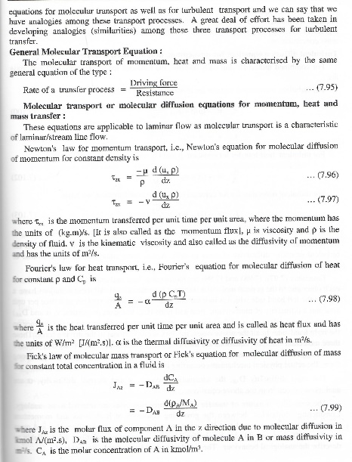 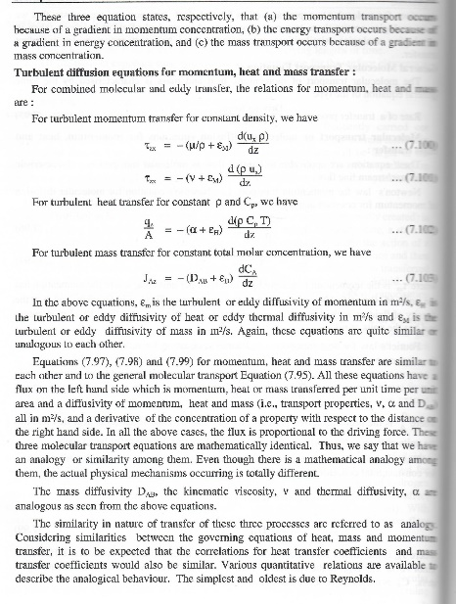 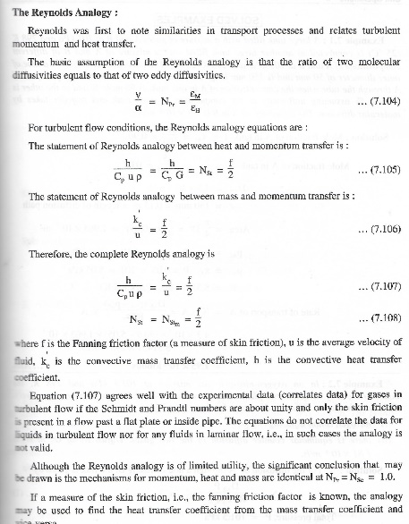

**3.d. Water is evaporating from the placid surface of a lake and the vapour (A) diffuses through a stagnant film of air (B) of estimated thickness of 3 mm. The water temperature is 23OC and the air temperature is 27OC. The relative humidity of air us 65%. If the diffusivity of water vapour through air is 0.257 cm2/s at 23OC and 0.262 cm2/s at 27OC, calculate the rate of evaporation. The vapour pressure of water pv (in bar) can be calculated using the Antoine equation ln pv = 13.8573 - 5160.2/T, where T is the temperature in K.**

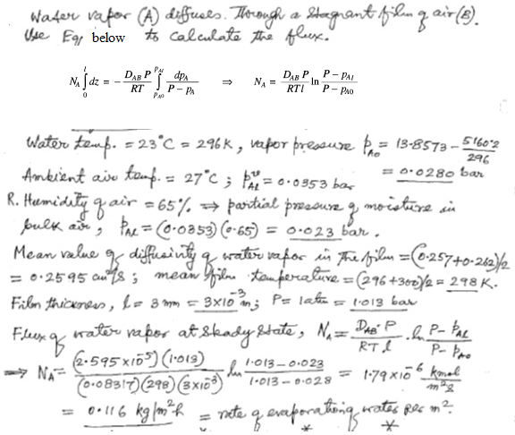

**4. a. Compare gas absorption and distillation**

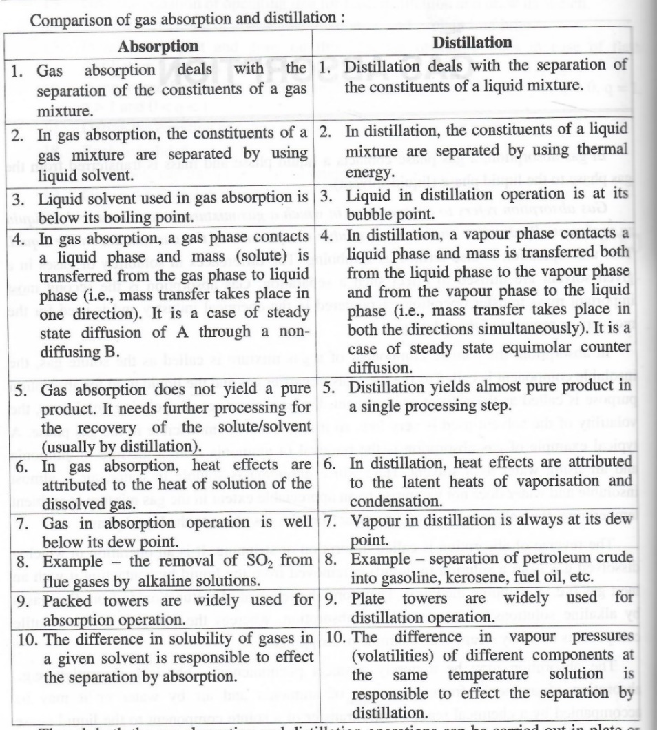

**4.b. 1000 m3/h of a gas mixture containing 10 mole% solute and rest inert enters an absorber at 300 K temperature and 106.658 kPa pressure. 90% of the original solute is removed. Solute-free water used for absorption contains 5 mole% solute when it leaves the absorber from the bottom. Calculate the solvent flow rate to the absorber.**

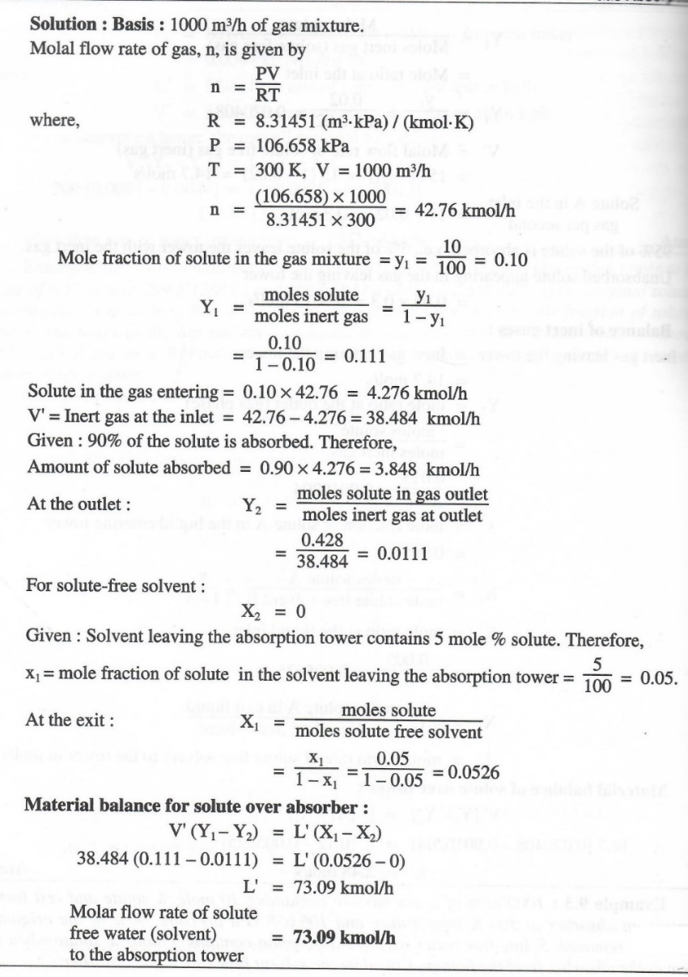

**4. c. What do you mean by channelling? How it can be avoided/minimized?**

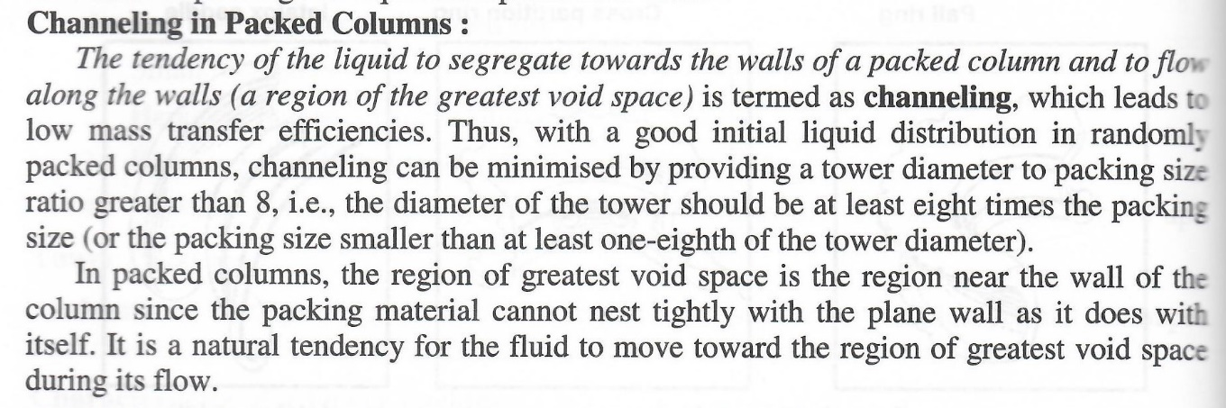

**4. d. Sulphur dioxide is to be scrubbed from an air stream in a small packed tower by contacting it with an organic amine. The feed gas 3% SO2 by volume, and 95% of it is to be absorbed. The total gas rate is 150 m3/h at 20OC and 1.1 bar absolute pressure. The liquid enters the column at a rate of 1.40 kmol/h. Given: the overall mass transfer coefficient, KG = 3.3×10-4 kmol/ (m2) (s) (Δp, bar); the effective gas-liquid contact area = 105 m2 per m3 of packed volume; slope of the equilibrium line, m= 0.17. Determine the number of overall gas-phase mass transfer units and the packed height if the column is 1 ft in diameter.**

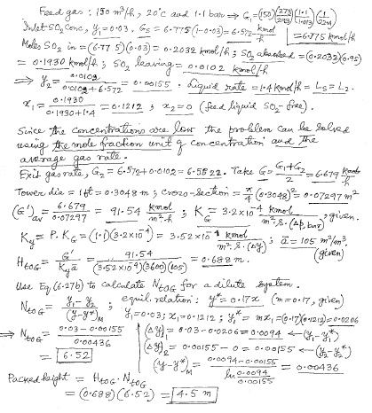

**5. a. Derive the equation of q-line; y = [-q/(1-q)] . x + xF / (1-q)**

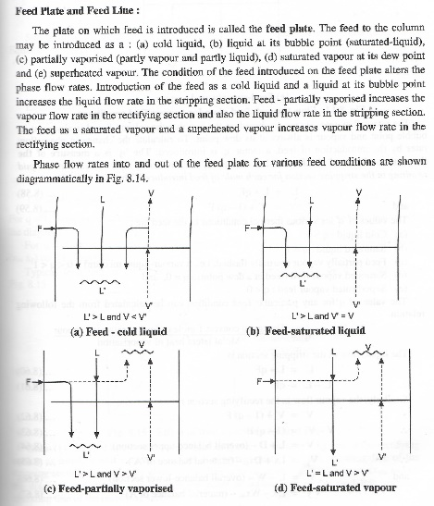 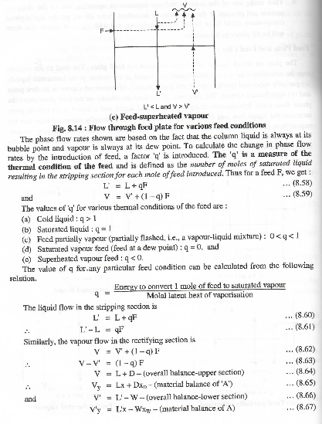 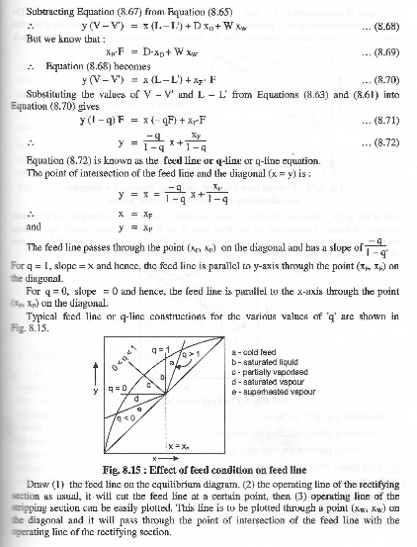

**5. b. Explain in brief (i) bubble cap tray/plate (ii) sieve plate**

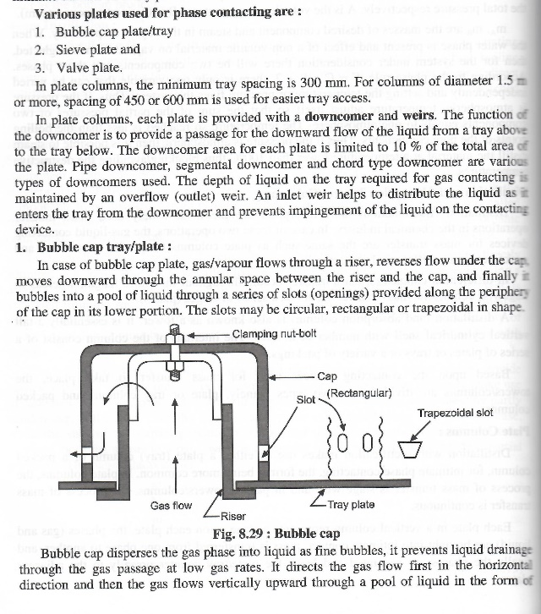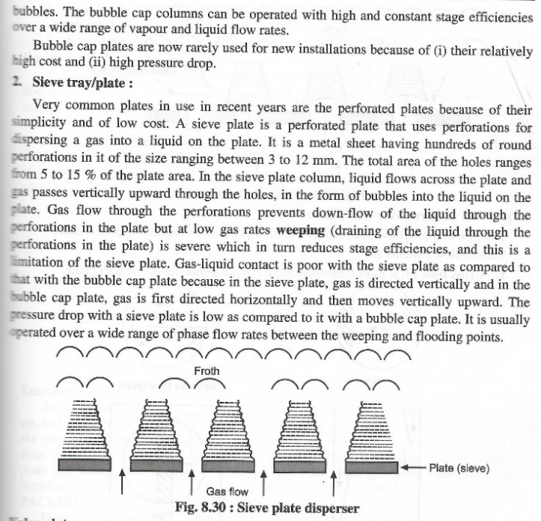

**5.c.A fractionating column is designed to separate 15000 kg/h of feed containing 60% toluene and 40% benzene into an overhead product containing 97% benzene and a waste containing 98% toluene. All % are by weight. Calculate the weights of the product and waste product per hour.**

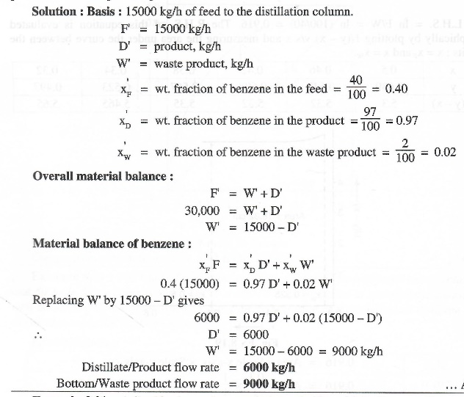

**5.d. 100 kmol/h of a feed containing 35 mole% methanol is to be continuously distilled in a fractionating column to get 96.5 mole% methanol as a distillate and 10mole% methanol as a bottom product. Find the molal flow rates of the distillate and the bottoms.**

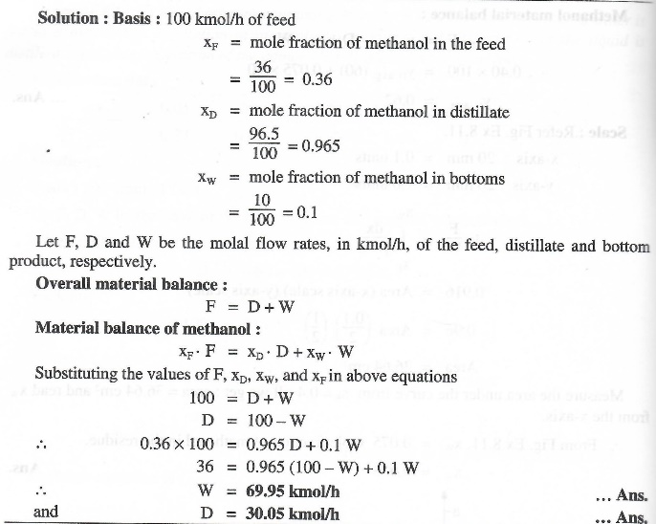

6.a. A steam of air (dry bulb temperature = 70OC; wet bulb temperature = 60OC) is dehumidified and cooled in contact with water entering at 26OC. The outlet air is essentially at thermal equilibrium with the water. Calculate the wet-bulb temperature of the outlet air and the moisture removed per kg of dry air.

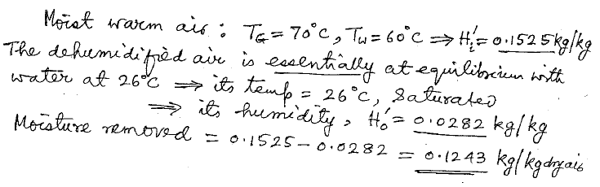

6.b. Explain the psychrometric chart and its use

|  |  |
| --- | --- |
|  |  |
|  | |

6.c. A stream of air (dry-bulb temperature = 80OC; wet-bulb temperature = 27OC; 4000 kg/h.m2, dry basis) is contacted with water maintained at the adiabatic saturation temperature of the gas. The gas leaves the tower 95% saturated. Calculate the overall gas-phase transfer units and the makeup water to be supplied.

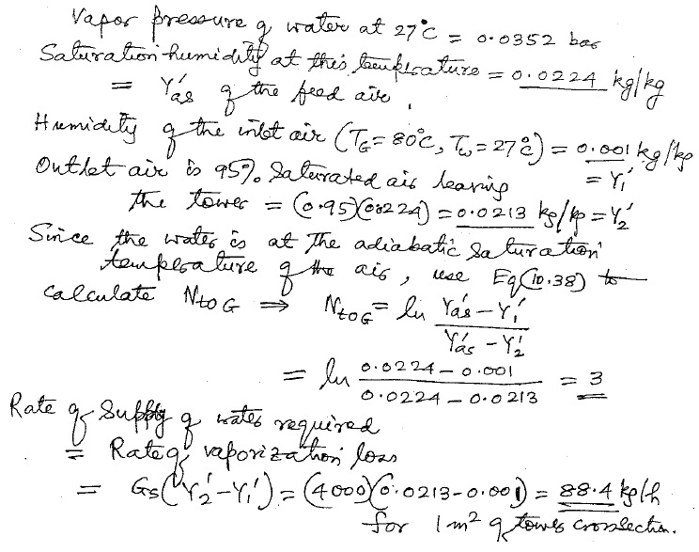

**6.d. Why does the internal passage for moist air in a crossflow induced draft tower have a V-shape? Why does such a tower need less fan power than counter flow one for the same air rate?**

Since air enters into the tower laterally, the cumulative air rate increases along the height. The V-shape passage allows gradually increasing flow area up the packing in order to accommodate the increasing air rate. Since the horizontal length of the flow path of air through the packing is less than the vertical flow path in counter flow tower, the pressure drop is less in a cross flow tower.

**7.a. Derive the equation for overall mass transfer coefficient.**

|  |  |  |
| --- | --- | --- |
| E:\JAN-MAY 2021\GIET QUESTION PAPER\7a.jpg | E:\JAN-MAY 2021\GIET QUESTION PAPER\7a-1.jpg | E:\JAN-MAY 2021\GIET QUESTION PAPER\7a2.jpg |

**7.b. Write a short note on tray efficiency and murphree efficiency**

|  |  |
| --- | --- |
|  | E:\JAN-MAY 2021\GIET QUESTION PAPER\7b-2.jpg |

**7.c. A mixture (40 mole% vapour, the rest liquid) of aniline and nitrobenzene (80 mole% aniline) is separated into a distillate having 98 mole% aniline and a bottom product with 3 mole% aniline. The reflux ratio used is 2.2. (a) Determine the equations of the operating lines and of the feed line. (b) Write down the same equations if the column operates at total reflux.**

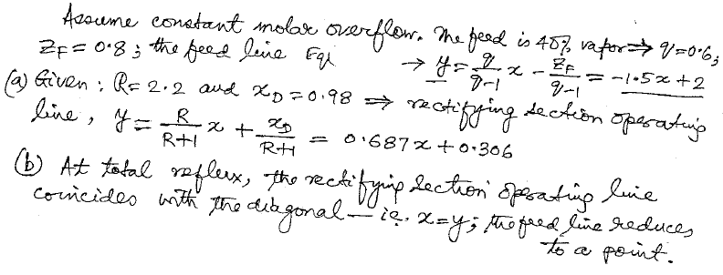

**7.d. A cooling tower has a rating of 10000 gph of warm water to be cooled from 45OC to 28OC. The TDS of the water in circulation should be limited to 600 ppm and that of the makeup water is known to be 250 ppm. Estimate the rate of blow down and the makeup water necessary.**

