|  |  |
| --- | --- |
| D:\VK\GIET LOGO.jpg | **GIET UNIVERSITY, GUNUPUR – 765022**  B. Tech (Fourth Semester – Regular) Examinations, April / May – 2021  **Geo Technical Engineering-1**  **Civil Engineering** |
| Time: 3 hrs Maximum: 70 Marks | |

**Answer ALL Questions**

**Paper-1 key**

**PART – A: (Multiple Choice Questions)**

a) Ans: (iv) All of the above

b)Ans: (i) - e = n⁄(1-n)

c) Ans: (iv) both a and b

d)Ans; (iii) Gap-graded soil

e)Ans; (iii) Plastic limit – shrinkage limit

f)Ans: (iii)Unified soil classification

g)Ans: (ii) Decreases

h)Ans: (ii) as square of grain size

i)Ans: (iv)All of the above

j) Ans: (ii) Cohesion

**PART – B: (Short Answer Questions)**

a) Ans: Stokes' Law is a formula for determining the rate of sedimentation. It states that a particle moving through viscous liquid attains a constant velocity or sedimentation rate.

The rate can be very slow for particles whose density is close to that of the liquid, for particles whose diameter is small, or where the viscosity is high.

Replacing gravitational acceleration with the acceleration generated by a rotating centrifuge results in faster sedimentation.

 Centrifugal acceleration can be thousands of times greater than that of gravity, so the centrifugal sedimentation rate is thousands of times greater.

b) Ans:Void ratio:

Voids ratio e of a given soil sample is the ratio of the volume of voids to the volume of soil solids in the given soil mass.

e=Vv /Vs

Degree of saturation:

Degree of saturation : In a given volume of voids of a sample, some space is occupied by water and the rest by air. In a fully saturated sample, the voids get completely filled with water. The degree of saturation S is defined as the ratio of the volume of water present in a given soil mass to the total volume of voids in it.Thus,

S=Vw/Vv

The degree of saturation is usually expressed as a percentage and is also known as percent saturation.

For a fully saturated sample Vw = Vv and hence S = 1.

For a perfectly dry sample, Vw = zero, and hence S = 0.

c) Ans: Soil index properties are properties which facilitate identification and classification of soils for engineering purposes. Plastic soils (clays) are normally described as cohesive as a distinction from non-plastic soils (sands and gravels) which are often called granular or non-cohesive. Plastic and cohesive are used as synonyms bearing in mind that all plastic soils are cohesive and cohesive soils are plastic. Fundamentally, electrochemical cohesion and geotechnical cohesion measured by a triaxial are very different. Cohesion in clays does not always translate to measurable cohesion that confers shear strength. The 3D network of attraction between negative particles and positive cations leads to plasticity.    The nature of some properties differs for coarse- and fine-grained soils.

d) Ans: Darcy’s law states the principle which governs the movement of fluid in the given substance. Darcy’s law equation that describes the capability of the liquid to flow via any porous media like a rock. The law is based on the fact according to which, the flow between two points is directly proportional to the pressure differences between the points, the distance, and the connectivity of flow within rocks between the points. Measuring the inter-connectivity is known as permeability.

Darcy’s law can be applied to many situations but do not correspond to these assumptions.

* Unsaturated and Saturated flow.
* Flow in fractured rocks and granular media.
* Transient flow and steady-state flow.
* Flow in aquitards and aquifers.
* Flow in Homogeneous and heterogeneous systems.

e) Ans : A flow net is a grid obtained by drawing a series of equipotential lines and streamlines. Flow net is very much useful in analysing the two dimensional, irrotational flow problems. Usually, the flow net is a square mesh. However in regions, where the boundaries converge or diverge or bend, the flow net does not contain squares.

Applications of Flow net  
The flow net helps in depicting and analysing the behavior of irrotational flow. Many flow phenomena which cannot be analysed easily by mathematical means can be analysed by drawing flow nets.  
  
The following are some of the important uses of flow net analysis -  
(i) For given boundaries of flow, the velocity and pressure distribution can be determined, if the velocity distribution and pressure at any reference section are known.  
(ii) Loss of flow due to seepage in earth dams and unlined canals can be evaluated.  
(iii) Uplift pressures on the underside (bottom) of the dam can be worked out.  
(iv) Outlets can be designed for their streamlining.

f) Ans:

Compaction is a process by which the soil particles are artificially rearranged and

packed together into a closer strata of contact by mechanical means in order to

decrease the porosity ( or voids ratio) of the soil and thus increase its dry density.

AIM:

• To increase the shear strength soil

• To improve stability and bearing capacity

• To reduce the compressibility

• To reduce the permeability of the soil.

g) Ans: According to Terzaghi : “Every process involving a decrease in the water content of a

saturated soil without replacement of the water by air is called a process of consolidation.

h) Ans: The shear strength of soil is determined in laboratory by the following methods

• Direct Shear

• Un confined compression test

• Tri axial Test

• Vane Shear Test

i) Ans: It is the principle engineering property which controls the stability of a soil mass

under loads. The shear strength of soil is the resistance to deformations by continuous shear displacement of soil particles.

j) Ans : The graphical method for the determination of stresses on a plane inclined to the

principal stress is called Mohr’s wide. The characteristics are

• The maximum angle of obliquity max is obtained by drawing a tangent to the

circle from the origin o.

• Shear stresses plane at right angle to each other are numerically equal but

are of opposite signs.

**PART – C: (Long Answer Questions)**

3) a) Ans:

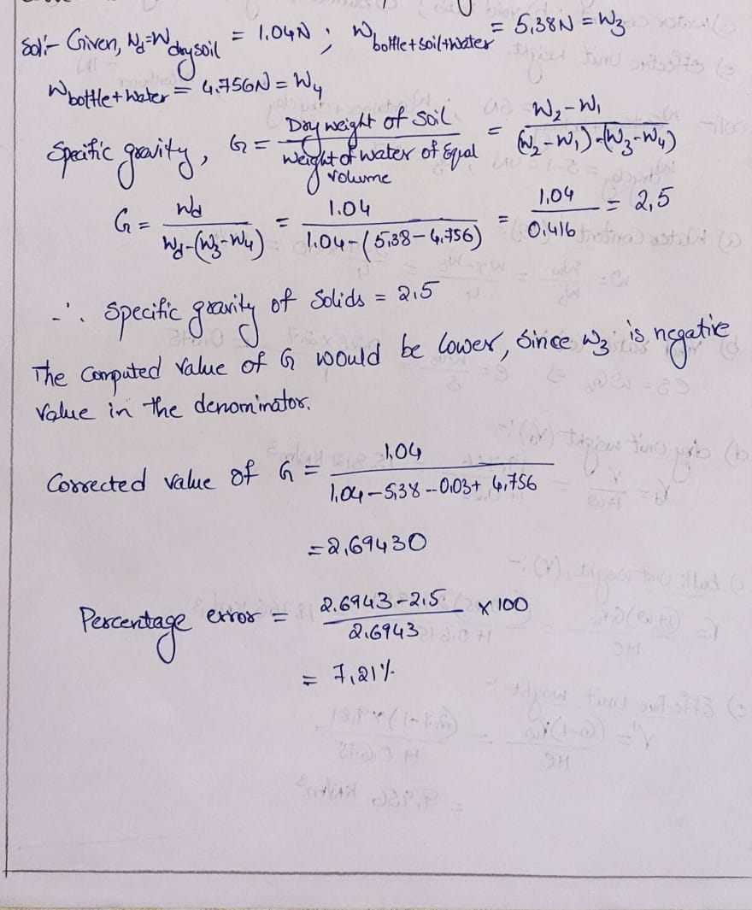

#### 3) b) Ans: Pycnometer Method:

The pycnometer method is a rapid method of water content determination for soils whose specific gravity is accu­rately known. The method is suitable for coarse-grained soils only as the entrapped air is likely to cause a signifi­cant error in water content determination for fine-grained soils.

Pycnometer is a density bottle of 900 mL capacity. A brass conical cap is used as a cover. The conical cap is always screwed to the pycnometer up to the mark on the pycnometer to give the designated volume of 900 mL. A rubber washer is placed inside the conical cap to prevent the leakage of water through the walls of the pycnometer and the conical cap.

Procedure:

The principle of water content determination by pycnometer method is illustrated in Fig. 4.16.

[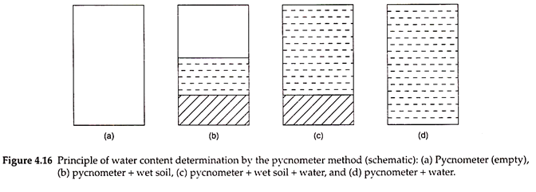](https://www.soilmanagementindia.com/wp-content/uploads/2018/02/clip_image006-1.png)

i. The weight of a clean and dry pycnometer with the cap is taken and recorded (W1).

ii. About 200-400 g of a wet soil sample is placed in the pycnometer and the weight of the pycnometer with cap and wet soil is taken (W2).

iii. Water is added to the pycnometer in increments and the contents are mixed using a glass rod. Care should be taken to remove the entrapped air completely by mixing the contents thoroughly. A vacuum pump may also be used for this purpose.

iv. The pycnometer is then completely filled with water up to the hole in the conical cap. The outside surface of the pycnometer is wiped with a cloth. The weight of the pycnometer with wet soil and water is taken (W3).

v. The contents of the pycnometer are then removed and the pycnometer is washed thoroughly. The pycnometer is again filled with water completely up to the hole in the conical cap. The outside surface of the pycnometer is wiped with a cloth and the weight of pycnometer with water is taken (W4).

vi. The water content of the soil is computed using the following equation:

[https://www.soilmanagementindia.com/wp-content/uploads/2018/02/clip_image008_thumb-1.jpg](https://www.soilmanagementindia.com/wp-content/uploads/2018/02/clip_image008-3.jpg)

The advantage of the pycnometer method is that drying of the soil is not required for determination of water content. However, entrapped air can become a source of serious error in this method. Also, the accuracy of the water content obtained through this method is dependent on the accuracy of the specific gravity used in calculations. The method is not recommended by IS – 2720 (Part 2) – 1973, which is the code of practice for water content determination.

Derivation of Expression for Water Content in Pycnometer Method:

Referring to Fig. 4.16, water content will be –

ω = Ww/Wd

and the weight of water in wet soil will be –

Ww = (W2 – W1) – Wd

Here, W2 and W1 are known.

The weight of dry soil (Wd) is determined as follows:

G = γs/γw = Wd/Vsγw Þ Vsγw = Wd/G

[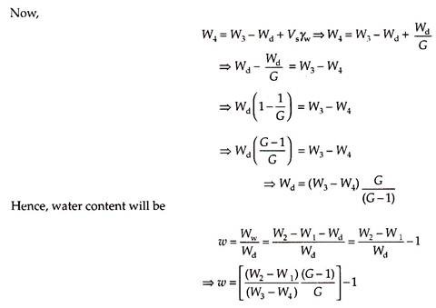](https://www.soilmanagementindia.com/wp-content/uploads/2018/02/clip_image010-3.jpg)

3) c) Ans; Acoording to unified classification system - CL (3M)

Acoording to Indian Standard classification system – CI (3M)

3) d) Ans: 0.736 , 0.992 ( each 2M)

4) a) Ans: For formula – 1M

And for finding coefficient of permeability (k) at 0.5 = 1.65* 10^-4 cm/sec – 3M

4) b) Ans: For horizontal the coefficient of permeability (k) = 0.0294mm/sec - 3M

For vertical the coefficient of permeability (k) = 2.5 * 10^-4 mm/sec – 3M

4)c) Ans: 66.23* 10^3 m^3/year -6M

4)d) Ans: 0.0275cm/sec -4M

5) a) Ans: Finding

Mass of wet soil = 5067.19gm - 3M

Void ratio = 0.285 – 3M

5)b) Ans: Four points – 4M

|  | **Compaction** | **Consolidation** |
| --- | --- | --- |
| 1 | Compaction is a process where a mechanical pressure is used to compress the soil mass for the purpose of soil improvement. | Consolidation is a process where steady and static pressure causes compression of saturated soil. |
| 2 | Dynamic loads by rapid mechanical methods like tamping, rolling and vibration are applied for a small interval in soil compaction. | Static and sustained loading is applied for a long interval in soil consolidation. |
| 3 | In compaction process, soil volume is reduced by removing air void from the saturated and dry soil. | In consolidation process, soil volume is reduced by squeezing out pore water from the saturated soil. |
| 4 | Compaction of soil is mainly used for sandy soil. | Consolidation of soil is mainly used for clayey soil. |
| 5 | Compaction is intentionally done to produce a high unit weight of soil and consequently improve other soil properties. | Consolidation is a natural process where soil below the building and other structure compacted by the transferred load to the soil through the provided foundation system. |

5)c) Ans: change in void ratio = e0 – e = Cc log {(p0+change in p)/p0} - 1M

(i) Ans: change in void ratio = e0 – e = 0.041 – 2M

Settlement = (Cc* H/1+e0) log {(p0+change in p)/p0} - 1M

(ii) Ans: 8.32cm – 2M

5) d)Ans: the factors affecting the field compaction of soil are

Water content, compactive effort , type of soil, method of compaction - 4M

6)a) Ans:

(i) the angle which the failure plane makes with major principle plane = 55.9 degrees –3M

(ii) The major and minor principle stresses are 159kN/m^2 and 73KN/m^2 – 3M

6)b) Ans: The **triaxial test** has the following merits and demerits: -4M

**Merits of Triaxial Test**

* Triaxial test has complete control over the drainage conditions. Tests can be easily conducted for all three types of drainage conditions.
* Pore pressure and volumetric changes are possible to be measured directly.
* Stress distribution is uniform on the failure plane.
* Another advantages is that the specimen will fail on its weakest plane.
* The state of stress at all intermediate stages upto failure is known. It is possible to draw the mohr circle at any shear stage.
* The test is suitable for accurate research work. The apparatus is adaptable to special requirements such as extension test and tests for different stress paths.

**Demerits of Triaxial Test**

* Triaxial apparatus is expensive.
* In the [direct shear test](https://civilengineersforum.com/direct-shear-test-merits-demerits/), the drained test takes shorter period.
* It is impossible to calculate cross sectional area of the specimen accurately at large strains, as the assumption that the specimen remains cylindrical does not hold good.
* The test simulates only axis-symmetrical problems. In the field, the problem is generally 3-dimentional. A general test in which all the three stresses are varied would be more useful.
* Specimen consolidation in the triaxial test is isotropic; whereas in the field, the consolidation is generally anisotropic.

Despite the above mentioned demerits, triaxial test is extremely useful. It is the only reliable test for accurate determination of the shear characteristics of all types of soils and under all the drainage conditions.

6)c) Ans: **Demerits of direct shear test**

* The stress condition is known only at failure. The conditions prior to failure are indeterminate and, therefore, the mohr circle cannot be drawn.
* In direct shear test ,the stress distribution on the failure plane (horizontal plane) is not uniform. The stresses are more at the edges and lead to the progressive failure, like tearing of a paper. Consequently, the full strength of the soil is not mobilised simultaneously on the entire failure plane.
* The area under shear gradually decreases as the test progresses. But the corrected area cannot be determined and therefore, the original area is taken for the computation of stresses.
* The orientation of failure plane is fixed. This plane may not be the weakest plane.
* Control on the drainage conditions is very difficult. So, only drained tests can be conducted on highly permeable soils.
* The measurement of pore water pressure is not possible in direct shear test.
* The side walls of the shear box cause lateral restraint on the specimen and do not allow it to deform laterally.

6)d) Ans: shear strength would be expected in the direct shear test when the normal stress is 240KN/m^2 is 160.7KN/m^2 - 6M