**BPCEC4030– SEMICONDUCTOR DEVICES SET-1 Answer Key**

**Part-A MCQ**

1. Covalent
2. Negative
3. +ve terminal to p and –ve terminal to n
4. Ec
5. Fixed donor and acceptor ions
6. saturation and cutoff regions
7. IC/IB
8. Can be operated as an enhancement MOSFET by applying +ve bias to gate
9. Metal oxide semiconductor FET
10. JFET and MOSFET

**Part-B**

1. The energy band definition is, the number of atoms within [a crystal stone](https://www.elprocus.com/piezoelectric-crystal-working-and-applications/) can be nearer to each other as well as a number of electrons will interact with each other. The energy levels of electrons within their shell can be caused due to the changes in their energy levels. The main feature of [the energy](https://www.elprocus.com/what-are-types-of-renewable-energies/) band is that the electron’s energy states of electronics are stable in different ranges. So, the level of energy of an atom will change in conduction bands & valence bands.
2. Charge carrier density, also known as carrier concentration, denotes the number of [charge carriers](https://en.wikipedia.org/wiki/Charge_carriers) in per [volume](https://en.wikipedia.org/wiki/Volume). In [SI units](https://en.wikipedia.org/wiki/SI_units), it is measured in m−3. As with any [density](https://en.wikipedia.org/wiki/Density), in principle it can depend on position. However, usually carrier concentration is given as a single number, and represents the average carrier density over the whole material.

Charge carrier densities involve equations concerning the [electrical conductivity](https://en.wikipedia.org/wiki/Electrical_conductivity) and related phenomena like the [thermal conductivity](https://en.wikipedia.org/wiki/Thermal_conductivity).

1. Doping concentration

In [semiconductor](https://en.wikipedia.org/wiki/Semiconductor) production, doping is the intentional introduction of impurities into an [intrinsic semiconductor](https://en.wikipedia.org/wiki/Intrinsic_semiconductor) for the purpose of modulating its electrical, optical and structural properties. The doped material is referred to as an [extrinsic semiconductor](https://en.wikipedia.org/wiki/Extrinsic_semiconductor). A semiconductor doped to such high levels that it acts more like a [conductor](https://en.wikipedia.org/wiki/Conductor_(material)) than a semiconductor is referred to as a [degenerate semiconductor](https://en.wikipedia.org/wiki/Degenerate_semiconductor).

In the context of [phosphors](https://en.wikipedia.org/wiki/Phosphor) and [scintillators](https://en.wikipedia.org/wiki/Scintillator), doping is better known as [activation](https://en.wikipedia.org/wiki/Activator_(phosphor)). Doping is also used to control the color in some pigments.

1. Einstein relationship between diffusion coefficient and mobility

D= μkBT Where,

*D* is the [diffusion coefficient](https://en.wikipedia.org/wiki/Fick%27s_law_of_diffusion);

*μ* is the "mobility", or the ratio of the particle's terminal [drift velocity](https://en.wikipedia.org/wiki/Drift_velocity) to an applied [force](https://en.wikipedia.org/wiki/Force), *μ* = *v*d/*F*;

*k*B is [Boltzmann's constant](https://en.wikipedia.org/wiki/Boltzmann%27s_constant);

*T* is the [absolute temperature](https://en.wikipedia.org/wiki/Absolute_temperature).

1. Explain the formation of PN Junction diode.

*P-n* junctions are formed by joining *n*-type and *p*-type semiconductor materials, as shown below. Since the *n*-type region has a high electron concentration and the *p*-type a high hole concentration, electrons diffuse from the *n*-type side to the *p*-type side. Similarly, holes flow by diffusion from the *p*-type side to the *n*-type side. If the electrons and holes were not charged, this diffusion process would continue until the concentration of electrons and holes on the two sides were the same, as happens if two gasses come into contact with each other. However, in a *p-n* junction, when the electrons and holes move to the other side of the junction, they leave behind exposed charges on dopant atom sites, which are fixed in the crystal lattice and are unable to move. On the *n*-type side, positive ion cores are exposed. On the *p*-type side, negative ion cores are exposed. An electric field **E** forms between the positive ion cores in the *n*-type material and negative ion cores in the *p*-type material. This region is called the "depletion region" since the electric field quickly sweeps free carriers out, hence the region is depleted of free carriers. A "built-in" potential Vbi is formed at the junction due to **E**. The animation below shows the formation of the **E** at the junction between *n* and *p*-type material.

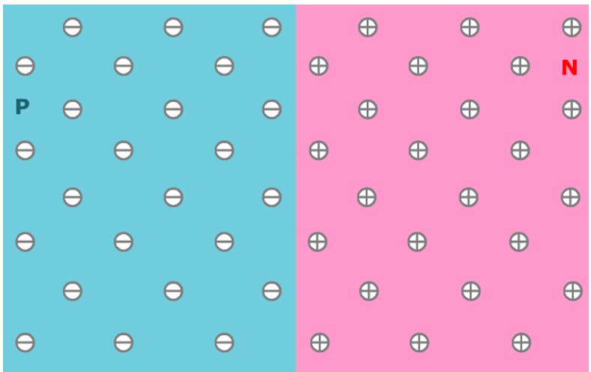

1. Need for biasing

If a signal of very small voltage is given to the input of BJT, it cannot be amplified. Because, for a BJT, to amplify a signal, two conditions have to be met.

* The input voltage should exceed cut-in voltage for the transistor to be ON.
* The BJT should be in the active region, to be operated as an amplifier.

1. Define Ohmic contact

An ohmic contact is a non-[rectifying](https://en.wikipedia.org/wiki/Rectifier) [electrical junction](https://en.wikipedia.org/wiki/Electrical_junction): a junction between two conductors that has a linear [current–voltage](https://en.wikipedia.org/wiki/Current%E2%80%93voltage_characteristic) (I-V) curve as with [Ohm's law](https://en.wikipedia.org/wiki/Ohm%27s_law). Low resistance ohmic contacts are used to allow charge to flow easily in both directions between the two conductors, without blocking due to rectification or excess power dissipation due to voltage thresholds.

1. Punch through mechanism

The punch through mechanism is described as reverse bias applied to drain, which results into extended depletion region. The two depletion regions of drain and source therefore are intersectional with each other, and this results into "one" depletion region, and flow of leakage current and consequently breakdown of MOSFET.

1. Draw basic MOS structure

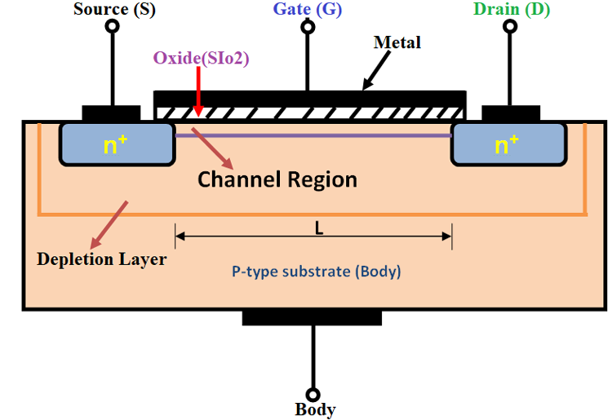

1. Advantages of LED
2. The cost of LED’s is less and they are tiny.
3. By using the LED’s electricity is controlled.
4. The intensity of the LED differs with the help of the microcontroller.
5. Long Lifetime
6. Energy efficient
7. No warm-up period
8. Rugged
9. Doesn’t affect by cold temperatures
10. Directional
11. Color Rendering is Excellent
12. Environmentally friendly
13. Controllable

**Part-C**

3.a Explain in detail about fermi energy

The Fermi energy is a concept in [quantum mechanics](https://en.wikipedia.org/wiki/Quantum_mechanics) usually referring to the energy difference between the highest and lowest occupied single-particle states in a quantum system of non-interacting [fermions](https://en.wikipedia.org/wiki/Fermion) at [absolute zero](https://en.wikipedia.org/wiki/Absolute_zero) [temperature](https://en.wikipedia.org/wiki/Temperature). In a [Fermi gas](https://en.wikipedia.org/wiki/Fermi_gas), the lowest occupied state is taken to have zero kinetic energy, whereas in a metal, the lowest occupied state is typically taken to mean the bottom of the [conduction band](https://en.wikipedia.org/wiki/Conduction_band).

The term "Fermi energy" is often used to refer to a different yet closely related concept, the [Fermi *level*](https://en.wikipedia.org/wiki/Fermi_level) (also called [electrochemical potential](https://en.wikipedia.org/wiki/Electrochemical_potential)).[[note 1]](https://en.wikipedia.org/wiki/Fermi_energy#cite_note-1) There are a few key differences between the Fermi level and Fermi energy, at least as they are used in this article:

* The Fermi energy is only defined at absolute zero, while the Fermi level is defined for any temperature.
* The Fermi energy is an energy *difference* (usually corresponding to a [kinetic energy](https://en.wikipedia.org/wiki/Kinetic_energy)), whereas the Fermi level is a total energy level including kinetic energy and potential energy.
* The Fermi energy can only be defined for [non-interacting fermions](https://en.wikipedia.org/wiki/Fermi_gas) (where the potential energy or band edge is a static, well defined quantity), whereas the Fermi level remains well defined even in complex interacting systems, at thermodynamic equilibrium.

Since the Fermi level in a metal at absolute zero is the energy of the highest occupied single particle state, then the Fermi energy in a metal is the energy difference between the Fermi level and lowest occupied single-particle state, at zero-temperature.

In [quantum mechanics](https://en.wikipedia.org/wiki/Quantum_mechanics), a group of particles known as [fermions](https://en.wikipedia.org/wiki/Fermion) (for example, [electrons](https://en.wikipedia.org/wiki/Electron), [protons](https://en.wikipedia.org/wiki/Proton) and [neutrons](https://en.wikipedia.org/wiki/Neutron)) obey the [Pauli exclusion principle](https://en.wikipedia.org/wiki/Pauli_exclusion_principle). This states that two fermions cannot occupy the same [quantum state](https://en.wikipedia.org/wiki/Quantum_state). Since an idealized non-interacting Fermi gas can be analysed in terms of single-particle [stationary states](https://en.wikipedia.org/wiki/Stationary_state), we can thus say that two fermions cannot occupy the same stationary state. These stationary states will typically be distinct in energy. To find the ground state of the whole system, we start with an empty system, and add particles one at a time, consecutively filling up the unoccupied stationary states with the lowest energy. When all the particles have been put in, the Fermi energy is the kinetic energy of the highest occupied state.

As a consequence, even if we have extracted all possible energy from a Fermi gas by cooling it to near [absolute zero](https://en.wikipedia.org/wiki/Absolute_zero) temperature, the fermions are still moving around at a high speed. The fastest ones are moving at a velocity corresponding to a kinetic energy equal to the Fermi energy. This speed is known as the Fermi velocity. Only when the temperature exceeds the related Fermi temperature, do the electrons begin to move significantly faster than at absolute zero.

The Fermi energy is an important concept in the [solid state physics](https://en.wikipedia.org/wiki/Solid_state_physics) of metals and [superconductors](https://en.wikipedia.org/wiki/Superconductor). It is also a very important quantity in the physics of [quantum liquids](https://en.wikipedia.org/wiki/Superfluid) like low temperature [helium](https://en.wikipedia.org/wiki/Helium) (both normal and superfluid 3He), and it is quite important to [nuclear physics](https://en.wikipedia.org/wiki/Nuclear_physics) and to understanding the stability of [white dwarf stars](https://en.wikipedia.org/wiki/White_dwarf) against [gravitational collapse](https://en.wikipedia.org/wiki/Gravitational_collapse).

3. c. Explain in detail about intrinsic semiconductor

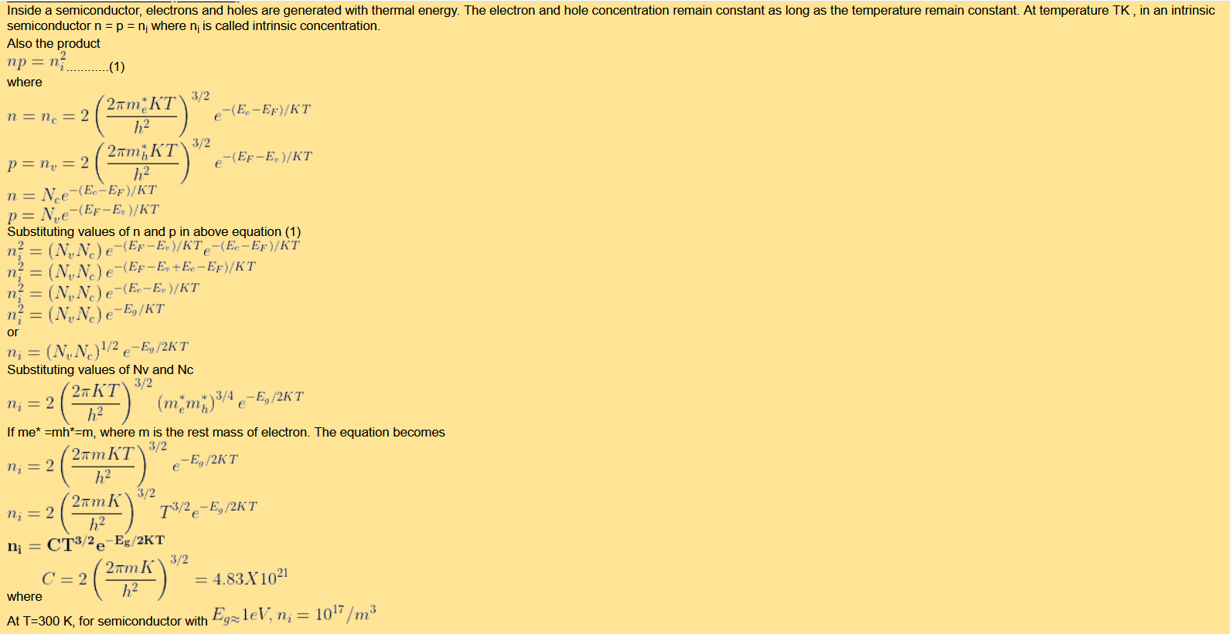

4.a How Carrier generation and recombination take place in semiconductors?

In the [solid-state physics](https://en.wikipedia.org/wiki/Solid-state_physics) of [semiconductors](https://en.wikipedia.org/wiki/Semiconductor), carrier generation and carrier recombination are processes by which mobile [charge carriers](https://en.wikipedia.org/wiki/Charge_carrier) ([electrons](https://en.wikipedia.org/wiki/Electron) and [electron holes](https://en.wikipedia.org/wiki/Electron_hole)) are created and eliminated. Carrier generation and recombination processes are fundamental to the operation of many [optoelectronic](https://en.wikipedia.org/wiki/Optoelectronics) [semiconductor devices](https://en.wikipedia.org/wiki/Semiconductor_device), such as [photodiodes](https://en.wikipedia.org/wiki/Photodiode), [light-emitting diodes](https://en.wikipedia.org/wiki/Light-emitting_diode) and [laser diodes](https://en.wikipedia.org/wiki/Laser_diode). They are also critical to a full analysis of [p-n junction](https://en.wikipedia.org/wiki/P-n_junction) devices such as [bipolar junction transistors](https://en.wikipedia.org/wiki/Bipolar_junction_transistor) and p-n junction [diodes](https://en.wikipedia.org/wiki/Diode).

The electron–hole pair is the fundamental unit of generation and recombination in [inorganic semiconductors](https://en.wikipedia.org/wiki/Semiconductor), corresponding to an electron transitioning between the valence band and the conduction band where generation of electron is a transition from the valence band to the conduction band and recombination leads to a reverse transition.

Like other solids, semiconductor materials have an [electronic band structure](https://en.wikipedia.org/wiki/Electronic_band_structure) determined by the crystal properties of the material. Energy distribution among electrons is described by the [Fermi level](https://en.wikipedia.org/wiki/Fermi_level) and the [temperature](https://en.wikipedia.org/wiki/Temperature) of the electrons. At [absolute zero](https://en.wikipedia.org/wiki/Absolute_zero) temperature, all of the electrons have energy below the Fermi level; but at non-zero temperatures the energy levels are filled following a Boltzmann distribution.

In undoped semiconductors the Fermi level lies in the middle of a *forbidden band* or [band gap](https://en.wikipedia.org/wiki/Band_gap) between two *allowed bands* called the [*valence band*](https://en.wikipedia.org/wiki/Valence_band) and the [*conduction band*](https://en.wikipedia.org/wiki/Conduction_band). The valence band, immediately below the forbidden band, is normally very nearly completely occupied. The conduction band, above the Fermi level, is normally nearly completely empty. Because the valence band is so nearly full, its electrons are not mobile, and cannot flow as electric current.

However, if an electron in the valence band acquires enough energy to reach the conduction band (as a result of interaction with other [electrons](https://en.wikipedia.org/wiki/Electron), [holes](https://en.wikipedia.org/wiki/Electron_hole), [photons](https://en.wikipedia.org/wiki/Photon), or the [vibrating crystal lattice itself](https://en.wikipedia.org/wiki/Phonon)), it can flow freely among the nearly empty conduction band energy states. Furthermore, it will also leave behind a hole that can flow as current exactly like a physical charged particle.

Carrier generation describes processes by which electrons gain energy and move from the valence band to the conduction band, producing two mobile carriers; while recombination describes processes by which a conduction band electron loses energy and re-occupies the energy state of an electron hole in the valence band.

These processes must conserve both quantized energy and [crystal momentum](https://en.wikipedia.org/wiki/Crystal_momentum), and the [vibrating lattice](https://en.wikipedia.org/wiki/Phonon) plays a large role in conserving momentum as, in collisions, [photons](https://en.wikipedia.org/wiki/Photon) can transfer very little momentum in relation to their energy.

4.c With neat diagram discus about the formation of depletion layer in PN Junction diode.

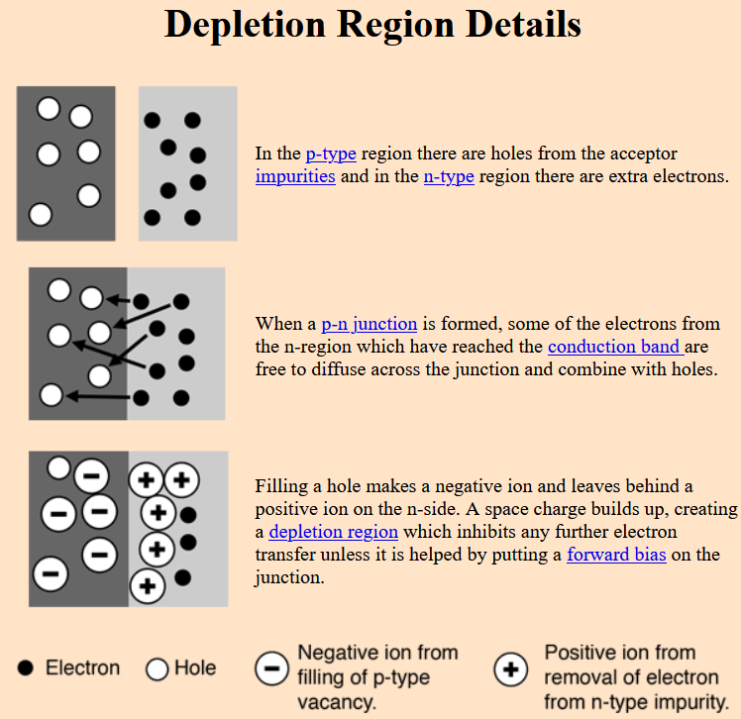

5.a Operation of BJT

The bipolar junction transistor (BJT) is manufactured with three semiconductor regions that are doped differently. If we’ve already lost you with that last sentence, please go check out some of our other [tutorials on the basics of semiconductors](https://www.circuitbread.com/tutorials/tags/semiconductor), as it’ll make this a lot easier to understand. These three regions that are doped differently are known as the base, collector, and emitter. The base region is lightly doped and is very thin compared to the collector and emitter regions. The collector region is moderately doped while the emitter region is heavily doped.

Bipolar junction transistors can be an npn or a pnp type. The npn type consists of two n regions separated by a p region. The base region is the p-type material while the collector and emitter regions are n-type materials. In pnp type, the transistor consists of two p-type regions, the collector and emitter, separated by an n-type base region. Regardless of the type, a BJT has two pn junctions that must be correctly biased with an external DC voltage to operate properly. One of these junctions is called the base-emitter junction, connecting the base and emitter regions and the other one is the base-collector junction, connecting the base and collector regions.

## Basic BJT Operation

In order for a bipolar junction transistor to operate as an amplifier, its base-emitter junction must be forward-biased while the base-collector junction is reverse-biased - please note that this means that an npn transistor and a pnp transistor are backwards compared to each other. And, as mentioned earlier, the emitter region is heavily doped. So in an npn transistor, the n-type emitter region has a very high density of free electrons while in a pnp transistor the p-type emitter region has a very high density of holes.

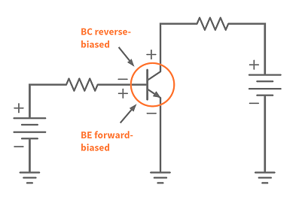NPN BJT Bias Arrangement

At this point, I’d like to remind you that current and electron flow are backwards, which may cause confusion. Since the base-emitter junction is forward-biased, free electrons from the emitter region easily cross the base-emitter junction and go into the very thin and lightly doped p-type base region. The p-type base region is just lightly doped, which means that, it doesn’t have that many holes in it. In this case, only a small percentage of the free electrons from the emitter region can recombine with the holes in the base region.

The small number of free electrons from the emitter region that recombined with the holes in the base region move through the base region as valence electrons. But when they leave the base region and move through the metallic base lead, they become free electrons and produce the external base current, which then goes out through the metallic lead, into the external circuit, and then, eventually, return to the emitter region.

The free electrons that entered the base region but didn’t recombine with the holes move toward the reverse-biased base-collector junction. Since the collector region is connected to the positive side of the external bias voltage, the free electrons are attracted to the positive side and are swept across into the collector region. They exit the collector region and and also move through the metallic collector lead, into the circuit, and return into the emitter region. So in this case, we know that the emitter current is the sum of the base and collector currents. Therefore, the emitter current is slightly greater than the collector current.

The operation inside a pnp transistor is very similar to the npn type. But the roles of the electrons and holes are swapped. The external bias voltages and the current directions are all reversed.

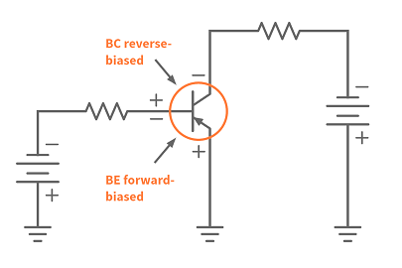PNP BJT Bias Arrangement

If you try to understand it, reversing the external bias voltages will forward bias the base-emitter junction of a PNP transistor and reverse bias the base-collector junction. Since the base-emitter junction is forward-biased, holes in the emitter region can move through the base-emitter junction and enter the base region. At the same time, electrons in the base region can also move into the emitter region. Inside the PNP transistor, the emitter current is due to the movement of holes from the emitter to the base region. But externally, emitter current is due to the movement of electrons from the emitter region to the positive terminal of the external bias voltage. The base current produced in a PNP transistor is due to the movement of electrons from the external bias voltage into the base region.

Since the base region is just lightly doped, only a small number of electrons in the base region recombine with the holes from the emitter region, and the rest of the holes move into the collector region. Internally, this movement of holes into the collector region produces the collector current but externally, the collector current is the flow of electrons from the external bias voltage into the collector region.

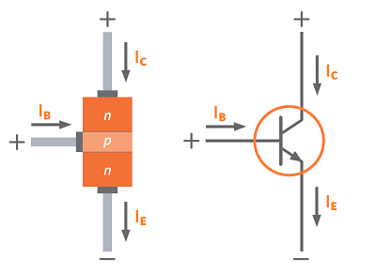D

Directions of the Currents in an NPN Transistor

If we compare the direction of the currents of an npn and a pnp transistor using conventional current flow, we’ll see that the flow of currents in the pnp transistor is just opposite to the flow of currents in the npn transistor.

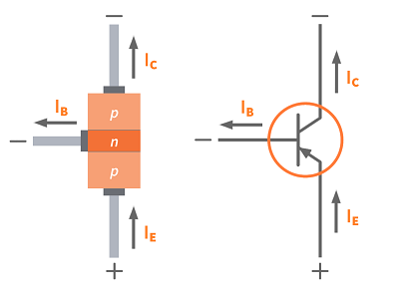

# 5.c Explain the I-V characteristics of Schottky Diode

# 

The **Schottky Diode** is another type of semiconductor diode but have the advantage that their forward voltage drop is substantially less than that of the conventional silicon pn-junction diode.

Schottky diodes have many useful applications from rectification, signal conditioning and switching, through to TTL and CMOS logic gates due mainly to their low power and fast switching speeds. TTL Schottky logic gates are identified by the letters LS appearing somewhere in their logic gate circuit code, e.g. 74LS00.

PN-junction diodes are formed by joining together a p-type and an n-type semiconductor material allowing it to be used as a rectifying device, and we have seen that when Forward Biased the depletion region is greatly reduced allowing current to flow through it in the forward direction, and when Reverse Biased the depletion region is increased blocking current flow.

The action of biasing the pn-junction using an external voltage to either forward or reverse bias it, decreases or increases respectively the resistance of the junction barrier. Thus the voltage-current relationship (characteristic curve) of a typical pn-junction diode is influenced by the resistance value of the junction. Remember that the pn-junction diode is a nonlinear device so its DC resistance will vary with both the biasing voltage and the current through it.

When forward biased, conduction through the junction does not start until the external biasing voltage reaches the “knee voltage” at which point current increases rapidly and for silicon diodes the voltage required for forward conduction to occur is around 0.65 to 0.7 volts as shown.

### PN-junction Diode IV-Characteristics

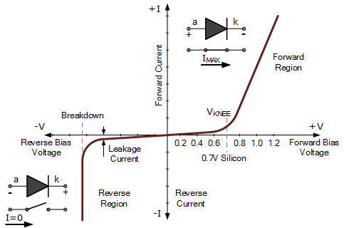

For practical silicon junction diodes, this knee voltage can be anywhere between 0.6 and 0.9 volts depending upon how it was doped during manufacture, and whether the device is a small signal diode or a much larger rectifying diode. The knee voltage for a standard germanium diode is, however much lower at approximately 0.3 volts, making it more suited to small signal applications.

But there is another type of rectifying diode which has a small knee voltage as well as a fast switching speed called a **Schottky Barrier Diode**, or just simply “Schottky Diode”. Schottky diodes can be used in many of the same applications as conventional pn-junction diodes and have many different uses, especially in digital logic, renewable energy and solar panel applications.

# 6.a Draw and explain energy band diagram of MOS capacitor in accumulation, depletion and inversion layer.

* MOS capacitor is an equilibrium device i.e. when the external voltage is not applied to the device the Fermi level of metal and semiconductor are at same level.
* When external voltage is applied to device it behaves according to the voltage applied with respect to flat band voltage and threshold voltage.
* Flat band voltage is defined as a work function difference between the gate metal and the semiconductor when no charge is present in oxide-semiconductor interface.
* Threshold voltage is defined as the minimum gate-to-source voltage required to induce or create a conducting channel. This can be divided into three types

**1. Accumulation layer:**

* In this case, applied voltage (*Vg*)
* is less than flat band voltage. Voltage applied to gate(on metal side) is negative

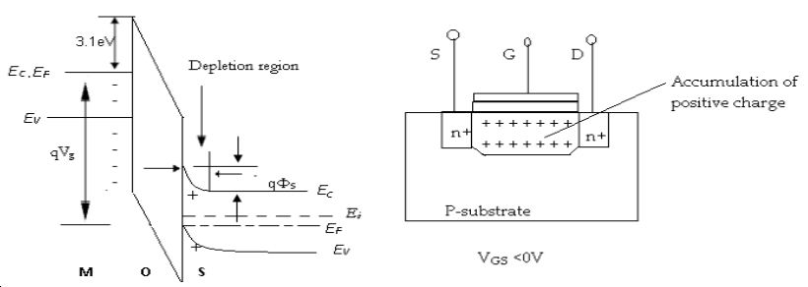

***Fig1 energy band diagram and MOSFET internal charge distribution in accumulation region***

Where

*EC* = conduction band energy level

*EF* = Fermi energy level

*EV* = valance band energy level

*Ei* = intrinsic energy level

Q = charge of electron

*Vg* =voltage applied on gate

Φ*s* =surface voltage

* When voltage is applied, mosfet no longer remain in equilibrium condition. The Fermi energy level of metal changes by charge of electron multiplied by applied voltage. Voltage applied is negative and hence rise in Fermi level of metal takes place while Fermi level of semiconductor remain constant
* Voltage applied to the gate is negative hence negative charge develops near metal-oxide junction thus positively charged hole travel towards the oxide junction thus creating positive charge near the oxide-semiconductor junction.
* Due to accumulation of positive charge, surface voltage is developed near oxide-semiconductor junction due to this energy band bending takes place and the value is charge of electron multiplied by surface voltage.
* Energy band bending is changes in energy offset (level) of semiconductor’s band structure near junction due to space charge.

**2. Depletion layer:**

* In depletion region, voltage applied to gate is greater than flat band voltage and less than threshold voltage.

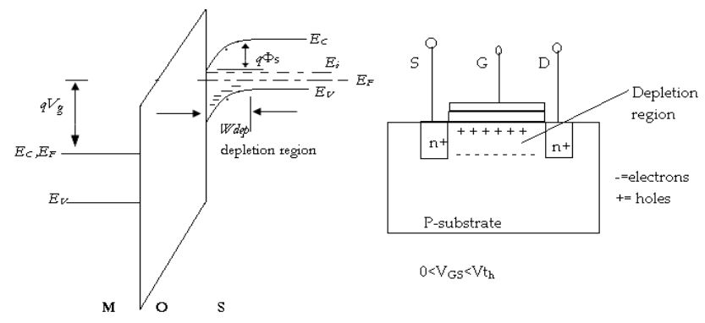

***Fig2 energy band diagram and MOSFET internal charge distribution in depletion region***

* In this case, voltage applied to gate is positive hence there is fall in Fermi energy level of metal while rise in Fermi energy level of semiconductor.
* Since voltage applied to positive and hence positive charge develops near metal-oxide junction thus the electrons travel towards the gate creating negative charge near oxide-semiconductor junction.
* Electrons recombine with holes present near oxide creating depletion region.
* Surface voltage develops in depletion region and effect of this we have energy band bending in depletion region.

**3. Inversion layer:**

* In inversion layer, applied voltage is greater than threshold voltage.
* The reason it is called as inversion layer as the surface is inverted from p-type to n-type near the junction.
* Voltage applied is very high hence Fermi level of metal goes down further
* Since voltage applied is positive to gate, electrons travel towards the gate and accumulates near semiconductor-oxide junction resulting development of surface potential. Due to surface potential energy band bending takes place.
* From the diagram p type substrate near semiconductor-oxide junction has intrinsic energy level below Fermi energy level and this part of substrate behave as n-type semiconductor and part above the Fermi level behave as p-type semiconductor. This happen due to concentration of electrons exceeds concentration of holes near semiconductor-oxide junction and the event is called as **surface inversion**.
* N-type semiconductor acts as a channel for current and current can flow through this channel on application of positive drain-source voltage.

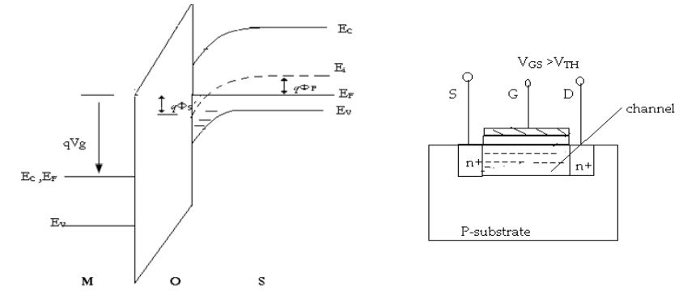

***Fig3 energy band diagram and MOSFET internal charge distribution in inversion region***

***6.c*** Introduction to the MOSFET

* The **MOSFET** is also known as metal oxide silicon transistor or MOS is a category of IGFET or insulated gate FET which is manufactured with the thermal oxidation of semiconductor material usually silicon.
* The voltage of the insulated gate calculates the electrical conductivity of transistor this behavior of variations in conductivity with quantity if given voltage can be used in amplifier and switching circuits.
* In 1959 first time MOSFET was created by the Egyptian engineer Mohamed M.Atalla and Dawon Kahng who was Korian engineer.
* This electronic component is most commonly used in electronic circuits and from 1960 to 2018 almost  (1.3 × 1022) MOSFETs have been created.
* It also used very commonly in digital, analog circuits and power instruments.
* The main benefits of MOSFET are that there is no need for input current to regulate load current is it required in [BJT](https://www.theengineeringknowledge.com/introduction-to-bjt-bipolar-junction-transistor/).
* The voltage given to the gate of E-MOSFET can increase the conductivity from off condition.
* While for D-MOSFET voltage given at gate can decrease the conductivity from on condition.
* The switching speed of this module is high, their size is small, uses less amount of power.

[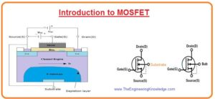](https://www.theengineeringknowledge.com/wp-content/uploads/2020/04/Introduction-to-MOSFET.jpg)

#### E-MOSFET (Enhancement MOSFET) Transistor

* The enhancement MOSFET functions only in the enhancement mode and there is no depletion-mode exits in it.
* The main difference between E-MOSFET and D-MOSFET is that in E MOSFET there is no structural channel.
* In below figure denoted as you can see that substrate has expands to the layer of silicon dioxide.

[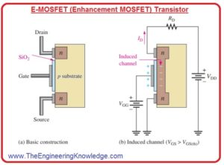](https://www.theengineeringknowledge.com/wp-content/uploads/2020/04/E-MOSFET-Enhancement-MOSFET.jpg)

* For n channel MOSFET the positive voltage at the gate over threshold value induces a channel by making a thin region of negative charges in substrate close to the silicon dioxide layer as shown in above figure denoted that ‘b’
* The conductive behavior of the channel increases with the increment in gate to source voltage that causes movement of electrons toward the channel region.
* The value of voltage less than threshold there is no channel exits.

**E-MOSFET Symbol**

* In below figure you can see the symbols for N and P channels E-MOSFET are shown.
* The dashes indicate that the physical channel does not exist.
* The inward substrate arrow indicates n channel and outward direction arrow show p channel.

[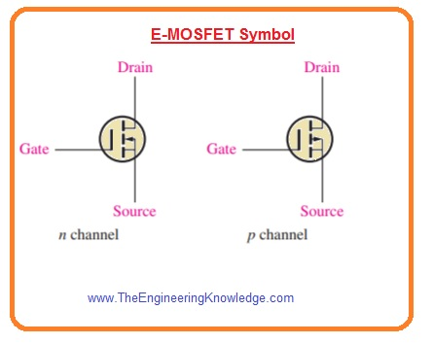](https://www.theengineeringknowledge.com/wp-content/uploads/2020/04/E-MOSFET-Symbol.jpg)

#### Depletion MOSFET (D-MOSFET)

* The second type of MOSFET is D MOSFET its structure is shown in below figure.

[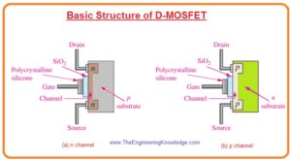](https://www.theengineeringknowledge.com/wp-content/uploads/2020/04/basic-structure-of-D-MOSFETs..jpg)

* In this structure drain and source are diffuse with the substrate substance and after than linked with the small area channel close to the insulated gate terminal.
* Both N and P channel D-MOSFET are shown in above figure.
* To understanding of basic operation we discuss the N channel D-MOSFET the working of P channel is also similar with the different voltage polarities.
* There are 2 operating mode of D MOSFET first is depletion mode an second is enhancement mode so it also known as depletion/enhancement MOSFET.
* As there is insulation among gate and channel so positive or negative voltage can be provided.
* The n channel MOSFET functions in depletion mode when we provide negative voltage to the gate to source and operate in enhancement mode when gate to source voltage is given.
* Normally it operates in depletion mode of operation.

**Depletion Mode**

* We consider the gate as first plate of the capacitor and channel as the second plate.
* the insulating layer of silicon dioxide is insulating material between them.
* Through Negative voltage at the gate conduction electrons bear the force of repulsion due to negative charges and positive ions are formed at their place.
* So electrons of N channel decreases that reduces the conductivity of the channel.
* The larger the negative voltage on the gate the increases the reduction of N channel electrons.
* At highly gate, to source voltage or VGS(off) the channel is completely depleted and the value of drain current is 0.
* In below figure denoted as ‘a’ depletion mode is explained.
* similar to the JFET the n channel D-MOSFET operates drain current for gate-to-source voltages among VGS(off) and 0.
* The D-MOSFET operates for values of VGS over 0.

**Enhancement Mode**

* Due to positive voltage across gate electrons moves toward the channel that increases the conductivity of channel it is explained in above figure denoted as ‘b’.

**D-MOSFET Symbols**

* The symbolic representation for both N and P channel D-MOSFET are shown in below figure.

[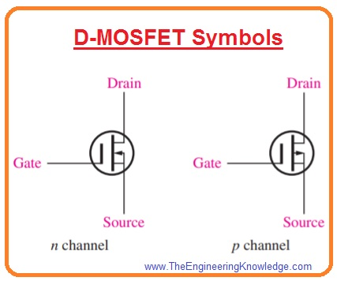](https://www.theengineeringknowledge.com/wp-content/uploads/2020/04/D-MOSFET-Symbols.jpg)