 | GIET UNIVERSITY, GUNUPUR – 765022  B. Tech (Fourth Semester – Regular) Examinations, April / May – 2021  Sub. Code – Fluid Mechanics & Hydraulics Machines  (Branch or Common to -------------)
Time: 3 hrs Maximum: 70 Marks

Answer ALL Questions
The figures in the right hand margin indicate marks.
PART – A: (Multiple Choice Questions) (1 x 10 = 10 Marks)

Q.1. Answer ALL questions |  |  | [CO#] | [PO#]
a. | The specific gravity of a liquid has
 | - the same unit as that of mass density | - the same unit as that of weight density | 1 | 1
 | - the same unit as that of specific volume | - no unit
b. | Which of the following contribute to the reason behind the origin of surface tension? |  | 1 | 1
 | - only cohesive forces | - only adhesive forces
 | - neither cohesive forces nor adhesive forces | - both cohesive forces and adhesive forces
c. | Which of the following is the correct relation between centroid (G) and the centre of pressure (P) of a plane submerged in a liquid? |  | 1 | 1
 | - G is always below P | - P is always below G
 | - G is either at P or below it. | - P is either at G or below it.
d. | What will be the shape of the pathline for an one-dimensional flow be like? |  | 2 | 1
 | - straight line | - parabolic
 | - hyperbolic | - elliptical
e. | When is orifice called ‘large orifice’? |  | 2 | 1
 | - If the head of liquid is less than 5 times the depth of orifice | - If the head of liquid is less than 2.5 times the depth of orifice
 | - If the head of liquid is less Hence, 4 times the depth of orifice | - If the head of liquid is less than 1.5 times the depth of orifice
f. | Which is the cheapest device for measuring flow / discharge rate. |  | 3 | 2
 | - Venturimeter | - Pitot tube
 | - Orificemeter | - None of the mentioned
g. | Which among the following is the correct formula to find out the shear modulus(G)? |  | 3 | 2
 | - E/2 | - v/2
 | - E/2(1+v) | - 2E(1+v)
h. | Which among the following is an assumption of Hagen-Poiseuille equation? |  | 4 | 2
 | - Fluid is compressible | - Fluid is uniform
 | - Fluid is laminar | - Fluid is turbulent
i. | A reciprocating pump is a class of _________ |  | 4 | 2
 | - Negative displacement | - Positive displacement
 | - Zero displacement | - Infinite displacement
j. | The force analysis on a curved vane is understood using______ |  | 4 | 2
 | - Velocity triangles | - Angle of the plate
 | (iii) Vane angles | (iv) Plate dimensions

PART – B: (Short Answer Questions) (2 x 10 = 20 Marks)

Q.2. Answer ALL questions |  | [CO#] | [PO#]
a. | Define Surface Tension.  Surface tension is defined as the tensile force acting on the surface of the liquid in contact with a gas or on the surface between two immiscible liquids such that the contact surface behaves like a membrane under tension. | 1 | 1
b. | List the types of fluid flow.  Steady and unsteady flow Uniform and non-uniform flow Laminar and Turbulent flow Compressible and incompressible flow Rotational and ir-rotational flow One,two and three dimensional flow. | 1 | 1
c. | List the instruments works on the basis of Bernoulli’s equation.  Venturi meter; Orifice meter; Pitot tube. | 1 | 1
d. | Define Vapour Pressure.  When vaporization takes place, the molecules start accumulating over the free liquid surface exerting pressure on the liquid surface. This pressure is known as Vapour pressure of the liquid. | 2 | 1
e. | Mention the range of Reynold’s number for laminar and turbulent flow in a pipe.  If the Reynold’s number is less than 2000, the flow is laminar. But if the Reynold’s number is greater than 4000, the flow is turbulent flow. | 2 | 1
f. | What is compound pipe or pipes in series?  When the pipes of different length and different diameters are connected end to end, then the pipes are called as compound pipes or pipes in series. | 2 | 2
g. | Define Priming of a centrifugal pump.  Priming of a centrifugal pump is defined as the operation in which the suction pipe, casing of the pump and a portion of the delivery pipe up to the delivery valve is completely filled up from outside source with the liquid to be raised by the pump before starting the pump. | 3 | 2
h. | How are fluid machines classified?  Fluid machines are classified into two categories depending upon transfer of energy: 1. Turbines – hydraulic energy is converted to mechanical energy and then electrical energy. 2. Pumps – electrical energy is converted to mechanical energy and then hydraulic energy. | 3 | 2
i. | Define volumetric efficiency.  The ratio of the volume of the water actually striking the runner to the volume of water supplied to the turbine is defined as volumetric efficiency | 4 | 2
j. | What is mean by Draft Tube?  The draft tube is a pipe of gradually increasing area which connects the outlet of the runner to the tail race. One end of the draft tube is connected to the outlet of the runner while the other end is sub-merged below the level of water in the tail race. | 4 | 2

PART – C: (Long Answer Questions) (10 x 4 = 40 Marks)

Answer ALL questions |  | Marks | [CO#] | [PO#]
3. a. | A tank of 1m length and of cross-section shown in fig. 3 a contains water. The tank is made of 4 mm steel plates.  (i) What is the force on the bottom due to water? (ii) What are the longitudinal tensile stresses in the side walls AB if (a) the tank is suspended from the top and (b) it is supported at the bottom?  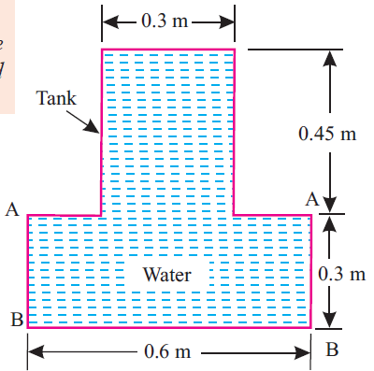  Figure 3b  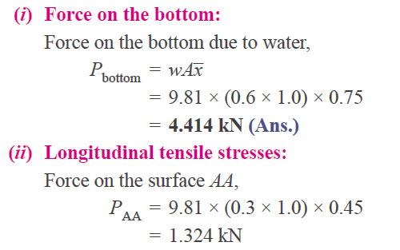  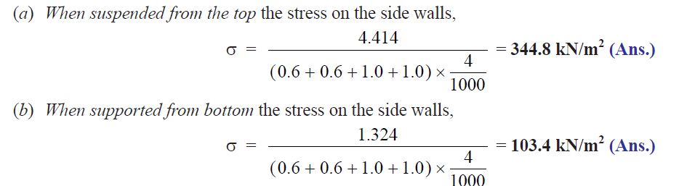 | 10
 | (OR)
b. | For the hydraulic jack shown in Fig. 3b find the load lifted by the large piston when a force of 400 N is applied on the small piston. Assume the specific weight of the liquid in the jack is 9810 N/m³.  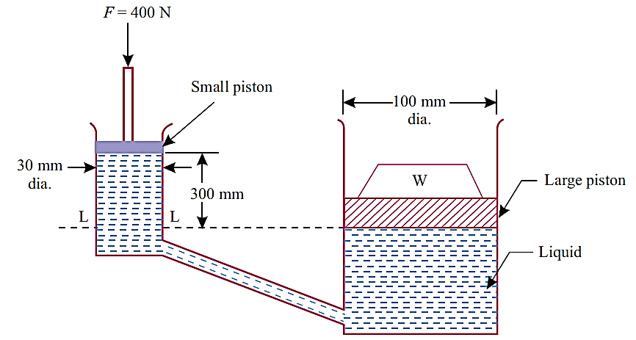  Figure 3 b  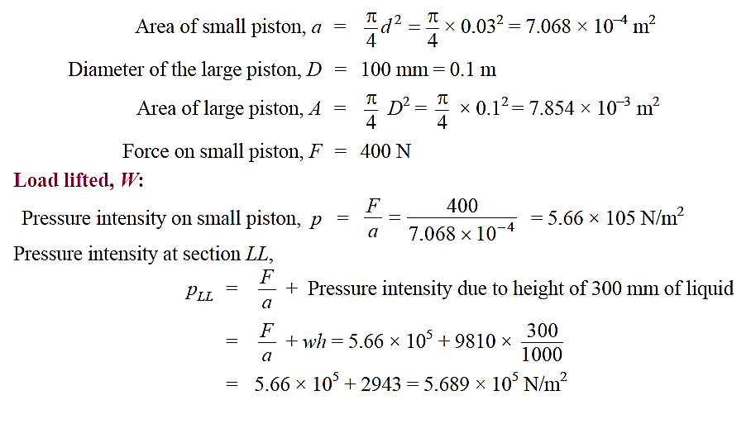  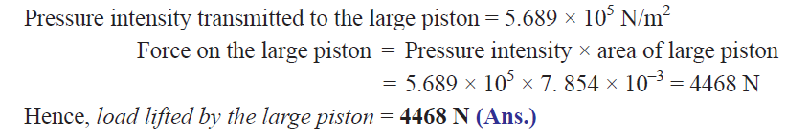 | 10
4. a. | A wooden block of specific gravity 0.75 floats in water. If the size of the block is 1 m × 0.5 m × 0.4 m, find its metacentric height.  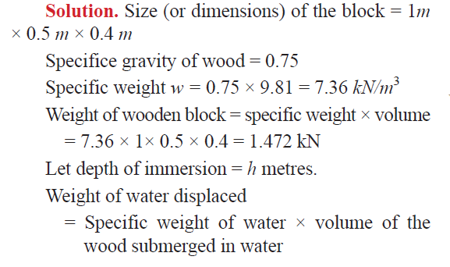  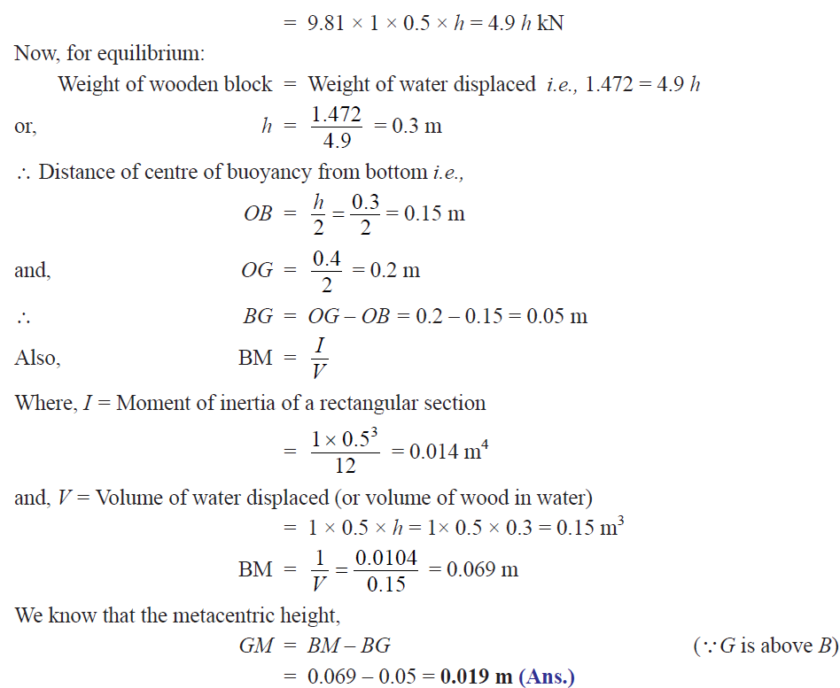 | 10
 | (OR)
b. | In a fluid, the velocity field is given by V = (3x + 2y) i + (2z + 3x² ) j + (2t – 3z) k Determine: (i) The velocity components u, v, w at any point in the flow field; (ii) The speed at point (1, 1, 1); (iii) The speed at time t = 2s at point (0, 0, 2). Also classify the velocity field as steady, or unsteady, uniform or non-uniform and one, two or three dimensional.  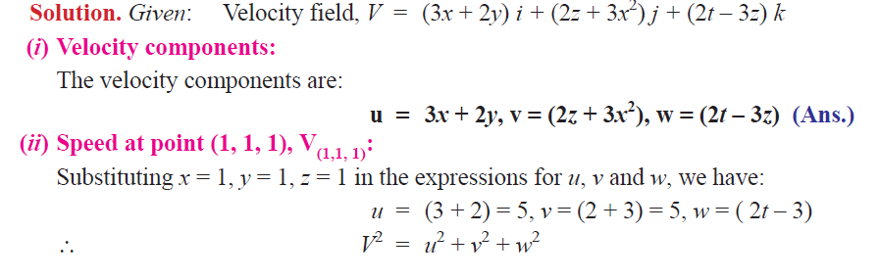  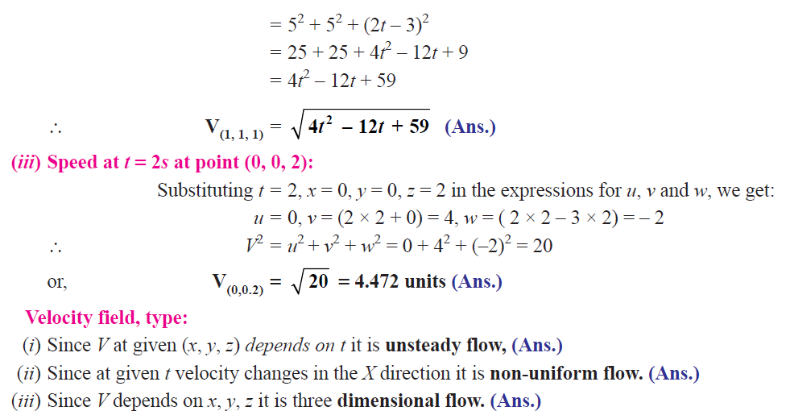 | 10
5. a. | A Francis turbine of specific speed 100 develops 15.2 *10³. kW under a head of 200 m. The overall efficiency is 0.86 and the velocity of flow is constant and is equal to 10 m/s. The hydraulic efficiency is 0.89, the ratio of width to diameter of wheel at the inlet is equal to 0.1 and the area occupied by the thickness of the blades is equal to 5% of the area of water way. Workout the area, guide blade angle, vane angle, peripheral velocity and velocity of whirl at the inlet. Assume axial discharge.  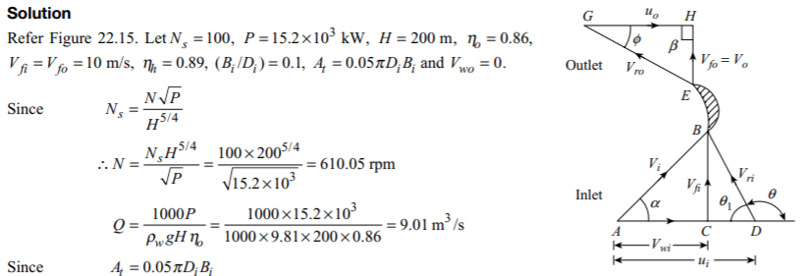  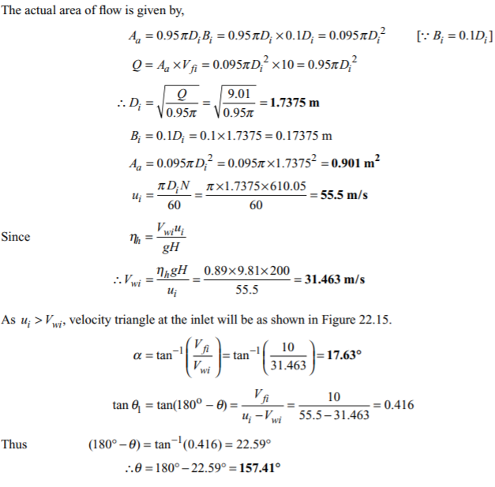
 | (OR)
b. | A Kaplan turbine develops 50*10³ kW under a net head of 30 m with an overall efficiency of 85%. Taking the value of speed ratio = 2, flow ratio = 0.6 and diameter of the hub = 0.35 times of the diameter of the runner, then calculate (i) the diameter of the runner, (ii) speed of the turbine and (iii) specific speed of the turbine.  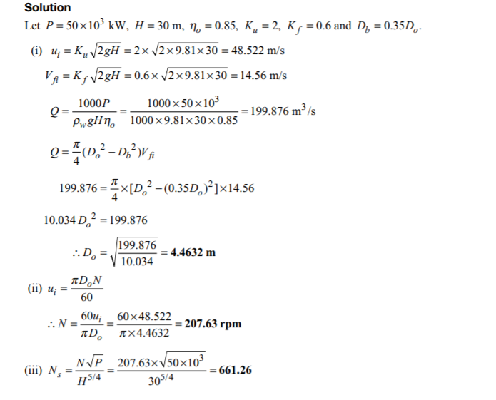
6. a. | The impeller of a centrifugal pump is of 0.3 m diameter, 0.05 m width at the periphery and has blades whose tip angle inclines backwards 60° from the radius. The pump delivers 15 m3/min and the impeller rotates at 1000 rpm. Assume that the pump is designed to admit radially and calculate (i) the speed and direction of water as it leaves the impeller, (ii) torque exerted by the impeller in water, (iii) shaft power required and (iv) lift of the pump. Take mechanical efficiency as 95% and hydraulic efficiency as 75%  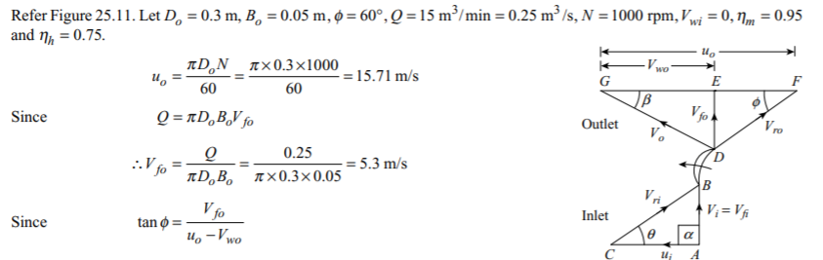  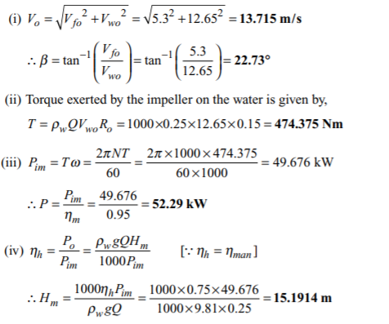
 | (OR)
b. | A single acting reciprocating pump delivers 9 litres per second of water against a suction head of 4 m and a delivery head of 16 m while running at a speed of 60 rpm. The diameter and stroke of the piston are 200 mm and 300 mm, respectively. Determine (i) the theoretical discharge, (ii) coefficient of discharge, (iii) slip, (iv) percentage slip and  (v) power required to drive the pump.  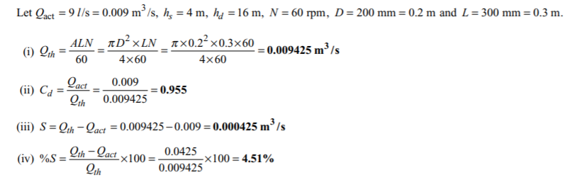  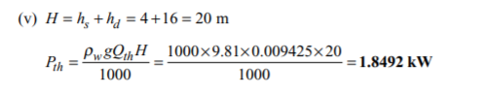

--- End of Paper ---

